LHUMC Worship Planning Retreat 2026
Meeting Preparation
Friday, Sept. 11 from noon – 7:00 pm
Saturday, Sept. 12 from 8:30 am – 2:00 pm
Church of the Dunes, 717 Sheldon Rd, Grand Haven, MI 49417

Yearlong Theme
Our mission is to make disciples of Jesus Christ for the transformation of the world.

What do we need to focus on in worship for the next year to accomplish our mission?

How does the theme encourage spiritual formation and help us carry out our mission?

Five Practices of Fruitful Congregations/Living: radical hospitality, passionate worship, intentional faith development, risk-taking mission and service, and extravagant generosity.

2027 Possibilities:
- Love boldly and sincerely. Serve joyfully and humbly. Lead courageously and faithfully.
- Dare to Dream Like Jesus. Related resource: Dream Like Jesus: Deepen Your Faith and Bring the Impossible to Life by Rebekah Simon-Peter and Mike Slaughter

Previous themes:
- 2026: Love boldly and sincerely. Serve joyfully and humbly. Lead courageously and faithfully.
- 2025: Living in the Light of Jesus. Key verse: John 8:12 – When Jesus spoke again to the people, he said, ‘I am the light of the world. Whoever follows me will never walk in darkness, but will have the light of life.’
- 2024: Following the Jesus Way. Key verse: John 13: 34 – A new commandment I give to you, that you love one another: just as I have loved you, you also are to love one another.
- 2023: Jesus Is Our Past, Present, and Future Hope. Key verse: Romans 8: 38-39
- 2022: The Spiritual Journey Continues...
- 2021: Still Blessed
- 2020: 20/20 Vision. Seeking God’s Vision for Ourselves, Our Church, Our Community, and Our World.
- 2019: Love God and love neighbor
- 2018: HOPE, PEACE, JOY, and LOVE are found in Jesus alone.

How do we make it known to our members? Hallway art? Hands-on item?

Spoken Needs:
As you think about the conversations you’ve had with people, remember the struggles, challenges, curiosities, and desires that people have expressed. What are people saying that they need?
- Answers to the “why” questions. Why did this happen? Why now? Why doesn’t this happen? Why did my young child die? Why did my loved one commit suicide? How do I live with my grief? Where is God when we need him?
- Why have the faith journeys been so different for my family?
- Witness: How do I talk to my children/grandchildren about faith and is there a book we could read together to facilitate conversation? (Night by Elie Wiesel)
- Support amidst health concerns and aging parents.
- Calm amidst uncertain times in our nation and world.
- Frustration over politics. Navigating a divided world. Pervasive lack of trust, respect, and civility. Anxiety and anger.
- Christian Nationalism or conservative identity politics. Related articles:
  - “How (Not) to Talk about Christian Nationalism” by Brad East, Christianity Today, March 13, 2024
  - “It’s Not ‘Christian Nationalism.’ It’s Conservative Identity Politics.” by George Yancey. Christianity Today, January 22, 2026.
  - “What Is Christian Nationalism” by Paul D. Miller, Christianity Today, Feb. 3, 2021
- Kindness in our society: How do we foster kindness?
  - “Make Faith Plausible Again” by Todd Watermann. A peculiar hospitality can awaken faith in our secular contexts.
- Turning from sin - true repentance.
- “Vertical morality” vs. “horizontal morality.” AI overview: Vertical morality and horizontal morality are frameworks used to describe where a person derives their sense of right and wrong. Vertical morality is a top-down system rooted in obedience to a higher authority, while horizontal morality is a side-by-side system focused on empathy and community well-being. Click here for more info.
- Discernment. Following God and not this world.
- I think most people are looking for meaning and community. Meaning should drive community and community should create meaning. It’s a dialect. I think this is the heart of Christ and his kingdom and Love is the center. It’s the energy. Everything the church does should have these two things as its focus. When that happens, the church can be a place where individual struggles, desires and challenges become the fuel that creates the energy for a thriving church. - Chris Ostrander
- Loneliness. Related article: “How One Man’s Cure for Loneliness Started a Movement” by Mathylda Dulian, Aug. 4, 2026, Wall Street Journal
- Inclusive communities: Age, abilities, backgrounds
- Integrity: The importance of our actions matching our words.
- Change and stress: How do we deal with it? Lack of support systems.
- Forgiveness. Grief. Where is God when we need him?
- AI (for good or evil?), phones, social media, privacy issues, impact on entry level jobs

Unspoken Needs
Unspoken needs are the things aren’t talking about. When someone is unhappy or feeling lost and can’t truly articulate why, you might be able to perceive his/her real, unspoken needs. What are those needs?
- How/why does God allow tragedies to occur?
- Why are some people healed and others not when both were held in prayer?
- I am sadly not as plugged into our church to know others' specific needs. But I think our community as a whole is looking for a place to be whole. Meaning that whatever lacks we have, whether they be financial, emotional/psychological, or spiritual can be filled. That looks like a church where you can get help with a bill or food to a place to grieve to a place to receive counseling to a place to experience a mystical union with the divine. - Chris Ostrander. Note: Our C3 Team is looking at this.
- Aging = Invisibility. Difficulties of aging/the elderly. Caregiving for grandchildren and aging parents. What does it mean to honor your parents? What are the limits of caregiving for aging parents and grandchildren?
- Understanding Methodist history. Related resource: “Rooted Methodism”
- Understanding the bible

Potentially Useful Stuff
Josh Larsen, editor/host/producer of Think Christian, says “glimpses of God’s truth can be found in unlikely places. There’s no such thing as secular, so let’s consider Christianity and pop culture together.” Author/pastor Rob Bell says that everything is spiritual. People want to understand their purpose here on earth. What books, articles, authors, films, TED Talks, podcasts, television shows, and comics are memorable because they speak to spiritual needs? What questions would you like to have answered?
Questions to explore:
- Deep faith questions:
  - Why haven’t I been blessed? Help me understand the nature of blessing.
  - Suffering: Why do bad things happen to good people and good things happen to bad people?
  - What about free will?
- Name people who have been quite willing to talk about their faith?
  - Steven Colbert (with Anderson Cooper).
  - Ben Sasse (former senator from Nebraska who is dying of pancreatic cancer – thoughtful, articulate and not weird).
  - Burrill Colburn.
- What would you say in 3 sentences when asked why you go to church? Why is your faith important to you?
  - Attending church grounds me in my faith in Jesus. I feel surrounded by other believers that I can love and be loved while worshipping God. Being part of a community that I know supports me and my family.
  - I go to church to worship and serve God through the community of believing brothers and sisters. My faith is strengthened by my church family and friends.
  - I go to church to worship God. I worship God in a community of faith made up of disciples of Jesus Christ learning to love God, loving others and serving as a disciple of Christ. My faith is strengthened by worship, prayer, Bible study and receiving the sacrament of holy communion. My faith guides how I live out my daily life and the choices I make for the transformation of the world.
  - I attend worship services out of gratitude for connection with other believers and to grow through the messages each time. My faith is an anchor in all times…smooth sailing or troubled waters
  - Going to church strengthens my faith. I feel part of a family of believers who wish to make an impact on our world.
  - Going to church with a community of believers brings peace to me in this chaotic world. I can love on and be loved in this safe place with Jesus as its center.
  - My faith is important to me because I know that God will always be with me and watching over me.
  - I go to church to worship God, to enjoy the community of faith filled brothers and sisters, to continue learning and because it brings me joy
  - My faith is important to me because it gives me hope
  - Everybody is so nice. For someone who has been a ball of anxieties most of my life, I go to church because that’s where I know that I am loved. And I am blessed and thankful
  - I go to church to worship God. I worship God in a community of faith made up of disciples of Jesus Christ, learning to love God, loving others and serving as a disciple of Christ. My faith is strengthened by worship, prayer, Bible study and receiving the sacrament of holy communion. My faith guides how I live out my daily life and the choices I make for the transformation of the world.
  - It’s so strange (God thing I’m sure!) that when I’m stressed about something the sermon is spot on! I go to church because it makes me feel whole and gives me power to face my week
  - Attending church just makes me feel more connected to God. And I need God to be helping me and watching over me
- What questions would you ask Jesus?
  - Why did my son have to die at only 6 years old?
  - Why did I have a miscarriage?
- World religions

Articles:
- Artificial Intelligence: UMC Discipleship resources
- “Curious Questions to Engage Skeptics” by Tim Keller. An appendix to Michael Keller’s article, “When They Trust Jesus But Not You.”
- David Crowder: “Worship and Justice Go Hand in Hand.” Relevant magazine, July 2026
- “Do Bible Passages Belong in English Class?” by the Editorial Board of the Wall Street Journal, June 21, 2026. It’s cultural literacy to read about ‘the valley of the shadow of death.’
- “Fatherhood and the Church” by Will Thibeau, June 18, 2026, Wall Street Journal, Houses of Worship column. The remedy for the empty pews isn’t a softer faith, but a harder one.
- “How to Help Gen Z Connect Spiritually Online and at Church” by Barna Group, July 7, 2026
- “Religion Belongs in American History Class” by Todd Weiler, Wall Street Journal, Houses of Faith column, April 9, 2026
- “The Hidden Factor in Student Success: Family Structure” by Ian Rowe and Brad Wilcox, Wall Street Journal, July 24, 2026

Resources: Pine Rest Church Assistance Program (video) includes two free programs per year with additional paid options.

Comics and memes: There are many examples in the Google album

Television shows and movies: See the “Faith in Film” handout

Stray stuff:
- Neighboring Movement

Books: People have been reading these books. Is there interest in a church book group?
- Theo of Golden by Allen Levi. A story of giving and receiving, of seeing and being seen, Theo of Golden is an unforgettable novel about the power of generosity, the importance of connection, and the quiet miracles that happen when we choose kindness and wonder.
- The Unbearable Wholeness of Being by Ilia Delio
- The Experience of God by David Bentley Hart
- All Things are Full of Gods by David Bentley Hart
- Truth and Beauty by Ann Patchett
- Judge Stone by Viola Davis and James Patterson
- Kin by Tayari Jones
- Keeper of Lost Children by Sadeqa Johnson
- The Listener by Terri Blackstock
- Fields of Blood by Karen Armstrong
- Psalm for the Wild-Built by Becky Chambers
- An Engineer's Guide to Roller Coaster Design by Nick Weisenberger
- Man’s Search for Meaning by Viktor Frankl. Viktor Frankl recounts his time in Auschwitz and shares his insight that we can choose our attitude in any circumstance to find meaning.
- Wesleyan Vile-tality by Dr. Ashley Boggan (I haven’t read this but she spoke at Annual Conference - Annette)
- The Supernatural: What the Bible Says about the Unseen World and Why It Matters by Michael Heiser

Authors:
- Kate Bowler
- Ann Lamott
- Adam Hamilton
- Matt Rawles
- Michael Adam Beck: Fresh Expressions and “Distortions”

Memorable traditions:
- Candle lighting. Holy Thursday worship.
- Excellent music that touch my soul
- Worship participation/leading by children and youth (with input from them ahead of time)
- Communion - serving and receiving
- I was raised in the Assemblies of God, which is a Pentecostal denomination, so worship services were focused on creating goosebump moments every Sunday. In my late teens, those experiences were almost like a drug. It was what I looked most forward to at church. For a long time though I was jaded about those experiences because I felt it was more about manipulating people into having them with music and emotional lyrics than anything the Holy Spirit was doing. However, today, rather than viewing the music and repetition of singing certain verses over and over again as manipulative, I do think it helps focus the mind into having mystical experiences. I think it’s probably a similar phenomenon to what people experience when chanting or meditating. In recent years, I’ve attended a convention called Theology Beer Camp. It is a very progressive theology conference where you drink beer in church and listen to speakers. A lot of the people who attend are people who grew up in conservative spaces and grew very cynical about church. Yet, there’s a big worship service at the end complete with communion and it’s such a moving experience because it’s a lot of jaded ex evangelicals who still love Jesus all coming together and worshipping. The first year I went was at a beautiful UMC church in Denver Colorado, btw. - Chris Ostrander

Memorable Advent and Lent traditions:
- “Instead of elf on a shelf, the holy family make a trek across the living room to the manger on the opposite side…Then the magi make their trek for twelve days after…the three kings bring presents at (divorced) dad’s house since Santa visits moms each year"

General feedback
- Google form response: Honestly, I’m not someone who is into the whole using pop culture to communicate spiritual truths. It was a popular trend in Evangelical churches I attended back in the late 90’s/early 2000’s, so it makes me think of back then. I’m not a big TED Talk watcher, but Brene Brown’s TED Talks are really good. Donald Hoffman’s TED Talk on the nature of reality is really fascinating because he uses math and science to show that the world we experience is more like a virtual reality which obviously has a lot of theological implications. - Chris Ostrander

Favorite Scriptures
- 2 Chronicles 15:7
- James 5:11
- Psalm 46:10
- Proverbs 3:5
- Psalm 46:10
- Psalm 139:1-18
- Joshua 24:15
- Proverbs 3:5-6
- Galatians 5:22-2

Books of the Bible you want to study
- Book of Acts (summer 2027?)
- 1 Thessalonians (5:16-18)
- Revelation

Hymns or songs
- Great is Thy Faithfulness
- Hymn of Promise
- It is Well with My Soul
- This is My Land
- Morning Has Broken
- For the Beauty of the Earth
- When the Roll Is Called in Glory
- This Is the Day the Lord Has Made
- Morning Cry
- Bulletproof by Citizen Way
- Standing on the Promises
- Hills and Valleys by Tauren Wells
- Amazing Grace
- Mary Did You Know
- Pass It On
- Hello My Name Is by Matthew West
- Sanctuary
- In the Garden
- Ten Thousand Reasons
- I Am Yours
- He Touched Me
- Precious Lord Take My Hand
- How Great Thou Art
- They’ll Know We Are Christians by Our Love
- Because He Lives
- God of All My Days by Casting Crowns
- The Blessing by Kari Jobe
- Help Us Accept Each Other
- He Lives
- Count Your Many Blessings
- Fragile by Sting
- Fear is a Liar by Zach Williams
- You Are Loved by Josh Groban
- Holy, Holy, Holy
- Hymn of Promise
- Be Thou My Vision
- Come, O Come Emmanuel
- Trust and Obey

VBS possibility: On the Boardwalk

Foundations of Our Faith
Nearly everyone, including non-Christians, has heard of the Lord’s Prayer and Ten Commandments. They are foundations of our faith. What other foundational beliefs would you like to explore in worship?

Series we have done:
- Nine Key Teachings of Jesus (winter & fall 2026)
- Apostles’ Creed (summer 2025)
- Beatitudes (summer 2024, Lent 2014)
- United Methodist Ten (summer/fall 2023)
- Ten Commandments (summer 2023)
- Lord’s Prayer (summer 2022)
- Psalms (summer 2018, Lent/Easter 2022)
- Fruits of the Spirit (summer 2021)
- Sermon on the Mount (after Easter 2020)
- Seven Deadly Sins (summer 2015, late summer/fall 2025)
- Gospel of Mark (Good News for the New Year 2021)
- Revelation (May 2022)
- Genesis (In the Beginning – summer 2017)
- The Trinity (September 2018)
- Minor Prophets (summer 2020)

Series to consider:
- “Fruits of the Spirit” - Annette Erbes
- The Early Creeds or maybe some of the writings of the early church fathers. I only started learning about church history in my adult years. I think most Christians are probably pretty ignorant about church history. I know I was and I was raised in church and went to Christian school k-12. - Chris Ostrander
- “Core Faith.” Discipleship Ministries. Romans 8. This chapter provides insight into some of the core elements of our faith. How does the law function in our faith? What does it mean to set our mind on the Spirit? What is our relationship with all creation? How are we bound together with other disciples in suffering and joy? St. Paul sets out to answer these and many other questions as he weaves a poetic vision of what it means to be a follower of Jesus and a part of the body of Christ.
  - “Delight in the Law.” Romans 7: 15-25a
  - “Set the Mind.” Romans 8: 1-11
  - “Wait with Eager Longing.” Romans 8: 12-25
  - “More than Conquerors.” Romans 8: 26-39

Series Ideas
Armed with a lot of perspective on spoken and unspoken needs, start to ask questions like: What Scriptures address these needs? What topical series could address these needs? From which book of the Bible could we teach? What creative series titles or “hooks” could we use?

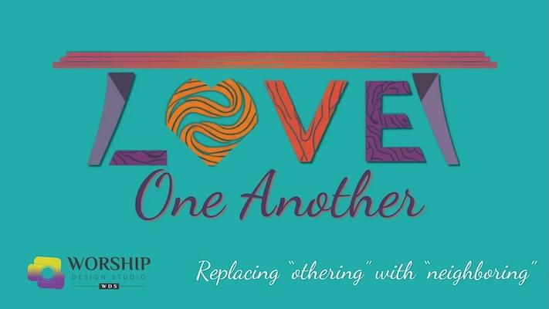
“Love One Another.” A series by Marcia McFee in conjunction with Resurrection Church (Adam Hamilton). Let’s sit down at the table together and check in, figure out how to attend to each other, and try to alleviate immediate pain on a granular level.
- Series intro video
- Scriptures and Synopses
- Overview
- Sample script week 1
- Related activity: Host a “Longest Table” event

“Control.” How do we address the tension between our desire for certainty and the biblical call to surrender? - Karen Booth
- “The Illusion of Control.” How the pursuit of control fuels anxiety and breaks relationships. Proverbs 3:5-6. Matthew 6:25-34.
- “The Roots of Control.” Why we strive for control, and how it often masks fear, pride, or a lack of trust. Genesis 3 – The Fall. Daniel 4.
- “The Art of Surrender.” Jesus in the Garden of Gethsemane as the ultimate example of letting go. Luke 22:42. Romans 12: 1-2.
- “Trusting the One in Control.” Resting in God’s character and sovereignty over our circumstances. Romans 8:28. Philippians 4:6-7.

Technology

Justice work
- Juneteenth. Celebrating Juneteenth (Discipleship Ministries).
- Defending the immigrant and refugee
- Defending the widow and orphaned
- David Crowder: “Worship and Justice Go Hand in Hand.” Relevant magazine, July 2026

“Do Not Worry” (from Matthew) - Annette Erbes

Hope (through Jesus) - Annette Erbes

“What Does the Bible Say About…?” Hope. Judgement. - Kathy Luckett

“Why?” Address grief, suffering, and living through the hard stuff of life.

Environment related series in April around Earth Day.
- Related article: “U.P. Church Seeking God in Michigan’s Outdoors” by John Carlisle, Detroit Free Press, July 12, 2026
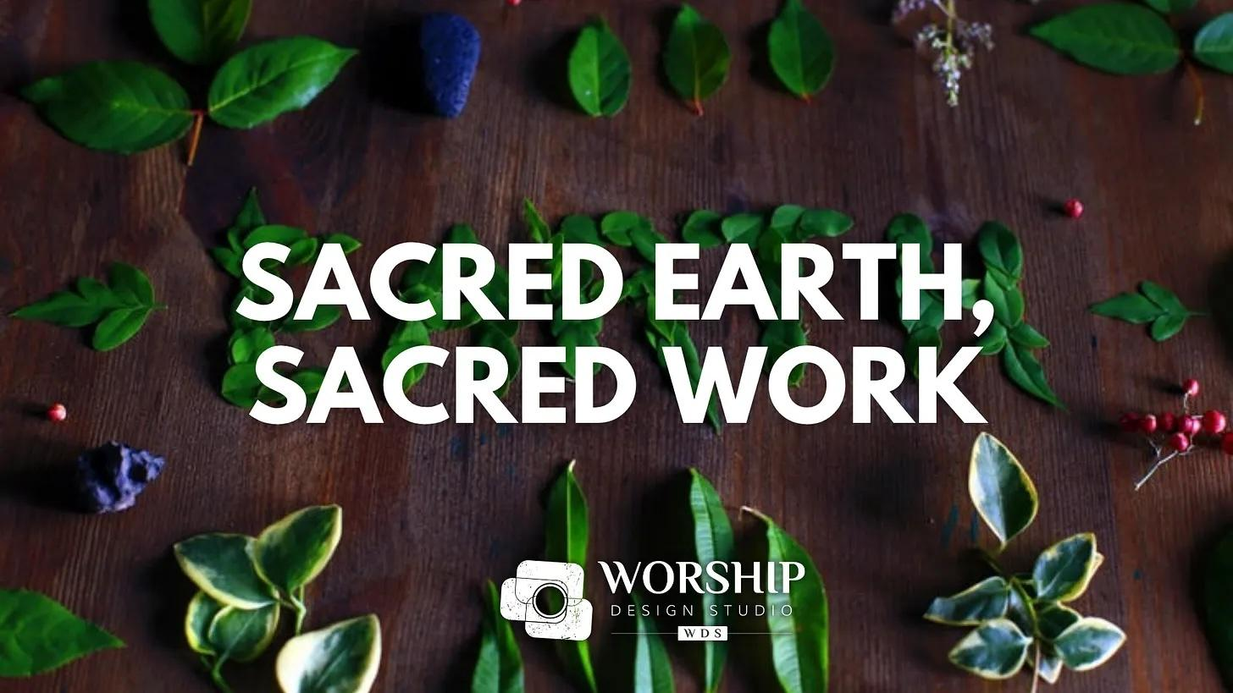
- “Sacred Earth, Sacred Work” by Marcia McFee (Worship Design Studio). What if we lived life truly connected to the origins of Creation and the Creator?
  - Scripture and synopses
  - Overview
  - Sample script week 1

“Embracing Adverbial Faith.” Love boldly and sincerely. Serve joyfully and humbly. Lead courageously and faithfully. To help churches explore and embody this vision, Discipleship Ministries offers a six-week worship series and small group study titled Embracing an Adverbial Faith. The series invites congregations to go deeper into what it means to love, serve, and lead not as obligations, but as expressions of a life formed by the Holy Spirit.

“Lessons in Leadership.” Discipleship Ministries. As we transition from summer to fall, we are called back together to work out how we will live in community as a witness to our faith. As a refresher, we ask you to consider these “Lessons in Leadership” as a way of shaping the body we seek to be. This is not a how-to with specifics for each communal situation, but an attitude check, a value inventory to ask who we will be together as we build up the church. Topics: Power, Acceptance, Conflict, Grace.

Google form response: So you referenced Rob Bell in a previous question. I attended Mars Hill when he was pastor there and one of the series he did was called Mastering the Art of Living. The idea was that Jesus teaches us the best way to live. The purpose of being human is to be image bearers so Jesus isn’t starting a new religion, he shows us how to be truly human. Another series could also be about addressing hard questions. Pastor Mary and I once talked about her Bible study she does and she was telling me how surprised people were to learn there are older myths that pre-date the Bible but have a lot of similarities such as the Epic of Gilgamesh. One of the reasons I think Rob Bell and Mars Hill got so popular was because he got into these kinds of topics and the history of the ancient world and how that history helps you see the Bible in new ways. That was what drew me there, at least. - Chris Ostrander

Resources from Worship Design Studio

Ideas from Ken Luckett:

“Sacred Rhythms & Bold Prayers”
- Part 1 - Sacred Rhythms: Disciples made for busy lives - prayer, fasting, solitude and silence, scripture reading, worship, service, fellowship, generosity.
- Part 2 - Bold Prayers: Moving beyond surface level requests to pray boldly like search me, break me, and send me.

“Theme Park Faith.” Life with God is not a smooth predictable stroll. It is a wild ride full of thrilling peaks, scary drops, and unexpected twists.

“The Color of Grace.” A vibrant series built around one core truth. Grace isn’t gray, it’s bursting with color. It shows up in every shade of human experience. Where grace enters, color returns! Grace is not a concept, it’s a palette. The emotional palette of grace consists of the following:
Red - Redeeming love
Blue - Peace in turbulence
Yellow - Joy that breaks through
Green - Growth in hidden places
Purple - Royal identity
Gold - God’s glory in ordinary life

“Bless this Mess.” God works right in the middle of the chaos, not after we have cleaned up. God does not wait for your life to be tidy; grace grows best in messy places. Stop hiding imperfections and start seeing them as where God does his best transformative work.

“The Ghosting Gospel.” A biblical response to the culture of disappearing. Ghosting is everywhere - friendships, dating, and workplaces - even church.

“The Gospel According to Social Media.” Fake News vs. Real Truth. Finding truth in a social world. Create a series to help people recognize the difference between the messages of social media and the message of Jesus. Learning biblical discernment in an age of misinformation.

“Battles of the Bible.” Battlefields were often a reflection of deeper unseen spiritual meaning. Take a look at iconic military moments to look at how God works through human weakness and breaks overwhelming odds. Show how God fights on behalf of his people with miraculous triumphs to the ultimate victory at the cross.

“Unchained.” Breaking free from the burden of shame, past mistakes, and generational patterns.

“The Story We Live.” Help people see their lives as a God-authored narrative that unfolds with purpose. Use examples from individuals in the bible.

“The Great I AM.” Dive into Jesus’ I AM statements as found in the gospel of John.
- “I am the bread of life.”
- “I am the light of the world.”
- “I am the door (or gate).”
- “I am the good shepherd.”
- “I am the resurrection and the life.”
- “I am the way, the truth, and the life.”
- “I am the true vine.”

Series ideas from previous years

- Focus on one book of the bible:
  - Proverbs
  - Prophets
  - Revelation
  - Women of the Bible
  - Unknown Apostles
  - Gospel of John.
  - Book of Acts.
- "Living Out the Great Commission”
- Holy Spirit
- Parables
- Suggestions from other pastors:
  - Don’t Look Back – We’re Not Going that Way
  - God’s Call in the Bible and on Our Lives
- “Worship with Rejoicing” (UMC). In this series, we invite you to consider that, for David, worship was life. Worship wasn’t something David did, we might say; it wasn’t a specific time in the day or week. Rather, worship was who he was. David lived and breathed worship. Yes, sometimes he got it wrong; sometimes he followed impulses that led him astray. And sometimes he got confused about who was the object of this worship and got in the way of the God he loved. But through it all, David lived as though his life was an offering to God. Gathering for Worship. Call to Worship. Call to Confession. The Weight of the Word. Prayer of the People. Benediction. Sent Out to Live.
- Spiritual mentoring
- Conflict resolution

Seasonal Series Ideas
We also need to identify ideas for specific series that we do every year. For example, we know we will celebrate Advent/Christmas and Lent/Easter every year. We also know that every fall we’ll have a Stewardship Campaign.

ADVENT
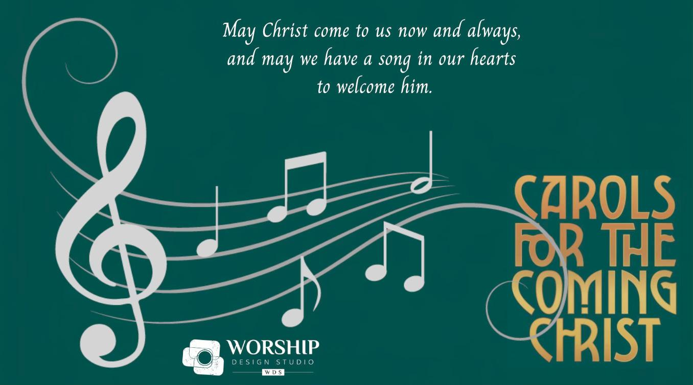
“Carols for the Coming Christ.” Marcia McFee (Worship Design Studio). Based on the companion book of devotionals by Adam Tice (coming Oct. 6, 2026). Like notes on a music staff, we are called to join together to sing songs that proclaim the renewed creation of Hope, Peace, Joy, and Love. This year throughout the Advent and Christmas season, we will encounter familiar and new Carols for the Coming Christ and pause to consider their messages in fresh ways. As a popular quote attributed to Hans Christian Anderson says, “Where words fail, music speaks.” Song poets have long helped us “speak” when our own words fail in the face of our human struggle. The promise of the Coming Christ is that our hearts can hold the world, and the songs in our hearts can heal our weariness.
- Scripture and Synopses
- Overview
- Sample script for Advent 1
- Related visuals on Pinterest.
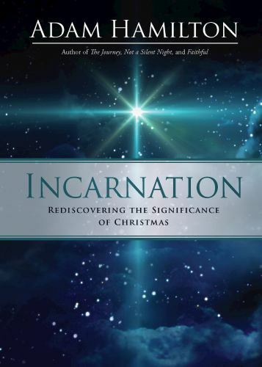
“Incarnation” by Adam Hamilton (Annette. We did this in 2021).
Google form response: I think, given the time we live, it would be especially important to look into the radical way the birth narratives and Christ’s teachings, death and resurrection challenged the political and religious systems of Jesus’s day. For example, many of the things the gospel writers say about Jesus’s birth are also things people said about Caesar Augustus. Or, how the big issue surrounding Jesus’s death is about Jewish insurrection against Rome. Barabbas was an insurrectionist, for example. There’s a clear message that Jesus is a different kind of insurrectionist who overturns the empire with self-sacrificial love rather than violence. - Chris Ostrander

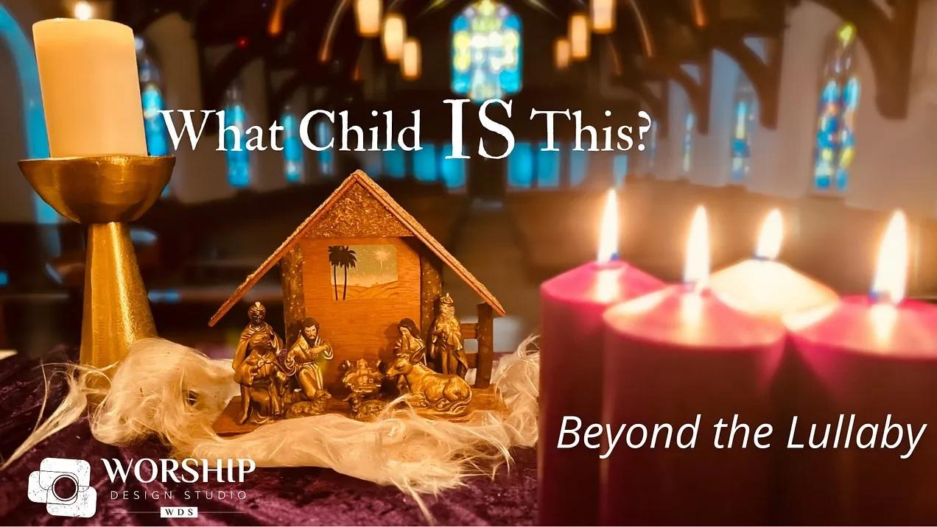
“What Child Is This?” Marcia McFee (Worship Design Studio). In 1865, William Chatterton Dix penned a poem that would become the beloved Christmas-time favorite, “What Child Is This?” During Advent, we will dive into this question that is much more complicated than the lilting lullaby tune, “Greensleeves,” conveys. We will see the story of the time leading up to the birth of Christ in its historical trauma-informed fullness. The story of humanity and its recurring themes of oppression and corruption run through history and into our own narratives. Yet, we can rely on the assurance of the carol to confirm that God is “present with us” in powerful ways that continue to be the Word of Hope, Peace, Joy, and Love even and especially in the midst of hard times.
- Series trailer
- Scripture and synopses
- Overview
- Sample script week 1
- Related visuals on Pinterest.

“Restoration Song.” Discipleship Ministries. Advent is a time for singing. We often debate whether we should sing Christmas hymns or only Advent ones. How about we sidestep that debate and sing Psalms instead? We don’t often turn to the psalms for worship texts during advent – or almost any time really. But this season the psalms can capture the experience of the season with surprising power and meaning. At the heart of the Advent season is a longing to find our place in the kingdom and kin-dom of God. So, this season let the psalms help us sing the restoration song.
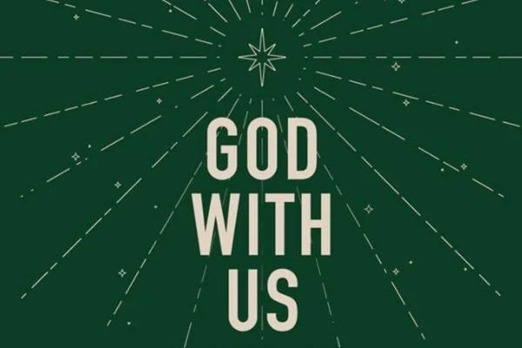
“God with Us.” Discipleship Ministries. Advent is a season of waiting, longing, and preparation. It is also a season when God’s promises break through the shadows of injustice with the light of hope, peace, joy, and love. This resource, God With Us: Advent Promises for a Just World, invites congregations to journey through Advent attentive not only to the coming of Christ into the world but also to the ways Christ calls us to enact justice, equity, and belonging in our communities. PDF with plans for the four Sundays of Advent.

Advent series ideas from previous years
- “Journey to the Nativity.” Skit Guys. Waiting on God. The Star. Silent Night. Angels and Shepherds. 90 Miles.
- “The Birth of Jesus in the Midst of a Troubled World”
- From the Skit Guys:
  - Christmas Carols. Opener. O Come O Come Emmanuel. Hark! The Herald Angels Sing. Joy to the World! Silent Night.
  - Mary for the Ages
  - Songs of the Savior: Come Thou Long Expected Jesus (Joseph), Joy to the World (Mary and Elizabeth), Oh Come All Ye Faithful (Shepherds), The Nativity. What Child Is This? (Wise Men)
  - The Wonder of His Peace, Joy, Hope, Love, Birth
- Advent from Mary’s perspective – her fears, concerns for her own safety, and the arrival of her baby
LENT
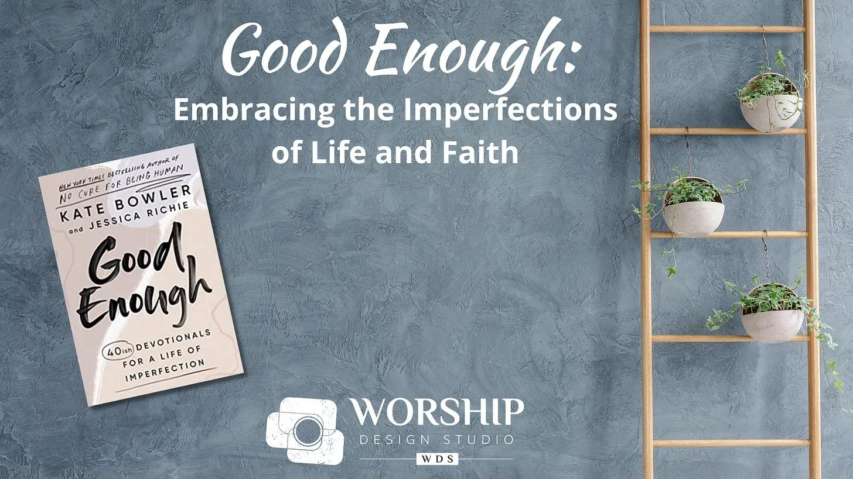
“Good Enough.” Marcia McFee (Worship Design Studio). Based on a book by Kate Bowler and Jessica Richie. We live in a culture bent on definitions of a good life as continuous upward mobility… But life happens, right? Most times we are not moving upward but trying to repair the rung we’ve just slipped from. So what if we stopped climbing and started fertilizing, water, and blooming right where we find ourselves? We can lean into embracing our “good enough” lives.”
- Series intro video
- Scripture and synopses
- Overview
- Sample script Lent 1

“The Way.” Marcia McFee (Worship Design Studio). Lent is a time of reflection, and there’s nothing like a pilgrimage to conjure that up. Making intentional journeys has been a ritual of humankind across time and traditions. Inspired by passages in the Judeo-Christian scripture that talk about the journey, roads, and pathways of life, we will make our way together through this season. The popular and poignant movie, “The Way,” about a father’s pilgrimage in honor of his late son on the famed Camino de Santiago in France and Spain, accompanies us as our modern-day inspiration to live the life we’ve been given to the fullest.
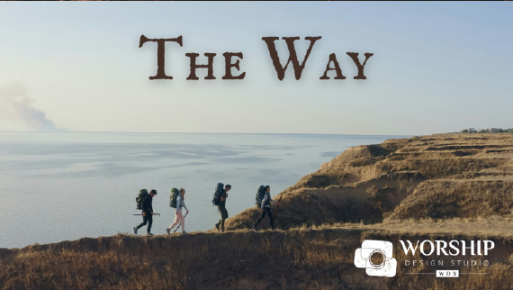
- Series intro video
- Scripture and synopses
- Overview
- Sample script Lent 1
- Related visuals on Pinterest.

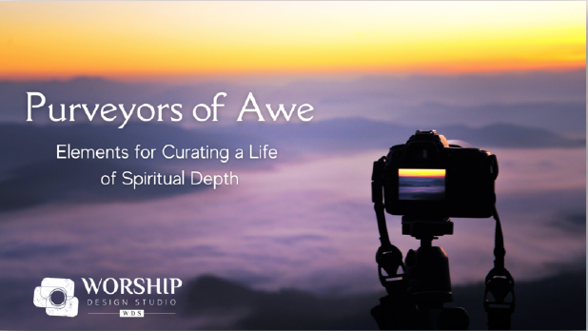
“Purveyors of Awe.” Marcia McFee (Worship Design Studio). Explores the elements of beauty, wonder, meaning, curiosity, delight, connection, and self-giving.” Scripture and overview.
- Series intro video
- Scripture and synopses
- Overview
- Sample script Lent 1
- Related visuals on Pinterest.

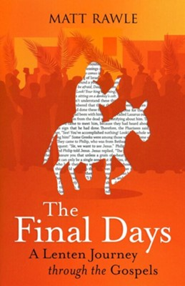
“The Final Days: A Lenten Journey through the Gospels” by Matt Rawle. Matthew, Mark, Luke, and John devote most of their storytelling to Jesus' last week in Jerusalem, but each version of the Gospels isn't quite the same. Each story is told through a different lens, sharing an abundant, diverse, and complementary picture of God's work in the suffering, death, and resurrection of Jesus.
- Series intro video
Lent – ideas from previous years
- The History of Lent: The practices of giving up something and/or fasting. Extra worship services.
- The History of Easter beyond the “church stuff” – new life, etc. in spring
- From Ken Luckett: “Were You There.” Based on the song, “Were You There?”
  - Week 1: Were You There… in the Shouting Crowd?
  - Week 2: Were You There… as a Spectator?
  - Week 3: Were You There… on the Way to Jerusalem?
  - Palm Sunday: Were You There… Waving and Cheering?
  - Holy Thursday: Were You There… When They Nailed Him to a Cross?
  - Easter Sunday: Were You There… When They Rolled away the Stone?

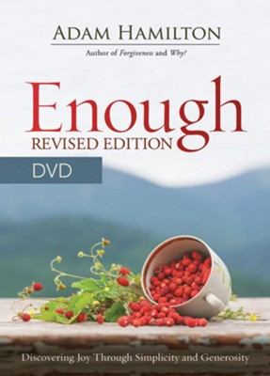
STEWARDSHIP
“What Is Enough?” based on the 2023 Version of Adam Hamilton’s book, Enough.

From Ken Luckett:
  - “The Ripple Effect.” Create ripples that reach far and wide. Highlight the transformative power of collective giving and showcase the impact it will create for the church and community.
  - “Faith in Action: Nurturing God’s Gifts, Serving His Kingdom.”

