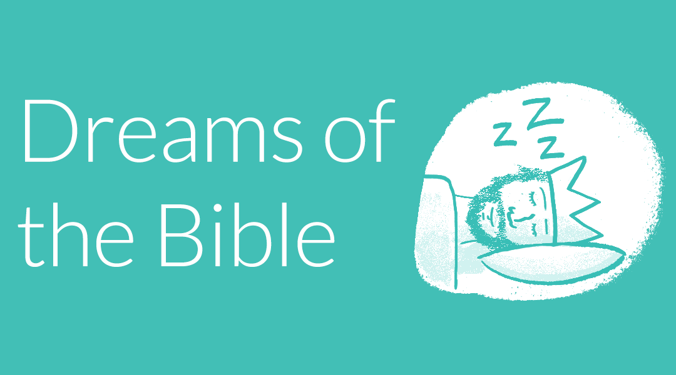
“Dreams of the Bible”
Summary
August 30 – September 27, 2026
(5 weeks)
Tues., August 4, 2026
Rob and Kathy Mertz’s house
12845 Pine Glen Drive
Grand Haven, MI 49417

Members present: Ed Baranowski, Jim Post, Jean Kelly, Pastor Mary Ivanov, Ken Lucket, Kathy Luckett, Annette, Erbes, Karen Booth, Dave Booth, Sue Baranowski, Betty Kinney, Ana Ivanov, Rob Mertz, Kathy Mertz
“The worship we hope to develop will be rooted in Scripture, centered on Christ, and empowered by the Holy Spirit. It will be relevant to local and emerging culture, while addressing the needs of believers and unbelievers alike. Above all, it will intentionally engage people physically, emotionally, intellectually, and soulfully.”

Felt needs: What physical, emotional, intellectual, or spiritual need are we addressing in this service so that worship is engaging and a means of making disciples? What question needs to be posed/answered so that we are making disciples?

2026 Theme: Love boldly and sincerely. Serve joyfully and humbly. Lead courageously and faithfully.

Key verses: 1 John 4: 7-12 (CEV)
⁷ My dear friends, we must love each other. Love comes from God, and when we love each other, it shows we have been given new life. We are now God's children, and we know him. ⁸ God is love, and anyone who doesn't love others has never known him. ⁹ God showed his love for us when he sent his only Son into the world to give us life. ¹⁰ Real love isn't our love for God, but his love for us. God sent his Son to be the sacrifice by which our sins are forgiven. ¹¹ Dear friends, since God loved us this much, we must love each other.
¹² No one has ever seen God. But if we love each other, God lives in us, and his love is truly in our hearts.

Major spoken/unspoken needs: Life is hard.
- Importance of community. Learning to live in community by being in community.
- Navigating an angry, divided world.
- Generational differences.
- Pervasive lack of trust, respect, and civility.
- Concerns about Artificial Intelligence.
- Aging. Caregiving. Death.
- Violence. Insecurity – housing, food.
- Misunderstanding scripture

Social justice issue for August 2026: Care for the Unhoused/Affordable Housing
Social justice issue for September 2026: Disability Awareness and Inclusion
Noisy offering for August: Ross Park Outreach - apple tree
Noisy offering for September: CROP Walk (Muskegon)
--------------------------------------------------
Synopsis: Exploring dreams in the Bible is a fascinating journey, as dreams play significant roles in conveying messages, prophecies, divine guidance, and reassurance. How does God continue to speak and guide us through dreams and visions?

2026 theme connection: To help us listen for God’s voice so that we can love, serve, and lead.

Key verse: “Thy kingdom come, thy will be done, on earth as it is heaven.” (Matthew 6: 10)
Guiding song: Be Thou My Vision (UMH 451) or other versions (i.e. Rend Collective)

Resources:
- Infographic: Every dream in the Bible (and what they mean) by Jeffrey Kranz | July 27, 2018. Comment: This is a good summary of all the dreams in the bible.
- What Do Dreams in the Bible Mean? These 9 Words Reveal Hints |Bible Study Magazine | Logos. The Bible uses different Hebrew and Greek words when it talks about dreams and visions.
- Interpreting Dreams with God’s Wisdom by Jennifer Leclaire |Faith Gateway. An excerpt from a book of the same title.
- From Psychology Today: Why humans dream remains one of behavioral science's great unanswered questions. Dreams have a purpose but it may not be to send us messages about self-improvement or the future, as many believe. Instead, many researchers now believe that dreaming mediates memory consolidation and mood regulation, a process a little like overnight therapy. But it's not a benefit all share equally: People who are sleep deprived also tend to be dream deprived, spending less time dreaming and perhaps not remembering dreams as well.
Visuals: Google album. Here are a concept picture and an explanation for the symbolism:
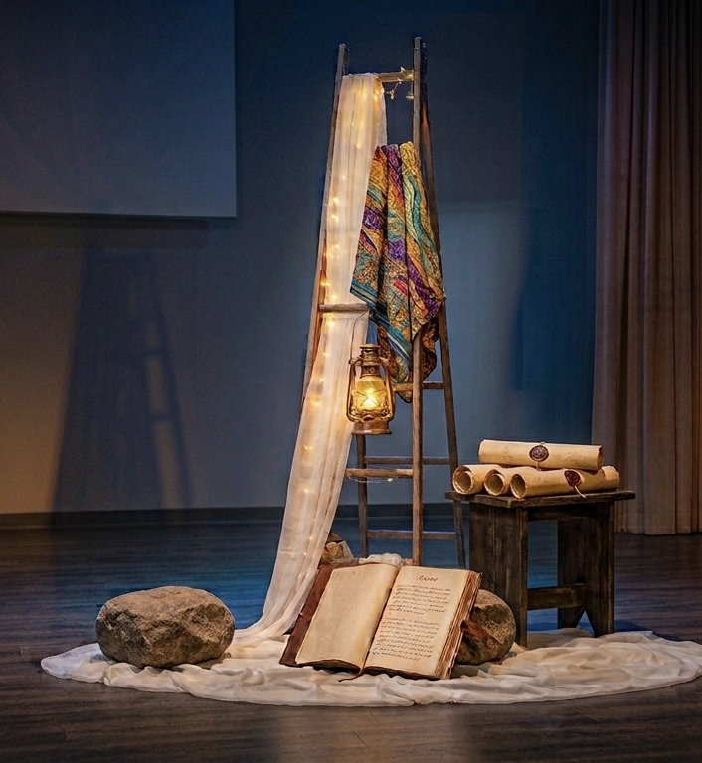
- Jesus’ Dream Team: Large Bible
- Jacob – Stone Pillows and Heavenly Ladders: Rocks, ladder (Jim P) and angel wings (Ken L?)
- Joseph – Livin’ the Dream: Colorful tapestry
- Solomon – The Right Ask: Lantern (light of wisdom)
- Daniel – Kingdom Will Come: The four beasts - Four scrolls

Media:
Music: People often sing about dreams - realized, waiting on, and deferred.

- Imagine by John Lennon - You may say I’m a dreamer, but I’m not the only one.
- A Dream Is a Wish Your Heart Makes from Cinderella
- The Impossible Dream from Man of La Mancha
- I Dreamed a Dream from Les Misérables
- Harlem by Langston Hughes - What happens to a dream deferred?
- Sweet Dreams Are Made of This by the Eurythmics
- Dreams by the Cranberries
Hands-on items:
- Lavender sachets. Amazon: 120/$32.99. Lavender has potential benefits for sleep quality.
- Sleepy-time tea bag

Note: One service at 10:00 a.m. through Sept. 6 (Labor Day weekend). We return to two services (9:00 a.m. & 11:00 a.m.) on Sept. 13.

Discussion points: Dreams:
- Fascinate most people.
- Whacko dreams (you wouldn’t share) vs. revelations from God
- Remembering dreams vs. not remembering?
- Examples: Recurring. Stress related (dreaming about work or school even when retired). Flying. Climbing ladders or steps.
- Can be comforting: A while after Pastor Mary’s dad died, she had a very vivid dream of him walking around the parsonage, restored to full health much as she remembered him when she was much younger. He was at perfect peace. Ken had a similar dream about his mom.
- Can be aspirational and may be more like a wish, e.g., a “dream job” or a vision of how we want our life to turn out.
- Can be a way of processing thoughts, understanding stresses, gaining perspective and clarity, processing trauma.
- Sleep deprivation may be a reason people forget dreams. The military experimented with drugs that helped personnel stay awake 3-4 days; they discontinued the study when they found that participants were seeing things (having visions) while awake. Some people would suggest our bodies need sleep to dream.
--------------------------------------------------
August 30, 2026 at 10:00 a.m.: “Jesus’ Dream Team”
14th Sunday after Pentecost

Scripture: Matthew 6: 5-15 (NIV)
⁹ “This, then, is how you should pray:
“‘Our Father in heaven,
hallowed be your name,
¹⁰ your kingdom come,
your will be done,
on earth as it is in heaven.
¹¹ Give us today our daily bread.
¹² And forgive us our debts,
as we also have forgiven our debtors.
¹³ And lead us not into temptation,
but deliver us from the evil one.’
¹⁴ For if you forgive other people when they sin against you, your heavenly Father will also forgive you. ¹⁵ But if you do not forgive others their sins, your Father will not forgive your sins.

Synopsis: Jesus was a visionary who dreamed big dreams. Those dreams are reflected in his prayer “Thy kingdom come, thy will be done, on earth as it is heaven.” Both church and community renewal can be traced directly to a bold vision. To dare to dream like Jesus means seeking God's kingdom on earth, aligning your life with a divine purpose, and taking courageous action to bring hope and healing to others. Dreaming like Jesus means that we put aside our will and seek God’s will so that the Kingdom of God is more visible.
Felt need: To dare to dream a new future with Jesus

Visuals: Bible.
Hands-on item:
Activity: 70th anniversary celebration and pig roast lunch. Comments: It is great that we are celebrating a big anniversary today. It would not have happened were it not for the people who dreamed big in 1956 (and earlier). At Marie Kordecki’s funeral, her family had a stock certificate for the Lake Harbor’s first building. It was signed by Lew Rousell.
Media:
Music: Seek Ye First (UMH 405), Build Your Kingdom Here
Children’s Time:
Social media:
Resources: Dream Like Jesus: Deepen Your Faith and Bring the Impossible to Life
by *Rebekah Simon-Peter and Mike Slaughter
What does a post-pandemic future look like for your congregation? What does a racially just future look like for your community?
D - Dare to Dream
A - Align Others to the Dream
R - Realize the Dream
E - Expand the Dream
Notes:
- Historical context: Rome was still in control when the disciples asked Jesus how to pray. Even speaking about power was controversial. Praying for God’s kingdom to come on earth – not Rome’s – was dangerous.
- To live in true Christian community, is to serve others so and usher in God’s kingdom.
- We pray for God’s will to be done, but have our own ideas on what that looks like. Our version: We pray for God’s will to be done, as long as it looks like our vision.
Discussion points:
- *We usually don’t dream big enough. Jesus-sized dreams require working with others to make the dream happen. Who are our visionaries?
- Daydreaming is a normal mental state where your attention drifts away from the current task into a stream of unconnected thoughts, images, or fantasies. It can boost your creativity, help you plan for the future, or become excessive and hard to control.
- Dream is both a noun and verb, just like hope and trust.
- Reflections on dreaming:
  - Hoping for a miracle. Hopes for our community and world.
  - Waiting to see a loved one who has passed – remembering.
  - Dealing with struggles (especially work)
  - Nightmares: Kids taking Dimetapp and having bad spider dreams.
  - Food. Looking forward to the pig roast. And silliness: I dreamed I was eating a giant marshmallow. I woke up and found my pillow was gone.
- Being in on the ground floor of building something big. Requires trust, hope, gumption, and vision. Example: Ed and four others building a pudding factory in Iowa.
--------------------------------------------------
September 6, 2026 at 10:00 a.m.: “Jacob - Stone Pillows and Heavenly Ladders”
15th Sunday after Pentecost, Labor Day weekend

Scripture: Genesis 28: 10-22 (NIV) - and reference Genesis 31: 10-13
¹⁰ Jacob left Beersheba and set out for Harran. ¹¹ When he reached a certain place, he stopped for the night because the sun had set. Taking one of the stones there, he put it under his head and lay down to sleep. ¹² He had a dream in which he saw a stairway resting on the earth, with its top reaching to heaven, and the angels of God were ascending and descending on it. ¹³ There above it stood the Lord, and he said: “I am the Lord, the God of your father Abraham and the God of Isaac. I will give you and your descendants the land on which you are lying. ¹⁴ Your descendants will be like the dust of the earth, and you will spread out to the west and to the east, to the north and to the south. All peoples on earth will be blessed through you and your offspring. ¹⁵ I am with you and will watch over you wherever you go, and I will bring you back to this land. I will not leave you until I have done what I have promised you.”
¹⁶ When Jacob awoke from his sleep, he thought, “Surely the Lord is in this place, and I was not aware of it.” ¹⁷ He was afraid and said, “How awesome is this place! This is none other than the house of God; this is the gate of heaven.”
¹⁸ Early the next morning Jacob took the stone he had placed under his head and set it up as a pillar and poured oil on top of it. ¹⁹ He called that place Bethel, though the city used to be called Luz.
²⁰ Then Jacob made a vow, saying, “If God will be with me and will watch over me on this journey I am taking and will give me food to eat and clothes to wear ²¹ so that I return safely to my father’s household, then the Lord will be my God ²² and this stone that I have set up as a pillar will be God’s house, and of all that you give me I will give you a tenth.”

Synopsis: Jacob’s dream is a welcome relief in the midst of his family drama. God reaffirms God’s covenant with Jacob and promises to bless him and his descendants, including a pledge of God’s presence and protection. Jacob marks the place as a way to remember God’s faithfulness and grace in his life. How do sacred moments stay with us and help us on our faith journey?
Felt need: To recognize and remember God’s presence in our dreams

Visuals: Ladder with angels ascending and descending. Stone pillows.
Hands-on item:
Activity: Holy Communion
Media: Jacob: The Ladder. Length: 0:30. Cost: $15.00. Web license: Probably not. While running from his family, Jacob is given a vision of a ladder that reaches up to heaven.
Music: We Are Climbing Jacob’s Ladder (UMH 418); Nearer My God to Thee (UMH 528); Surely the Presence (UMH 328). Loosely related song: Stairway to Heaven by Led Zepplin
Children’s Time: Use a toy Jacob’s ladder (and maybe give one to each child)
Social media:
Resources:
- What Is the Meaning of Jacob’s Ladder? By Katia Bolotin | Chabad.org. Comments: Annette found these headings helpful:
  - The Bridge vs. the Ladder
  - The Ladder Symbolizing the Rise and Fall of Nations
  - The Ladder of Prayer: Transitioning between Heaven and Earth
  - The Ladder as a Spiritual GPS: Charting Spiritual Growth
- Dreams in the Bible – Part 1 – Jacob’s Ladder by Antonio Silveira | Sermon Central
- A Stone for a Pillow: Journeys with Jacob by Madeleine L’Engle. Note from Karen Booth: It is worth reading the three-page forward by Rachel Held Evans, even if you don’t have time to read the book itself.
Notes:
- Though Jacob is on the run and at odds with his brother, Esau, as usual, he does rest long enough to recognize a God moment in his dream. There is power in dreams. He could see heaven and earth coming together.
- A thin place is a term used for millennia by Celtics and Celtic Christians to describe a place in time where the space between heaven and earth grows thin and the sacred and the secular seem to meet.
Discussion points:
- Jacob doesn’t have it all figured out. He is distracted by family drama. He misses God’s presence (v. 16). He does mark the place to remember God’s faithfulness, but “bargains” with God when he says the Lord will be his God “as long as…” (v. 20-21).
- The thin place: God moments. Do we listen? Are we distracted by family drama.
- We probably tend to pay attention more when we are alone or on the run.
- Jean noted that there is always a gap or something just out of reach when she dreams of ladders or stairways.
- Climbing the corporate ladder – fingers get stepped on. It isn’t as great as you expected.
--------------------------------------------------
September 13, 2026: “Joseph - Livin’ the Dream?”
16th Sunday after Pentecost

Scripture: Genesis 37: 1-20 (NIV) - and reference Genesis 40-41 when Joseph interprets
dreams
37 Jacob lived in the land where his father had stayed, the land of Canaan.
² This is the account of Jacob’s family line.
Joseph, a young man of seventeen, was tending the flocks with his brothers, the sons of Bilhah and the sons of Zilpah, his father’s wives, and he brought their father a bad report about them.
³ Now Israel loved Joseph more than any of his other sons, because he had been born to him in his old age; and he made an ornate robe for him. ⁴ When his brothers saw that their father loved him more than any of them, they hated him and could not speak a kind word to him.
⁵ Joseph had a dream, and when he told it to his brothers, they hated him all the more. ⁶ He said to them, “Listen to this dream I had: ⁷ We were binding sheaves of grain out in the field when suddenly my sheaf rose and stood upright, while your sheaves gathered around mine and bowed down to it.”
⁸ His brothers said to him, “Do you intend to reign over us? Will you actually rule us?” And they hated him all the more because of his dream and what he had said.
⁹ Then he had another dream, and he told it to his brothers. “Listen,” he said, “I had another dream, and this time the sun and moon and eleven stars were bowing down to me.”
¹⁰ When he told his father as well as his brothers, his father rebuked him and said, “What is this dream you had? Will your mother and I and your brothers actually come and bow down to the ground before you?” ¹¹ His brothers were jealous of him, but his father kept the matter in mind.
¹² Now his brothers had gone to graze their father’s flocks near Shechem, ¹³ and Israel said to Joseph, “As you know, your brothers are grazing the flocks near Shechem. Come, I am going to send you to them.”
“Very well,” he replied.
¹⁴ So he said to him, “Go and see if all is well with your brothers and with the flocks, and bring word back to me.” Then he sent him off from the Valley of Hebron.
When Joseph arrived at Shechem, ¹⁵ a man found him wandering around in the fields and asked him, “What are you looking for?”
¹⁶ He replied, “I’m looking for my brothers. Can you tell me where they are grazing their flocks?”
¹⁷ “They have moved on from here,” the man answered. “I heard them say, ‘Let’s go to Dothan.’”
So Joseph went after his brothers and found them near Dothan. ¹⁸ But they saw him in the distance, and before he reached them, they plotted to kill him.
¹⁹ “Here comes that dreamer!” they said to each other. ²⁰ “Come now, let’s kill him and throw him into one of these cisterns and say that a ferocious animal devoured him. Then we’ll see what comes of his dreams.”

Synopsis: Joseph’s dreams foretold his future prominence and leadership over his family. It’s no surprise that those dreams sparked jealousy and put him on a trajectory of great struggles and unexpected opportunities. Our life with God isn’t a guarantee of ease, but God’s dream will come to pass.
Felt need: To trust in God’s plan for our lives and God’s gifts in our lives

Visuals: Coat of many colors or colorful tapestry
Hands-on item:
Activity: Bible Sunday, Commissioning of Christian Education leaders
Media:
- “Joseph” (Skit Guys). Length: 7:14. Cost: $18.00. Web license: Yes. Watch as The Skit Guys tells the story of Joseph and his multi-colored coat, and how he was used by God to demonstrate His mercy and forgiveness. Like this, but too long.
- “Joseph: Dreams.” Length: 1:30. Cost: $15. Web license: No. God sends Joseph a dream that alienates him from his family.
- Joseph: Betrayal. Length: 0:55. Cost: $15.00. Web license: Probably not. Joseph’s brothers create a scheme to sell him into slavery.
- The Life of Joseph - Forgotten. Length: 1:20. Cost: $9.00. Web license: Yes. Joseph spent two years in prison waiting to be set free. He was overlooked. Ignored. His voice unheard. Though his future looked grim, he continued to use the gifts God gave him exactly where he was.
- Joseph: The Interpreter. Length: 2:33. Cost: $15.00. Web license: Probably not. Pharaoh rescues Joseph out of prison on the condition that he can interpret a confounding series of dreams. Needs captions.
Music: A Mighty Fortress Is Our God (UMH 110), The First Song of Isaiah (FWS 2030), You Are My Hiding Place (FWS 2055)
Children’s Time:
Social media:
Resources: The lyrics could be the script for a Reader’s Theater.
Joseph Was His Father's Favorite (BEACH SPRING 8.7.8.7 D)
by Carolyn Winfrey Gillette

Joseph was his father's favorite out of all his family there,
And his brothers did not like it when he got his coat to wear.
It was different from the others — brighter, bolder than the rest.
So he bragged to all his brothers that his father loved him best.

Joseph's nights were filled with dreaming; in his mind, he'd always win.
Soon his brothers started scheming so they could get rid of him.
In a pit they took and threw him, then they sold him. Who could save?
To a land where no one knew him, he was taken as a slave.

Bought in Egypt, Joseph labored for a man named Potiphar.
In that house he soon was favored — once again, a rising star.
What went wrong? That star was falling — falsely charged and locked up tight.
In his dreams, he heard a calling in the middle of the night.

Joseph, dreamer, there in prison saw a famine on the way.
So his wondrous gift of vision set him free and saved the day.
When his brothers came in hunger, begging, "Help us! Give us food,"
Joseph told them, "Weep no longer! "God intended this for good."

Soon the family reunited; so began new, joyful days.
And through Joseph, we're reminded God can work in wondrous ways.
God, we trust in you to guide us when we cannot see your plans.
Always, always you're beside us; all of life is in your hands.

Discussion points:
- We’ve looked at Joseph’s whole life story before. His dreams are problematic. He probably shouldn’t have shared them with his older brothers as they then plotted to get rid of him. It took a long time, but Joseph did learn humility even though his father favored him over his brothers. Joseph finds that God can make good out of bad circumstances. There is an element of reconciliation in his story, which is not easy.
- VBC 2026 focused on Joseph using his gift of interpreting dreams to help others. While in prison, the baker and guy with the cup, learned about his gift and later relayed that information to Pharoah. At that point, Joseph had been in jail for two years. Dream fulfillment takes time.
- Love Letters from God – Brave Little Brother tells Joseph’s story.
--------------------------------------------------
September 20, 2026: “Solomon - The Right Ask”
17th Sunday after Pentecost

Scripture: I Kings 3: 1-15 (NIV)
3 Solomon made an alliance with Pharaoh king of Egypt and married his daughter. He brought her to the City of David until he finished building his palace and the temple of the Lord, and the wall around Jerusalem. ² The people, however, were still sacrificing at the high places, because a temple had not yet been built for the Name of the Lord. ³ Solomon showed his love for the Lord by walking according to the instructions given him by his father David, except that he offered sacrifices and burned incense on the high places.
⁴ The king went to Gibeon to offer sacrifices, for that was the most important high place, and Solomon offered a thousand burnt offerings on that altar. ⁵ At Gibeon the Lord appeared to Solomon during the night in a dream, and God said, “Ask for whatever you want me to give you.”
⁶ Solomon answered, “You have shown great kindness to your servant, my father David, because he was faithful to you and righteous and upright in heart. You have continued this great kindness to him and have given him a son to sit on his throne this very day.
⁷ “Now, Lord my God, you have made your servant king in place of my father David. But I am only a little child and do not know how to carry out my duties. ⁸ Your servant is here among the people you have chosen, a great people, too numerous to count or number. ⁹ So give your servant a discerning heart to govern your people and to distinguish between right and wrong. For who is able to govern this great people of yours?”
¹⁰ The Lord was pleased that Solomon had asked for this. ¹¹ So God said to him, “Since you have asked for this and not for long life or wealth for yourself, nor have asked for the death of your enemies but for discernment in administering justice, ¹² I will do what you have asked. I will give you a wise and discerning heart, so that there will never have been anyone like you, nor will there ever be. ¹³ Moreover, I will give you what you have not asked for—both wealth and honor—so that in your lifetime you will have no equal among kings. ¹⁴ And if you walk in obedience to me and keep my decrees and commands as David your father did, I will give you a long life.” ¹⁵ Then Solomon awoke—and he realized it had been a dream.
He returned to Jerusalem, stood before the ark of the Lord’s covenant and sacrificed burnt offerings and fellowship offerings. Then he gave a feast for all his court.

Synopsis: Solomon asks for wisdom to govern well instead of power or riches. What would you ask for if God gave you the opportunity? How do we understand our prayer life as a way to ask God for what’s needed in our lives?
Felt need: To seek wisdom from God

Visuals: Lantern (light of wisdom)
Hands-on item: Serenity Prayer in its entirety.
Activity:
Media:
Music: God of Grace and God of Glory (UMH 577)
Children’s Time: King Solomon’s Dream – Superbook. Animated retelling. Length: 1:44. Comments: The little blue guy is weird. Could we stage this as a reading?
Social media:
Resources: Serenity Prayer by Reinhold Niebuhr
God, grant me the serenity
to accept the things I cannot change
the courage to change the things I can
and the wisdom to know the difference.
Serenity Prayer comments:
- We rarely see the whole prayer so we miss the part about surrendering to God’s will.
- It is used in almost all 12-step programs.

On a lighter note:
3/23/26 Pearls before Swine comic
Living one day at a time,
enjoying one moment at a time.
Accepting hardships as the pathway to peace.
Taking, as he did, the sinful world as it is,
not as I would have it.
Trusting that he will make all things right
if I surrender to His will;
that I may be reasonably happy in this life,
and supremely happy with Him forever.
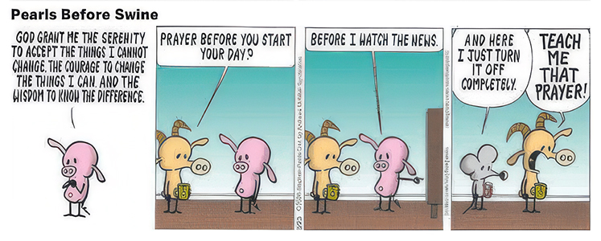

Discussion points:
- If you could ask for anything and your wish were granted, would you ask for the wisdom to govern as King Solomon did?
- The main message of the Book of Proverbs is that true wisdom begins with the fear of the Lord, leading to a moral, successful, and disciplined life. It teaches practical choices over foolishness. It is traditionally ascribed to King Solomon and his students.
- An active prayer life is a way to seek God’s will. Thy will be done.
- Qualities of a wise person:

  - Faithfulness. Grounded in prayer.
  - Humility. Does not flaunt his/her wisdom.
  - Large sense of perspective.
  - Not judgmental.
  - Not bitter.
  - Listens without reacting.
  - Learns from life experiences.
- You cannot equate intelligence (book smarts) with wisdom (street/life smarts)

--------------------------------------------------
September 27, 2026: “Daniel - The Kingdom Will Come”
18th Sunday after Pentecost

Scripture: Daniel 7: 1-28 (NIV) - and reference ch. 4 - Daniel's interpretation of dreams
7 In the first year of Belshazzar king of Babylon, Daniel had a dream, and visions passed through his mind as he was lying in bed. He wrote down the substance of his dream.
² Daniel said: “In my vision at night I looked, and there before me were the four winds of heaven churning up the great sea. ³ Four great beasts, each different from the others, came up out of the sea.
⁴ “The first was like a lion, and it had the wings of an eagle. I watched until its wings were torn off and it was lifted from the ground so that it stood on two feet like a human being, and the mind of a human was given to it.
⁵ “And there before me was a second beast, which looked like a bear. It was raised up on one of its sides, and it had three ribs in its mouth between its teeth. It was told, ‘Get up and eat your fill of flesh!’
⁶ “After that, I looked, and there before me was another beast, one that looked like a leopard. And on its back it had four wings like those of a bird. This beast had four heads, and it was given authority to rule.
⁷ “After that, in my vision at night I looked, and there before me was a fourth beast—terrifying and frightening and very powerful. It had large iron teeth; it crushed and devoured its victims and trampled underfoot whatever was left. It was different from all the former beasts, and it had ten horns.
⁸ “While I was thinking about the horns, there before me was another horn, a little one, which came up among them; and three of the first horns were uprooted before it. This horn had eyes like the eyes of a human being and a mouth that spoke boastfully.
⁹ “As I looked,
“thrones were set in place,
and the Ancient of Days took his seat.
His clothing was as white as snow;
the hair of his head was white like wool.
His throne was flaming with fire,
and its wheels were all ablaze.
¹⁰ A river of fire was flowing,
coming out from before him.
Thousands upon thousands attended him;
ten thousand times ten thousand stood before him.
The court was seated,
and the books were opened.
¹¹ “Then I continued to watch because of the boastful words the horn was speaking. I kept looking until the beast was slain and its body destroyed and thrown into the blazing fire. ¹² (The other beasts had been stripped of their authority, but were allowed to live for a period of time.)
¹³ “In my vision at night I looked, and there before me was one like a son of man, coming with the clouds of heaven. He approached the Ancient of Days and was led into his presence. ¹⁴ He was given authority, glory and sovereign power; all nations and peoples of every language worshiped him. His dominion is an everlasting dominion that will not pass away, and his kingdom is one that will never be destroyed.
¹⁵ “I, Daniel, was troubled in spirit, and the visions that passed through my mind disturbed me. ¹⁶ I approached one of those standing there and asked him the meaning of all this.
“So he told me and gave me the interpretation of these things: ¹⁷ ‘The four great beasts are four kings that will rise from the earth. ¹⁸ But the holy people of the Most High will receive the kingdom and will possess it forever—yes, for ever and ever.’
¹⁹ “Then I wanted to know the meaning of the fourth beast, which was different from all the others and most terrifying, with its iron teeth and bronze claws—the beast that crushed and devoured its victims and trampled underfoot whatever was left. ²⁰ I also wanted to know about the ten horns on its head and about the other horn that came up, before which three of them fell—the horn that looked more imposing than the others and that had eyes and a mouth that spoke boastfully. ²¹ As I watched, this horn was waging war against the holy people and defeating them, ²² until the Ancient of Days came and pronounced judgment in favor of the holy people of the Most High, and the time came when they possessed the kingdom.
²³ “He gave me this explanation: ‘The fourth beast is a fourth kingdom that will appear on earth. It will be different from all the other kingdoms and will devour the whole earth, trampling it down and crushing it. ²⁴ The ten horns are ten kings who will come from this kingdom. After them another king will arise, different from the earlier ones; he will subdue three kings. ²⁵ He will speak against the Most High and oppress his holy people and try to change the set times and the laws. The holy people will be delivered into his hands for a time, times and half a time.
²⁶ “‘But the court will sit, and his power will be taken away and completely destroyed forever. ²⁷ Then the sovereignty, power and greatness of all the kingdoms under heaven will be handed over to the holy people of the Most High. His kingdom will be an everlasting kingdom, and all rulers will worship and obey him.’
²⁸ “This is the end of the matter. I, Daniel, was deeply troubled by my thoughts, and my face turned pale, but I kept the matter to myself.”

Synopsis: Daniel’s attention to the dreams of others and his own dream offer hope in a difficult time and the assurance the God’s Kingdom will come in its fullness. Where do we see signs of God’s coming Kingdom?
Felt need: To trust in God’s Kingdom to come

Visuals: Four scrolls. There is no way we’ll use the imagery from Daniel.
Hands-on item:
Activity:
Media:
- The Book of Daniel. Length: 0:48. Cost: $19.00. Web license: Yes. Visions of angels. Kingdoms fighting for power. A king who exalts himself above God. The secret to living godly in an ungodly age. The Book of Daniel.
- The Book of Daniel: An Introduction. Length: 4:11. Cost: $19.99. Web license: Probably not. Watch our Introduction video on the book of Daniel, which outlines the book's main theme and how it is fulfilled in Jesus. Despite what it looks like, God is in control. Note: This is probably better as background information rather than as a message illustration.
Music: Ancient of Days, A Mighty Fortress is Our God (UMH 110), All Earth is Waiting (UMH 210), Hail to the Lord’s Anointed (UMH 203), I Need Thee Every Hour (UMH 397)
Children’s Time: Oh, the Places You’ll Go by Dr. Seuss. From soaring to high heights and seeing great sights to being left in a Lurch on a prickle-ly perch, Dr. Seuss addresses life’s ups and downs with his trademark humorous verse and whimsical illustrations. This book is often given to graduates and retirees.
Social media:
Resources:
- Daniel 1:1-16 Where God Disturbs He Calms by Jeff Stevens | Sermon by Logos
Notes: The Book of Daniel is an example of apocalyptic literature - a genre of prophetic writing that emerged in ancient Judaism and early Christianity. Stemming from the Greek word apokalypsis (meaning "unveiling" or "revelation"), it features heavily symbolic, cataclysmic visions designed to offer hope and divine vindication to oppressed communities. Daniel is the earliest prominent example of Jewish apocalyptic writing, written to encourage the Jewish people during the Seleucid crisis.
Discussion points:
- Pastor Mary will send out a link to The Bible Project’s video overview of Daniel. Synopsis: The book of Daniel is apocalyptic literature that includes several strange visions that point to the coming Son of Man, the messianic King who will deliver Israel and the nations. Daniel is also about hope and faith in the midst of exile, as Daniel remains faithful to Yahweh and hopeful for the restoration of Israel.
- Big question: What is the book of Daniel designed to do in the time and place (of terrible struggles, oppression, and persecution) that it was written? Answer: Confirm that evil is alive and well, but the powers of the world won’t win. God’s kingdom will come. So, what should we be doing now? Focus on our fear or help bring about God’s kingdom?
- Animals as predators would have made sense in Daniel’s time. Our culture might attribute these visions as figments of a wild imagination.
- Dispensationalism is a Christian framework that divides human history into distinct ages—or dispensations—during which God tests humanity under changing rules or responsibilities. It emphasizes a literal reading of prophecy, a strict distinction between Israel and the Church, and a premillennial end-times view featuring a secret rapture.
  - The “last days” or “end times prophecy” was formulated in the 1830’s. It is interesting to study and hear different interpretations, but it is not designed to give either a timeline or firm answers. Jesus said no one knows the day or time.
  - No denominations give a timeline or interpretation of what that will look like.
- Some cult leaders have claimed “end time” knowledge. Example: David Koresh and the Brand Davidians (1980’s Waco TX).
- Our culture is obsessed with time, timing, needing to understand the understandable, planning, etc.
- Movie portraying end times: “This Is the End” with Seth Rogan
- Stray stuff: Y2K. Mayan calendar’s prediction of end times. Freeze dried meals (aka MRE). Hoarding. Fear of flying monkeys and witches.

