**All-Church Worship Brainstorming Summary**

**“Creed”**

A series based on the Apostles’ Creed

May 11 – June 15, 2025 (6 weeks)

Thursday, April 10, 2025

**Members present:** Annette Erbes, Janna Chelland, Jean Kelly, Ed Baranowski, Marie Kordecki, Diane Thompson, David Booth, Pastor Mark Erbes, Fred Woodworth, Barb Gripton, Pastor Mary Ivanov, Karen Booth

*“The worship we hope to develop will be rooted in Scripture, centered on Christ, and empowered by the Holy Spirit. It will be relevant to local and emerging culture, while addressing the needs of believers and unbelievers alike. Above all, it will intentionally engage people physically, emotionally, intellectually, and soulfully.”*

Felt needs: What physical, emotional, intellectual, or spiritual need are we addressing in this service so that worship is engaging and a means of making disciples? What question needs to be posed/answered so that we are making disciples?

**2025 theme:** Living in the Light of Jesus

**2025 key Scripture verse:** *When Jesus spoke again to the people, he said, ‘I am the light of the world. Whoever follows me will never walk in darkness, but will have the light of life. – John 8: 12*

**Major spoken/unspoken needs:** Life is hard.

* Navigating an angry, divided world
* Pervasive lack of trust, respect, and civility
* Aging. Caregiving. Death.
* Violence. Insecurity – housing, food.
* Misunderstanding scripture

**2025 theme connection:** Understanding foundational beliefs is crucial. They help us differentiate between the essential and the rest.

**Series synopsis:** We’re all searching. Sometimes the search is easy: simply type a question and the answer pops up. But sometimes our questions are complicated, and the answers are difficult to see and harder to articulate. How do we discover and examine the truths that give meaning and purpose to life? Some powerful answers are contained in the Apostles’ Creed, an early statement of foundational Christian beliefs.

**Resources:** The QR code takes you to more resources on our website.

* #882 The Apostles’ Creed and [UMC.org](https://www.umc.org/en/content/apostles-creed-traditional-ecumenical)

I believe in God, the Father Almighty,

creator of heaven and earth.

I believe in Jesus Christ, his only son, our Lord,

who was conceived by the Holy Spirit,

born of the Virgin Mary,

suffered under Pontius Pilate, was crucified, died, and was buried;

he descended to the dead.

On the third day he rose again;

he ascended into heaven,

is seated at the right hand of the Father,

and will come again to judge the living and the dead.

I believe in the Holy Spirit,

All of the Scripture possibilities listed below end the end of each line of the Creed are from [biblestudytools.com](https://www.biblestudytools.com/bible-study/topical-studies/what-you-need-to-know-about-the-apostles-creed.html).

the holy catholic church,

the communion of saints,

the forgiveness of sins,

the resurrection of the body

and the life everlasting. Amen.

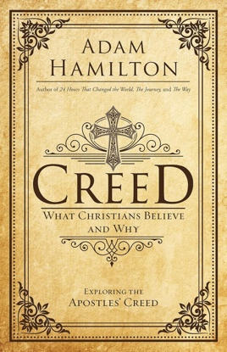**NOTE:** We could use a different media to share the creed each week (see below).

* [Creed: What Christians Believe and Why](https://www.amazon.com/Creed-What-Christians-Believe-Why/dp/1501813714) by Adam Hamilton (2016). Related resources are available at [Amplify Media](https://my.amplifymedia.com/amplify/series/unitedmethodistpublishinghouse/13926-creed).
* [Rotation.org’s](https://www.rotation.org/topic/apostles-creed-ideas-lesson-plans) Sunday School Lessons on the Apostles’ Creed

**Hands-on items:** Visually inspiring…

* Printed copy of the Apostle’s Creed. Examples:
  + [Mapleton prints](https://www.etsy.com/listing/1843005369/apostles-creed-christian-wall-art?external=1&rec_type=cs&ref=pla_similar_listing_top-6&pro=1&sts=1&logging_key=815f6dbf97361a3f33c1cab7b9c153aa3def51e4%3A1843005369) on Etsy. Digital file ~~$5.10,~~ now $2.80.
  + [Agapi Art Prints](https://www.etsy.com/listing/1702577793/apostles-creed-nicene-creed-scripture?gpla=1&gao=1&&utm_source=google&utm_medium=cpc&utm_campaign=shopping_us_e-art_and_collectibles&utm_custom1=_k_Cj0KCQjwhYS_BhD2ARIsAJTMMQbxd7uTFXFjmWDocBWh3DFS6aUWSkH6llygv-VGXnRRjG-AyeK35FwaAs6hEALw_wcB_k_&utm_content=go_21500568411_167985810679_716809480441_pla-314954651933_c__1702577793_12768591&utm_custom2=21500568411&gad_source=1&gclid=Cj0KCQjwhYS_BhD2ARIsAJTMMQbxd7uTFXFjmWDocBWh3DFS6aUWSkH6llygv-VGXnRRjG-AyeK35FwaAs6hEALw_wcB) on Etsy. Digital file $8.35.
* [Coloring pages](https://www.etsy.com/listing/558036735/apostles-creed-memory-coloring) (and [related poster](https://www.etsy.com/listing/1666707104/art-print-apostles-creed-original-art)) $8.00/9 pages
* [Apostles’ Creed Memorization Cards](https://www.catechesisbooks.com/products/p/creedcards) $15.99 – shown on the following page.

**Visuals:** I BELIEVE on the ledge, wall, or in front of the altar. Artwork based on the memorization cards: Nine canvasses. “I believe…” on the first canvas. Images on the remaining eight. Possible media: Acrylic paint. Marker outlines. Tissue paper.

* Painter’s Canvas: Hobby Lobby, 2 pack of 18”x24” for $9.99 (shown below). Need 5 packs and wood for hanging.
* 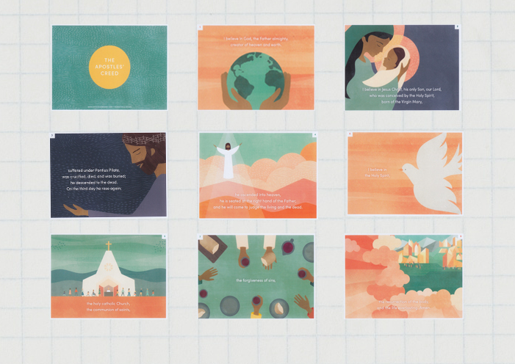Foamboard: 2 sheets of 1.5”x4’x8’ extruded polystyrene boards at $17.98 each. Cut 5 2’x3’ panels from each sheet. Must prime before using.

**Media:** Intro videos – not in any particular order. Plan on using a different video each week and have the congregation read along. Stick with the shorter videos.

* [Apostles’ Creed – What Do You Believe?](https://www.youtube.com/watch?v=92ipgzFLinY) Length: 2:15. Cost: Free. Web license: Yes. Series intro by Church of the Resurrection. **Comments:** Nicely done. Like that it has people.
* [The Apostles’ Creed: Illustrated.](https://www.youtube.com/watch?v=C7SQCCnWRpo) Length: 6:28. Cost: Free. Web license: Not sure. An artist from Central church of Christ Amarillo illustrates the creed.
* [Apostles’ Creed](https://www.playbackmedia.com/mini-movies/133414/apostles-creed) (Shift Worship) Length: 1:34. Cost: Free with subscription. Web license: Yes. Features the words of the creed. Two different versions are available. Background: Photos and geometric shapes.
* [Apostles’ Creed](https://www.playbackmedia.com/mini-movies/60046/apostles-creed) (Shift Worship). Length: 2:19. Cost: Free with subscription. Web license: Yes. Features the words of the creed over nature backgrounds. Two different version are available. Background: Nature.
* [The Apostles’ Creed](https://www.worshiphousemedia.com/mini-movies/147547/the-apostles-creed) (Church Fuel). Length: 1:07. Cost: $19.99. Web license: Yes. Features the words of the creed. Background: Nature. Bold words.
* [Apostles’ Creed](https://www.worshiphousemedia.com/mini-movies/141465/apostles-creed) (Rype.tv). Length: 2:14. Cost: $19.99. Web license: Yes. Features the words of the creed. Background: Nature. Dramatic music.
* [All Nations Apostles’ Creed](https://www.worshiphousemedia.com/mini-movies/112880/all-nations-apostles-creed) (Street Studio). Length: 1:55. Cost: $19.98. Web license: No. This compilation of the creed uses poetic typography to display a chorus of languages in unity making declaration of our historic faith. **Note:** This might be good for Pentecost Sunday. Reminds us that the church is global. Want to know what languages are being spoken. New iPods offer real time translation.

Note after the brainstorming: Neither Skit Guy video is true to the Apostle’s Creed.

* [Believer’s Creed](https://skitguys.com/videos/believers-creed) (Skit Guys Studio). Length: 2:15. Cost: $18.00. Web license: Yes. Have you ever considered what you believe and why you believe it?
* [Resurrection Creed (](https://skitguys.com/videos/resurrection-creed)Skit Guys Studio). Length: 1:34. Cost: $19.99. Web license: Yes. What do you believe about Easter? About God? About Christ? This video combines spoken word and an artful depiction to articulate what we believe and what that means.
* [The Apostles’ Creed](https://www.worshiphousemedia.com/mini-movies/6705/the-apostles-creed) (Student Life). Length: 4:37. Cost: $8.00. Web license: Probably not. A creative look at The Apostles’ Creed, tying scripture along with the reading. Includes a Leader’s Guide (PDF). Interesting approach with scripture mixed in with the “I believe” statements. Dated look and quite long.
* [The Apostles’ Creed](https://www.worshiphousemedia.com/mini-movies/40407/the-apostles-creed) (Igniter Media). Length: 1:45. Cost: $20.00. Web license: Yes. Features the words of the creed. Two different versions are available. Background: City.

**Music:**

* [“This I Believe (The Creed)”](https://www.youtube.com/watch?v=x7AQeYL9c74) by Hillsong Worship
* [This I Believe (The Creed)](https://www.worshiphousemedia.com/worship-tracks/107820/this-i-believe-the-creed). Length: 6:26. Cost: $15.00. Web license: Yes. Music video.
* “Creed” by Rich Mullins - <https://www.youtube.com/watch?v=9LR2hFP1yb4>

**Publicity:** “See You on Sunday!” and Harbor Light

**Social Justice Issue for May 2025:** Food Insecurity (KFB, H2H, MAP, SH, FP)

**Social Justice Issue for June 2025:** Gender-based Violence

**Noisy offering for May 2025:** Child Abuse Council

**Noisy offering for June 2025:** HS Youth Mission Team

**Leading questions, reflections, etc.:**

* Why are creeds important?
* The UMC is not a creedal church (meaning that a person doesn’t have to affirm a strict list of beliefs to be received as a member). We recite the creed often when we receive new members, but it’s not a condition of membership.
* Our hymnal is organized by the “big ideas” of the Apostles’ Creed.
* Encourage people to write down their beliefs to create a personal creed.
* What do I believe? What do you believe? What does this church believe? *On a related note:* Confirmation may be the only time people are asked to write down what they believe.

**Discussion points:**

* Now that worship is online, people can get a sense of what we (and other churches believe), before stepping through our doors. Many church websites (not ours) spell out what they believe also. Pastor Mary watches for these red flags:
  + Belief in biblical inerrancy. UMC position: The bible is inspired by God.
  + Who are the church leaders? Are women empowered to lead?
  + What is the church?
* Definition – **creed:** noun \kreed\ a statement of the basic beliefs of a religion; an idea or set of beliefs that guides the actions of a person or group.
* Some of us learned/memorized the Apostles’ Creed when young. Now we say it a few times a year, especially when people join the church.
* The Apostles’ Creed is not straight out of scripture. It comes out of conflict and church tradition, meaning that there were some winners and losers when it came to including what were considered essential beliefs. *On a related note:* As Methodists we believe scripture is primary, but reason and faith traditions are important too.
* Catholic: Small “c” refers to the church universal. Big “C” refers to the Catholic church.
* What jumps out at you? Jesus descended to the dead (or hell).
* Why repeat statements in unison? It brings us together. Connects us. Reminds us we are not alone. Teaches us the faith?
* What else do say or sing in unison? The Lord’s Prayer. The Pledge of Allegiance. Boy/Girl Scout pledge. The National Anthem.
* Nondenominational churches probably don’t recite the creed. Episcopalians and Lutherans say it often.
* Faith informs everything we do.
* Getting married in a church used to be common. Not so now. Pastors ask why the couple wants that. Also includes counseling.  *On a loosely related note:* People who have been “ordained” online can’t maintain membership in a UMC as you can’t be members of two churches.

----------------------------------------------------

**May 11, 2025:** “I Believe in God”

4th Sunday of Easter, Mother’s Day

**Creed:** I believe in God, the Father Almighty, creator of heaven and earth.

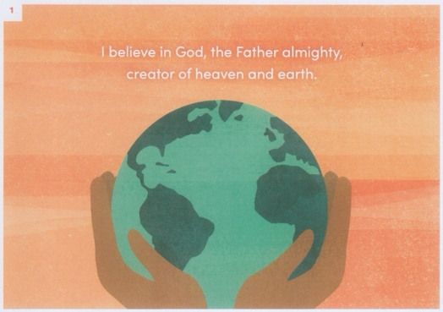**Scripture:** Genesis 1: 1-2, 31 (NIV)

1In the beginning God created the heavens and the earth. 2Now the earth was formless and empty, darkness was over the surface of the deep, and the Spirit of God was hovering over the waters.

31God saw all that he had made, and it was very good. And there was evening, and there was morning—the sixth day.

**Scripture:** Exodus 3: 11-15 (NLT)

11But Moses protested to God, “Who am I to appear before Pharaoh? Who am I to lead the people of Israel out of Egypt?”

12God answered, “I will be with you. And this is your sign that I am the one who has sent you: When you have brought the people out of Egypt, you will worship God at this very mountain.”

13But Moses protested, “If I go to the people of Israel and tell them, ‘The God of your ancestors has sent me to you,’ they will ask me, ‘What is his name?’ Then what should I tell them?”

14God replied to Moses, “I AM WHO I AM. Say this to the people of Israel: I AM has sent me to you.” 15God also said to Moses, “Say this to the people of Israel: Yahweh, the God of your ancestors—the God of Abraham, the God of Isaac, and the God of Jacob—has sent me to you.

This is my eternal name, my name to remember for all generations.

**Scripture:** Deuteronomy 6: 4-5 (NIV)

4Hear, O Israel: The Lord our God, the Lord is one. 5Love the Lord your God with all your heart and with all your soul and with all your strength.

**Synopsis:** Is there a God? How do we know? If God exists, what is God like? Scripture is where we start, but church tradition, human reason, and our experience help us to understand who God is and what God is like.

**Felt need:** To trust that God is active, personal, and constantly reaching out to us and inviting us into relationship

**Visuals:**

**Hands-on item:** Sticky note for writing down who God is to you. Display the responses.

**Activity:** Special prayers for all experiences of mothering/being mothered

**Media possibilities:**

* ["Be Still."](https://www.theworkofthepeople.com/be-still) Length: 2:17. Cost: We own it. Web license: Yes. The video that starts with the whole phrase and ends with "Be Still." *Comments:* Used many times, but still a favorite.
* [“I Am God.”](https://www.worshiphousemedia.com/mini-movies/37683/i-am-god) Length: 2:12. Cost: We own it. Web license: Yes. Often, we want to hear the voice of God; but often we don't realize that God speaks to us through SILENCE. *Comments:* Need narration.

**Music:** #145 “Morning Has Broken”; #2060 “God the Sculptor of the Mountains”; #3034 “God of Wonders”; #2040 “Awesome God”

**Children’s Time:**

**Resource:**

* [What the UMC believes about God](https://www.umc.org/en/content/our-christian-roots-god)

We can put into words what God does and how we experience God's action in our lives. God works in at least these seven ways:

1. *God*creates*.*
2. *God*sustains*.*
3. *God*loves*.*
4. *God*suffers*.*
5. *God*judges*.*
6. *God*redeems*.*
7. *God*reigns*.*

* [Creed 1st Session Video](https://www.youtube.com/watch?v=39VS17oPWGs) with Adam Hamilton. [Ministry Matters](https://www.ministrymatters.com/all/entry/7968/adam-hamilton-on-the-apostles-creed) has the highlights of the video in printed form.
* Use hymns with images of God as mother - “Then to thy need, God as a mother doth speed…”
* God is “for us” - not against us. *Comments:* We have used “As We Gather” to open worship during Lent. Someone mentioned to Pastor Mary how this phrase stood out.

**Discussion points:**

* What is the nature of God? Do we see him as an “old man in the sky”? Involved in our personal lives? As our Deist founding fathers did, “one who created, but is no longer active in day-to-day living?
* What images do we have of God? Angry? Loving? Ready to smite us? Wondering if we’ve screwed up too badly for him to love us? [*Related article and interview:*](https://www.indystar.com/story/sports/nfl/colts/2025/04/08/ocd-colts-tackle-braden-smith-religiously-scrupulosity/82738055007/) Indiana Colts football player, Braden Smith’s battle with OCD and religious scrupulosity meant he had to quit football while getting treatment. **Note from Karen:** You can only access this article once without signing up for the Indy Star. There are similar articles on a number of sites, including [ESPN](https://www.espn.com/nfl/story/_/id/44590173/colts-braden-smith-details-struggle-recovery-severe-ocd).
* Wonderings: How does God have time for me? How can he know what I am doing all the time? How would I have gotten through life without him? Does he send guardian angels?
* God moments are an important part of our witness. We can see how different people experience God through their witness.

----------------------------------------------------

**May 18, 2025:** “Jesus Christ: God With Us”

5th Sunday of Easter, Graduation Sunday

**Creed:**

I believe in Jesus Christ, his only son, our Lord, (John 3:16)

who was conceived by the Holy Spirit, born of the Virgin Mary, (Luke 1: 26-38)

suffered under Pontius Pilate, was crucified, died, and was buried; (Luke 23:23-25)

he descended to the dead. On the third day he rose again; (I Peter 3: 18-20; I Cor. 15: 3-5)

he ascended into heaven, is seated at the right hand of the Father, (Mark 16:19)

and will come again to judge the living and the dead. (II Timothy 4:1)

**Scripture:** John 1: 1-5, 12-14 (NIV)

1In the beginning was the Word, and the Word was with God, and the Word was God. 2He was with God in the beginning. 3Through him all things were made; without him nothing was made that has been made. 4In him was life, and that life was the light of all mankind. 5The light shines in the darkness, and the darkness has not overcome it.

12Yet to all who did receive him, to those who believed in his name, he gave the right to become children of God— 13children born not of natural descent, nor of human decision or a husband’s will, but born of God.

14The Word became flesh and made his dwelling among us. We have seen his glory, the glory of the one and only Son, who came from the Father, full of grace and truth.

**Synopsis:** What do we believe *about* Jesus and why? What does it mean to believe *in* Jesus and to be saved? Our words and actions reflect the One we follow.

**Felt need:** To understand that Jesus is God’s revelation to us because God loves us, that he is with us in our humanity, and that he saves us from sin and for eternal life

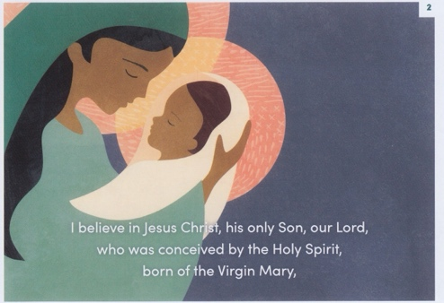

**Visuals:** Ichthus symbol ΙΧΘΥΣ

**Hands-on item:**

**Activity:** Celebration of graduates

**Media possibilities:**

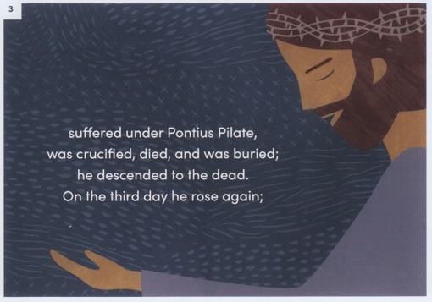**Music:** #3105 “In Christ Alone”; “Jesus Messiah” (Chris Tomlin); #2071 “Jesus, Name Above All Names”

**Children’s Time:**

**Resource:** [What the UMC believes about Jesus](https://www.umc.org/en/content/our-christian-roots-jesus)

1. Son of God
2. Son of man
3. Christ/Messiah
4. Lord
5. Savior (Redeemer)
6. 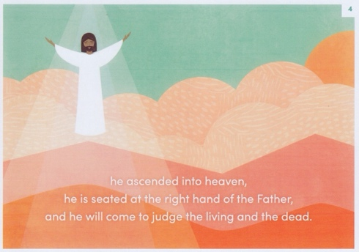Word (not word) - Pastor Mary’s addition
7. Teacher (added at brainstorming)

**Discussion points:**

* You might recall some of the names of Jesus from our Advent series, “Incarnation.”
* Most of the Apostles’ Creed is devoted to saying what we believe about Jesus. *On a related note:* Theologian Karl Barth wrote 14 volumes on Jesus. When asked for a summary, he said it is what his mother taught him, “Jesus loves me, this I know…”
* “Are you saved?” Do you believe in Jesus? People want to know how belief in Jesus becomes a bigger question when they or a loved one is dying?
* Sinners’ Prayer: There are several versions. Here is one. See more on [Wikipedia](https://en.wikipedia.org/wiki/Sinner%27s_prayer). Is this a “one and done” or should we be concerned when we invariably mess up?

Dear Lord Jesus, I know that I am a sinner, and I ask for Your forgiveness. I believe You died for my sins and rose from the dead. I turn from my sins and invite You to come into my heart and life. I want to trust and follow You as my Lord and Savior. In Your Name. Amen.

— [*Billy Graham*](https://en.wikipedia.org/wiki/Billy_Graham)

* What do you think Jesus looked like? Full beard. Long, dark hair. Dark complexion. Height – different opinions, but in general, people were much shorter then. Kind and piercing eyes. Probably thin by today’s standards – food was not as plentiful and he walked regularly. In short, a Jewish guy from the Middle East, as portrayed in the LUMO Project videos. *On a related note:* Artists often portray Jesus based on their own culture.
* Other characteristics of Jesus: Approachable, especially if you were in need. Smart. People person. Came to show us how to live.
* We have more information on John the Baptist’s appearance than we do Jesus’.

----------------------------------------------------

**May 25, 2025 at 10:00 a.m.:** “The Holy Spirit: God In Us”

6th Sunday of Easter, Memorial Day weekend

**Creed:** I believe in the Holy Spirit, (John 15:26)

**Scripture:** Genesis 1: 1-2 (The Message)

1First this: God created the Heavens and Earth—all you see, all you don’t see.  2Earth was a soup of nothingness, a bottomless emptiness, an inky blackness. God’s Spirit brooded like a bird above the watery abyss.

**Scripture:** John 14: 25-27 (Contemporary English Version)

25I have told you these things while I am still with you.

26But the Holy Spirit will come and help you, because the Father will send the Spirit to take my place. The Spirit will teach you everything and will remind you of what I said while I was with you.

27I give you peace, the kind of peace that only I can give. It isn’t like the peace that this world can give. So don’t be worried or afraid.

**Scripture:** John 15: 26-27 (NIV)

26“When the Advocate comes, whom I will send to you from the Father—the Spirit of truth who goes out from the Father—he will testify about me. 27And you also must testify, for you have been with me from the beginning.

**Scripture:** Romans 8: 26-27 (TEV)

26In the same way the Spirit also comes to help us, weak as we are. For we do not know how we ought to pray; the Spirit himself pleads with God for us in groans that words cannot express.

27And God, who sees into our hearts, knows what the thought of the Spirit is; because the Spirit pleads with God on behalf of his people and in accordance with his will.

*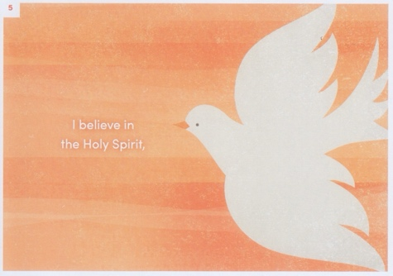***Synopsis:** Who or what is the Holy Spirit? What does the Holy Spirit do? All of us are helped and sustained by the Holy Spirit - God’s ongoing presence in our lives.

**Felt need:** To open ourselves to the Spirit’s presence and power as God working in us and through us

**Visuals:** wind, fire, dove

**Hands-on item:** Use the words from Rosetti prayer (see below) to make a photo card.

*O Holy Spirit who is light unto your children,*

*may you enlighten us.*

*O Holy Spirit who gives never-ending grace,*

*may you replenish us.*

*O Holy Spirit who is the fire of love.*

*may you burn in our hearts.*

*O Holy Spirit who is Lord and giver of life,*

*May you live within us:*

*As a cloud lessening our temptations;*

*As the dew reviving our weariness;*

*As fire purging the waste in our hearts;*

*As water purifying our spirits;*

*As the wind sending us out;*

*As a dove turning our eyes toward heaven.*

*Amen.*

**Activity:** Consecration of Memorial Gifts, opening of Memorial Garden?

**Media possibilities:**

* [“Three Minute Theology: Who Is the Holy Spirit?”](https://www.youtube.com/watch?v=8RUiPfB6EGQ) Length: 3:30. Cost: Free. Web license: Not sure.
* [“Holy Spirit Prayer.”](https://www.worshiphousemedia.com/mini-movies/75861/holy-spirit-prayer) Length: 1:37. Cost: $17.98. Based on “A Prayer to the Holy Spirit” by Christina Rossetti. Like the way the spirit is portrayed through images (shown in red, above).

**Music:** #328 “Surely the Presence of the Lord”; #2120 “Spirit, Spirit of Gentleness”; #334 “Sweet, Sweet Spirit”

**Children’s Time:**

**Resource:** [What the UMC believes about the Holy Spirit](https://www.umc.org/en/content/our-christian-roots-the-holy-spirit)

We receive gifts and fruits of the Holy Spirit to continue God’s work in the world.

**Discussion points:**

* The Holy Spirit may be the most mysterious part of the Trinity.
* Holy Spirit as Advocate: Supports us. Speaks for us. Counsels us. Helps us offer witness. Acts as a conscience, i.e. the little voice inside us. *On a related note:* Other names for the Holy Spirit: Guide. Counselor.
* Examples of when we’ve felt the Holy Spirit’s presence the most:
  + Pastor Mark: Going to the hospital when something terrible has happened, not knowing what to say, and being given the right words by the Spirit.
  + Karen: While getting ready for family to visit and being in the “stuck place,” not knowing what to do for the next series. Hearing an audible voice say, “You know don’t actually need it (an idea) until Monday.”
  + Marie: Calling or texting someone and being told how important it was to hear from her at that moment.
  + Diane: Being reticent to accept the position as Lake Harbor, but getting a big push from the Spirit.
  + Jean: Facing surgery and hearing a voice saying that it would be okay.
  + Barb: Lots of the time as she has gone through difficult times and had the church there beside her.
  + Pastor Mary: At General Conference in 2000, members of the Westborough Baptist Church were protesting hateful signs when she heard an audible voice telling her to walk the other way. “This is not from me.”
  + Pastor Mary: Ask a man a question and he responded with his own question of how did she know to ask that?
  + Pastor Mary: Hearing from a colleague that the Spirit goes before you. It is already there in the hospital, prison, every tough situation

----------------------------------------------------

**June 1, 2025:** “Be the Church”

7th Sunday of Easter, **Laity Sunday (Annual Conference weekend)**

**Creed:** I believe in…. the holy catholic (universal) church, the communion of saints, (I Cor 12: 12-13; Rev. 8: 3-4)

**Scripture:** I Corinthians 12: 12-14, 27-30 (The Message)

12-13You can easily enough see how this kind of thing works by looking no further than your own body. Your body has many parts—limbs, organs, cells—but no matter how many parts you can name, you’re still one body. It’s exactly the same with Christ. By means of his one Spirit, we all said good-bye to our partial and piecemeal lives. We each used to independently call our own shots, but then we entered into a large and integrated life in which *he* has the final say in everything. (This is what we proclaimed in word and action when we were baptized.) Each of us is now a part of his resurrection body, refreshed and sustained at one fountain—his Spirit—where we all come to drink. The old labels we once used to identify ourselves—labels like Jew or Greek, slave or free—are no longer useful. We need something larger, more comprehensive.

14I want you to think about how all this makes you more significant, not less. A body isn’t just a single part blown up into something huge. It’s all the different-but-similar parts arranged and functioning together.

12: 27You are Christ’s body—that’s who you are! You must never forget this. Only as you accept your part of that body does your “part” mean anything.

28You’re familiar with some of the parts that God has formed in his church, which is his “body”: apostles, prophets, teachers, miracle workers, healers, helpers, organizers, those who pray in tongues.

29But it’s obvious by now, isn’t it, that Christ’s church is a complete Body and not a gigantic, unidimensional Part? It’s not all Apostle, not all Prophet, not all Miracle Worker, 30not all Healer, not all Prayer in Tongues, not all Interpreter of Tongues.

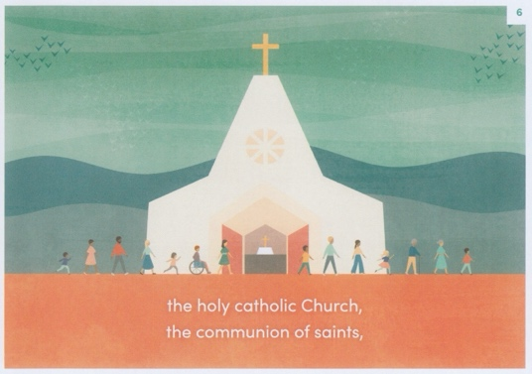**Synopsis:** Why do we describe the church as holy (set apart) and catholic (universal)? We are a gathered community of people seeking to follow Jesus Christ – actively loving God and loving neighbor through worship and mission by the power of the Holy Spirit.

**Felt need:** To claim our identity as a part of the Body of Christ in the world called to love God and neighbor

**Visuals:**

**Hands-on item:**

**Activity:** Pastor Mary will invite a small group to share about what the church means to them.  *Note from Karen:* Testimony can be shared via a recording.

**Media possibilities:** [“Be the Church.”](https://www.worshiphousemedia.com/mini-movies/39680/be-the-church) Length: 1:43. Cost: $20.00. Web license: No. Two young men encounter “The Church” and they learn what it means for the church to help those in need. This is a great way to introduce a lesson on what the church really is. **Comments:** This one's funny - I'm not sure I'd use it, but it makes a point.

**Music:** “The Church’s One Foundation” (tune from #545, words from #546, v. 1-2); #558 “We Are the Church”

**Children’s Time:**

**Resource:** [What the UMC believes about the communion of saints](https://www.umc.org/en/content/ask-the-umc-who-are-the-communion-of-saints-apostles-creed)

The term "holy catholic church" refers to Christians "throughout the whole" (a literal

translation of the Greek word katholikēn) of time and space. The "fellowship" or

"communion of saints" is the expression of that "whole" reality of church in a particular time and place.

**Discussion points:**

* Can we make a video asking people to share what it means to be the church? Or what the church means to them?
* How would your life be different if you did not have the people in this church and a community of faith?
* We part of our membership vow is presence. Whether we are in a season of questioning or someone else it, we find strength in community. People in the church to have us there.
* Pastor Mary was so happy to see Jerry Scott in worship and hear him ask her to serve communion to him in his seat. She knows what a struggle it is to get to church. Ironically, she saw “A Beautiful Noise” later that day. The show is based on the life and music of Neil Diamond and is framed as him revisiting his career through therapy sessions after being diagnosed with Parkinson’s disease.
* Two recent funerals for Elanor Daniels and Linda Herbert, spoke to the early hardships both women faced and the importance of church community.
* Communion of saints refers to both the dead and living.
* What does church mean to you? Love. Acceptance. Comradery. Sharing. Family. Strength. Togetherness. Welcome. Everything. Making it through the next stage of life – childhood to teenager to adulthood/marriage/parenting/caregiving. Centering force. Inspiration. Understanding. Help. Safety (like a blanket fresh from the dryer). Comfortable (part of the time). Place where I’ve felt closest to God.
* How do we invite other to share so that more people can experience “good church”? Show kindness.

----------------------------------------------------

**June 8, 2025:** “The Forgiveness of Sins”

Pentecost Sunday

**Creed:** I believe in… the forgiveness of sins, (Matthew 6:14-15)

**Scripture:** Acts 2: 1-4 (Contemporary English Version)

1 On the day of Pentecost all the Lord’s followers were together in one place.

2Suddenly there was a noise from heaven like the sound of a mighty wind! It filled the house where they were meeting. 3Then they saw what looked like fiery tongues moving in all directions, and a tongue came and settled on each person there. 4The Holy Spirit took control of everyone, and they began speaking whatever languages the Spirit let them speak.

**Scripture:** Matthew 6: 9-15 (MSG)

With a God like this loving you, you can pray very simply. Like this:

Our Father in heaven,  
Reveal who you are.  
Set the world right;  
Do what’s best—  
    as above, so below.  
Keep us alive with three square meals.  
Keep us forgiven with you and forgiving others.  
Keep us safe from ourselves and the Devil.  
You’re in charge!  
You can do anything you want!  
You’re ablaze in beauty!  
Yes. Yes. Yes.

14-15“In prayer there is a connection between what God does and what you do. You can’t get forgiveness from God, for instance, without also forgiving others. If you refuse to do your part, you cut yourself off from God’s part.

**Synopsis:** Why does it matter that we believe in “forgiveness of sins”? Rather than being a guilt trip, confession reminds us that God is faithful to forgive. The prayer Jesus teaches (and invites us to pray) shows that forgiveness is central to our faith in him.

**Felt need:** To be confident in God’s grace and willingness to forgive us and set us free from the burden of guilt

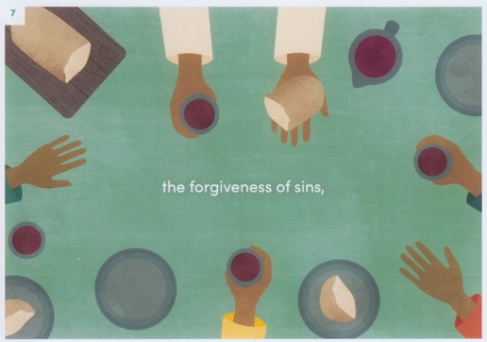**Visuals:** Invite the congregation to dress in red, orange, and yellow

**Hands-on item:**

**Activity:** Holy Communion

**Media possibilities:**

* [“God So Loved the World.”](https://www.playbackmedia.com/mini-movies/73693/god-so-loved-the-world) Length: 1:45. Cost: Free with subscription. Web license: Yes. Combining several favorite scriptures about love (1 John 4:16, John 3:16, 1 Corinthians 13, 1 John 4:11), this fresh mini-movie features voices and languages from across the world. It reminds us that God’s love is for the whole world, not just the part of it that we see. *Comments:* We like this.
* Use recording of the Acts 2 Scripture with wind and voices (or maybe we enlist new help and do it again?).

**Music:** #389 “Freely, Freely”; #560 “Help Us Accept Each Other”

**Children’s Time:**

**Resource:** [What the UMC believes about forgiveness of sin](https://www.umc.org/en/content/ask-the-umc-what-is-the-methodist-belief-about-forgiveness-of-sin)

It is explicitly within that community (the church) that we find ourselves most often

experiencing the forgiveness of sins, because it is precisely against these people, with

whom we are most regularly in contact, that we sin.

**Discussion points:**

* Confession comes before forgiveness.
* Forgiveness: For ourselves and for others. Do we accept it when it is offered? What role do our insecurities play in accepting forgiveness? It goes back to what you believe about God, is he punishing or loving/forgiving?
* The need for humility.
* What is the role of the Holy Spirit here? Our Convicter? Conscience?
* God knows all, is faithful to forgive, and calls us to forgive.
* The Apostles’ Creed say that we are part of what forgiveness looks like in the world.

----------------------------------------------------

**June 15, 2025:** “Resurrection and Life”

Trinity Sunday, Father’s Day

**Rev. Kim Bos is preaching** (Pastor Mary is on vacation)

**Creed:** I believe in… the resurrection of the body and the life everlasting. (John 6: 35- 40; I John 5:11-12)

**Scripture:** John 11: 17-27 (NIV)

17On his arrival, Jesus found that Lazarus had already been in the tomb for four days. 18Now Bethany was less than two miles[[b](https://www.biblegateway.com/passage/?search=john%2011&version=NIV#fen-NIV-26542b)] from Jerusalem, 19and many Jews had come to Martha and Mary to comfort them in the loss of their brother. 20When Martha heard that Jesus was coming, she went out to meet him, but Mary stayed at home.

21“Lord,” Martha said to Jesus, “if you had been here, my brother would not have died. 22But I know that even now God will give you whatever you ask.”

23Jesus said to her, “Your brother will rise again.”

24Martha answered, “I know he will rise again in the resurrection at the last day.”

25Jesus said to her, “I am the resurrection and the life. The one who believes in me will live, even though they die; 26and whoever lives by believing in me will never die. Do you believe this?”

27“Yes, Lord,” she replied, “I believe that you are the Messiah, the Son of God, who is to come into the world.”

### **Scripture:** II Corinthians 5: 1-5

5For we know that if the earthly tent we live in is destroyed, we have a building from God, an eternal house in heaven, not built by human hands. 2Meanwhile we groan, longing to be clothed instead with our heavenly dwelling, 3because when we are clothed, we will not be found naked. 4For while we are in this tent, we groan and are burdened, because we do not wish to be unclothed but to be clothed instead with our heavenly dwelling, so that what is mortal may be swallowed up by life. 5Now the one who has fashioned us for this very purpose is God, who has given us the Spirit as a deposit, guaranteeing what is to come.

**Synopsis:** What happens when we die? Most of us have probably thought about it – and maybe even worried and wondered about it. We trust in the hope of God’s promise that physical death is not the end of the story, but that there is life in heaven with God – and life with God now.

**Felt need:** To have blessed assurance in God’s promise of life now and eternal life

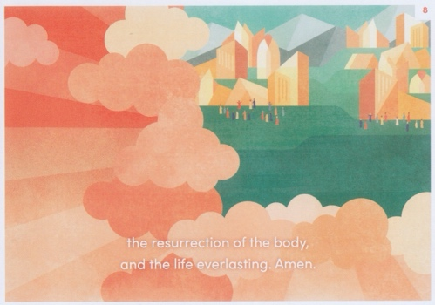

**Visuals:**

**Hands-on item:** Chocolate for the men (Father’s Day).

**Activity:** Father’s Day prayer.

**Media possibilities:**

**Music:** #2282 “I’ll Fly Away”; #389 “Blessed Assurance”

**Children’s Time:**

**Resource:** [What the UMC believes about death and resurrection](https://www.umc.org/en/content/ask-the-umc-death-and-resurrection)

Resurrection describes a form of life that is not of this present age, but rather of the age to come.

So eternal life is not about how long life lasts after our deaths, but rather about the

nature of life itself, everything about it, when it is moving in harmony with God’s

purposes—both here and now, AND in the “age to come,” when God’s kingdom finally comes in its fullness.

**NOTE:** Peace with Justice Sunday - special offering

**Discussion points:**

* From Rev. Kim Bos (April 2, 2025)

Wrapping up a series? I'd be honored! I like the scriptures and the hymn suggestions. My first read instinct is that I will be talking about the resurrection of the body means acknowledging that we will need it - that all of us have finite days in this world (a little Ash Wednesday call back), and then moving to the life everlasting and how that starts now, starts today, too many of us treat the "hope of heaven" as a reason to put off living in the here and now and that isn't how it's meant to be. The kingdom of already and not yet.   
 That's pretty wander-y but I'll tighten it up. Looking forward to being back with LHUMC.

* Denominations do not agree on whether cremation is okay. Catholics – no. UMC – yes.
* Examples of resurrection before death:
  + Dave and Karen’s in-law, Larry, who was sent home under hospice care in late September and is not only still alive, but is on oxygen and up and doing things.
  + Other healing stories that defy explanation.
  + Breaking free from addiction.
* How do we understand death and dying for ourselves and our loved ones and particularly what happens if we do or don’t believe in Jesus? Is it just worry or the need to know that this is not the end? That we’ll leave a legacy even once we are gone?
* Pastor Mary found wisdom in a Hospice nurse who found it helpful to ask her patients, “Do you want Jesus to remember you?”
* People who have died and been revived tell of powerful experiences in the moments when they were gone.
* Death is guaranteed? What do we do now?
* People fear dying more than death? Pain and suffering. Peace in the end.
* Jean’s mom waited until all of her children had said goodbye and left the room before she passed. Jean noted her peaceful countenance.
* What stories ICU staff must have to tell.