**[Ding-Dong! The Witch Is Misunderstood](https://www.christianitytoday.com/2024/11/wicked-movie-evil-righteousness/?utm_source=Newsletter&utm_medium=email&utm_content=Our%20Favorite%20New%20Christmas%20Music%20%7C%20Who%20s%20Really%20%20Wicked%20%3F%3A%20CT%20Daily&utm_campaign=CT%20Daily%20Briefing%20-%2011-27-2024%20-%20NONMembers&vgo_ee=UBVeIlNgplXPHEyqknynvEmN%2FhUz9MMeaE8JY4MujE5EGOQ%3D%3ALN8gYXZRpdO1q%2BKgov%2F2GJ1WA%2F%2F6mS7o)**

[Paul Marchbanks](https://www.christianitytoday.com/search/Paul+Marchbanks/)

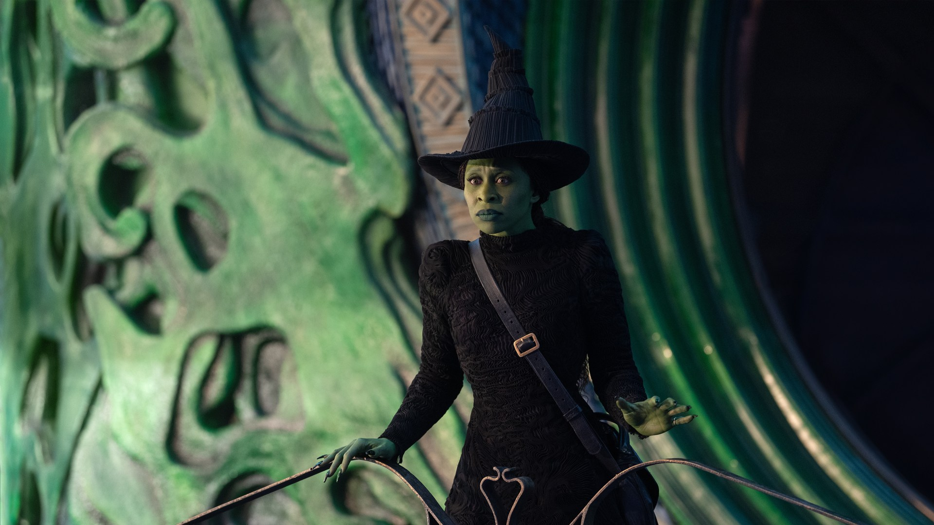“Wicked” calls our judgments into question.

Cynthia Erivo is Elphaba in WICKED

Christianity Today November 27, 2024

Giles Keyte / Universal Pictures

Belief in wickedness both clarifies and complicates human relations. Accepting that an Adversary bent on our destruction actually exists, one who can’t be bargained with or appeased, places the sword of the Spirit in ready hands (Eph. 6:17). Configuring metaphysical struggles as active combat helps energize not only the prayer warrior on their knees but also the caregiver committed to returning love for endless demands and the day worker who braves mistreatment from a series of oppressive employers.

If we can remember that our true foe is neither the recalcitrant coworker nor the disgruntled family member, martial imagery can prove useful—focusing devotion and inspiring endurance.

But a mind primed for conflict can also mistake difference for malevolence or confuse an imperfect individual with the author of deception. Lucifer only inhabits a stabbable body in [video games](https://diablo4.blizzard.com/en-us/) and [horror films](https://www.imdb.com/title/tt0118971/?ref_=fn_al_tt_1), and crossing swords without causing collateral damage requires discernment. No matter how flawed the person in question, remembering the call to love our enemies (Matt. 5:44), those who also bear the divine imprint (Gen. 1:27), should prevent us from targeting pesky people as if they were the Devil incarnate.

Victorian novelist Mary Ann Evans (aka George Eliot) had little patience for knee-jerk assessments of others’ moral character. She recognized the temptation to inflate our own sense of righteousness by deriding those who appear to fall short of invisible, exacting benchmarks. In the novel *Adam Bede*, she anticipates her reader’s desire to label as pagan a rural pastor who neglects to prevent sexual malfeasance. Pausing the tale to speak directly to her audience, her narrator declares that condemning others for such failures, as for their brusque manners or lack of beauty, constitutes egregious self-deception.

Jesus cautions against seeking specks with our log-filled eyes (Matt. 7:1–5). Similarly, the narrator of *Adam Bede* insists we remember our shared fallibility with those we denounce, lest we “leave them quite out of our religion and philosophy, and frame lofty theories which only fit a world of extremes.”

If we can instead learn to sympathize with fictional characters in books like hers, Eliot argues, we’ll be primed to extend charity in the real world.

This merciful ethos transformed storytelling in the last half of the 20th century with the [retconning](https://www.merriam-webster.com/wordplay/retcon-history-and-meaning) of established villains. Jean Rhys’s *Wide Sargasso Sea* (1966) reimagined Charlotte Brontë’s Bertha Mason as a mistreated, wrongly imprisoned Caribbean heiress instead of the violent adulteress in *Jane Eyre*. John Gardner’s *Grendel* (1971) recast the monster of *Beowulf* as a stymied philosopher. In the years since, nearly every classic villain bent on frustrating the happily ever after of a Snow White, Little Mermaid, or Sleeping Beauty has been reconfigured as a misunderstood victim of prejudice or bad luck.

Or take George Lucas’s original trilogy, in which a murderous psychopath fond of telekinetic chokeholds turns into a remorseful, conflicted father willing to die for his son. Darth Vader’s return to the light mirrored the redemptive arc of a Christian penitent, supercharging my young imagination with salvific possibility.

Today’s storytellers tend to either flatten baddies into risible, easily dismissed puppets whose defeat moves us not at all or grant villains the depth traditionally reserved for heroes. Marvel’s Killmonger, Loki, and Magneto fit the ranks of the latter, as do J. J. Abrams’s Kylo Ren, Todd Phillips’s version of the Joker, and Gregory Maguire’s Elphaba, otherwise known as the Wicked Witch of the West.

Maguire’s first novel about Elphaba, *Wicked: The Life and Times of the Wicked Witch of the West*, launched a book series and Broadway musical so popular that cinematic translation was inevitable. The movie *Wicked: Part One* (Part Two arrives in November 2025) writes backward from that weird moment in *The Wizard of Oz* when the diminutive inhabitants of Munchkinland sing a rousing, eerily vengeful chorus of “Ding-Dong! The Witch Is Dead.” *Wicked* opens with a similarly disturbing anthem, “No One Mourns the Wicked.”

“Ding-Dong” assumes that an individual can be wholly evil, that there is social utility in a scapegoat, and that an enemy’s death constitutes an intrinsic good. “No One Mourns the Wicked” ironizes such thinking by pushing its suppositions to the breaking point. Its cheerful melody is undercut with barely disguised cruelty. “The good man scorns the Wicked,” we’re told, leaving the pariah to “cry alone” until, finally, thankfully, they one day “die alone.”

How do we justify such marginalization? By convincing ourselves “we know what Goodness is” and “the truth we all believe’ll by and by / outlive a lie.” Lyricist Stephen Schwartz nimbly undermines the conviction that we can ever know another person well enough to damn them by appending the subtle caveats “we all believe” to “truth” and “we know” to “goodness.”

The Christian knows we are prone to rely too heavily on appearances (1 Sam. 16:7; John 7:24), and that darkness often obscures our understanding of truth (1 Cor. 4:5). The Munchkins’ summary judgment of Elphaba should make us cringe, not cheer.

Like the book and the musical, *Wicked: Part One* refuses to limit its critique to a single social dynamic. The most obvious target is racial discrimination, an abhorrence of green skin standing in for race-based prejudice writ large. (That cinematographer Alice Brooks lights certain passageways so Cynthia Erivo’s green makeup briefly resembles the dark brown of the actor’s skin underscores this commentary.)

*Wicked* also questions why we dole out pity toward people with mobility impairments. And (in a move C. S. Lewis would approve) it questions the mistreatment of talking animals. Every point in this multipronged assault on intolerance hinges on the central premise that all bigotry proceeds from unquestioned conclusions about others’ moral constitution.

Some might ask whether all this restructuring goes too far. If we recast every evildoer as a survivor of trauma and attribute actions we once thought evil to mischance and others’ willful misinterpretations, are we whitewashing the human condition? Does such relentless character revision amount to a methodical deconstruction of brokenness that explains away human error by blaming it on faulty design and unhappy circumstance?

Not really. For every villain we rehabilitate, there’s another waiting in the wings, hiding behind a veneer of respectability and effectively deceptive propaganda. *Wicked* is no exception. The film’s big reveal does not ask us to disbelieve in badness, merely to question those biases that so often mislead and misname. Something wicked this way comes, just not by way of the usual suspects.

Paul Marchbanks is a professor of English at California Polytechnic State University. His YouTube channel is “[Digging in the Dirt](https://www.youtube.com/channel/UCcDjiOMHHg-a8KWAN7Q2k8Q).”