**All Church Worship Brainstorming Summary**

**The Miracles of Jesus**

Mon., September 16, 2024

October 6-27, 2024 (4 Sundays)

**Members present:** Ed Baranowski, Annette Erbes, Sue Baranowski, Marie Kordecki, Paul Powers, Jean Kelly, Pastor Mary Ivanov, Pastor Mark Erbes, Rose Emmons, Jim Post, Karen Post, Kathy Luckett, Ken Luckett, David Booth, Karen Booth

*“The worship we hope to develop will be rooted in Scripture, centered on Christ, and empowered by the Holy Spirit. It will be relevant to local and emerging culture, while addressing the needs of believers and unbelievers alike. Above all, it will intentionally engage people physically, emotionally, intellectually, and soulfully.”*

**Felt needs:** What physical, emotional, intellectual, or spiritual need are we addressing in this service so that worship is engaging and a means of making disciples? What question needs to be posed/answered so that we are making disciples?

---------------------------------------------------------

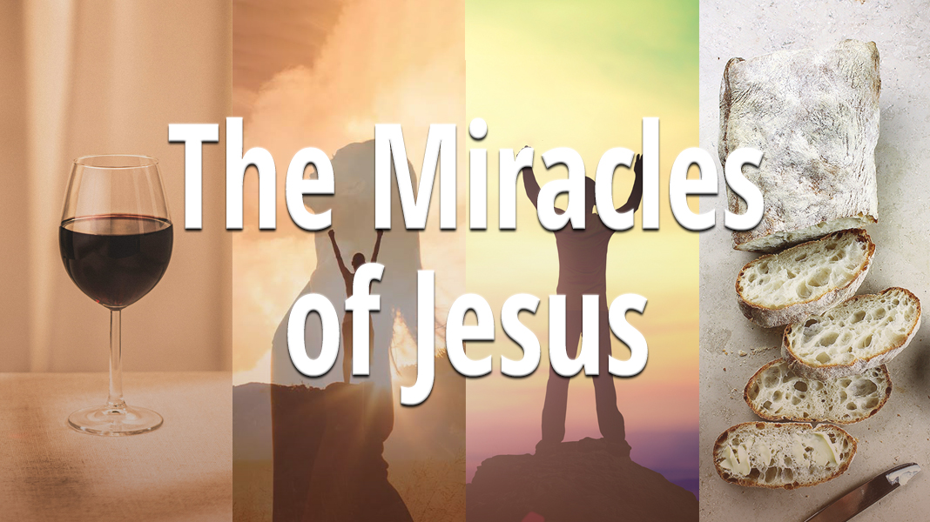**2024 Theme:**  Following the Jesus Way

**Inspiration:** [*The Jesus Way*](https://www.youtube.com/watch?v=ARSGgC9iQb0) by Phil Wickham

**Related songs:** *I Have Decided to Follow Jesus*

**Key verse:** John 13: 34 – A new commandment I give to you, that you love one another: just as I have loved you, you also are to love one another.

**Synopsis:** Did Christ actually work the miracles that the Gospels record? What do we learn from them? What is their significance? Does our cultural bias keep us from seeing modern-day miracles? In our modern-day Western culture, how does our skepticism blind us to ancient and modern miracles?

**2024 theme connection:** Jesus’ miracles show who he is and God’s plan for redeeming the world. We place our trust in him to do more than we can think or imagine even when it comes to the gifts we offer.  **As we focus on our role as stewards of God’s gifts,** **we’ll focus on how miracle stories demonstrate the abundance of God’s love and grace for us and through us.**

**Major spoken/unspoken needs:**

* Hope in something beyond ourselves – that something also better and more powerful than we are

**Social justice issue for October 2024:** Addiction (how bad habits can become serious)

**Noisy offering for October 2024:** TBD

**Ideas to explore:**

* What is a miracle? What do Jesus’ miracles tell us about him? (from Gemini AI)

A miracle is generally defined as **an extraordinary event that is attributed to the supernatural power of God or another divine entity. It's something that defies the laws of nature or is inexplicable by scientific means.**

The concept of miracles is often associated with religious beliefs and faith. However, it can also be used more informally to describe something exceptionally fortunate or unexpected.

* **Key characteristics of a miracle often include:**
  + **Defiance of natural laws:** Miracles are typically seen as events that go against the ordinary course of nature.
  + **Divine intervention:** They are often attributed to the direct intervention of a higher power.
  + **Awe and wonder:** Miracles can inspire a sense of awe and amazement.
  + The Bible, particularly the New Testament, is filled with accounts of miracles performed by Jesus Christ and his disciples. These miracles are seen as manifestations of God's power and grace, often serving as evidence of Jesus' divine nature and authority.
  + **Common types of miracles in the Bible include:**
    - **Healings:** Jesus healed various ailments, including blindness, paralysis, and leprosy.
    - **Resurrections:** He raised people from the dead, most notably Lazarus.
    - **Exorcisms:** Jesus cast out demons from people who were possessed.
    - **Natural phenomena:** He controlled the elements, such as calming storms and walking on water.
    - **Feedings:** He miraculously fed thousands of people with a small amount of food.
* World view: Faith (personal) vs. Science (impersonal)
* What is luck? Luck of the draw? Are we willing to hold ourselves accountable?
* Quote from Betty’s coach friend: As long as there is breath, there is a possibility of a miracle.
* “We all know that miracles come from God, but sometimes we forget that there are times when **God asks us to participate in the miraculous.”** – [Discipleship Ministries, Nov. 26, 2008](https://www.umcdiscipleship.org/resources/get-your-feet-wet-21st-century-liturgy-for-the-twenty-second-sunday)
* How do we understand the role of **“signs and wonders”** in our faith story - and in our lives?
* What role does faith play in miracles?
* **Miracles are a spiritual gift** - the gift of an ability to operate at a spiritual level that recognizes the miraculous work of God in the world. Miracle workers invoke God’s power to accomplish that which appears impossible or impractical by worldly standards. Miracle workers remind us of the extraordinary nature of the ordinary world, thereby increasing faithfulness and trust in God. Miracle workers pray for God to work in the lives of others, and they feel no sense of surprise when their prayers are answered. (Copyright © 2010 Barbara & Dan R. Dick, <http://equippedforeverygoodwork.wordpress.com>)

**Resources:**

* [“The Miracles of Christ.”](https://www.thegospelcoalition.org/essay/the-miracles-of-christ/) An essay by Vern Poythress of The Gospel Coalition. Key ideas:
  + The Reality of Miracle:
    - Cultural narrowness of skepticism – mostly in Western culture
    - God’s power
    - The divinity of Christ
    - Evidence for historical reliability of the Bible
    - 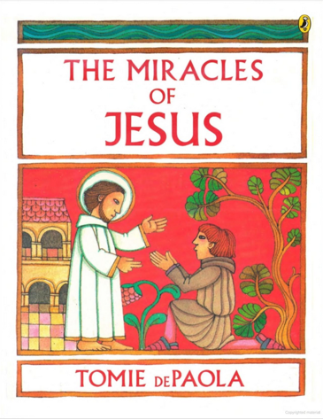Divine authority of the written text of the Bible
    - Miracles outside the bible
  + The Significance of the Miracles of Christ
    - The larger plan of God for history
    - Jesus as Messiah
    - Jesus as divine son of God
    - Miracles as signs of redemption
* **The Miracles of Jesus** by Tomie dePaolo. After Jesus of Nazareth was baptized, he began his public life, and he performed many miracles. Inspired by Romanesque art, Tomie dePaola brings the New Testament to life as he retells the stories of twelve miracles in the Bible. The Miracles of Jesus begins with "the Wedding at Cana," the first miracle, when Jesus turned water into wine at a wedding feast. This is followed by other miracles Jesus performed, such as his calming of a storm, walking on water, and raising the dead to life. This delightful collection filled with memorable illustrations is perfect for sharing and reading aloud.
* [10 facts about miracles that will build your faith](https://www.crosswalk.com/slideshows/10-facts-about-miracles-that-will-build-your-faith.html) – shared by JOY 99.3 on 1/26/24
* “We Need Both” by Rich Pérez. Doubt, belief, and the subtlety of miracles. Christianity Today Pastors Newsletter, Jan. 30, 2024
* [Inside the Miracles of Jesus](https://www.cokesbury.com/Inside-the-Miracles-of-Jesus?refq=miracles): Discovering the Power of Desperation by Jessica LaGrone
* Signs and Wonders: A Beginner's Guide to the Miracles of Jesus by Amy-Jill Levine. The author explores selected miracles of Jesus in historical and theological context. For each miracle, she discusses not only how past witnesses would have understood the events, but also how today’s readers can draw meaning from Jesus’s words and actions. Chapter topics include:  
   Giving sight to the blind: Metaphors of understanding (Mark 8, John 9)  
   “Take up your pallet and walk” (the paralyzed man): On the role of caregivers  
   A bleeding woman and a dead girl: The importance of women’s bodies  
   Walking on water and stilling the storm: Ecological readings of the Gospels  
   The feeding of the 5,000 (or more): The centrality of bread  
   The raising of Lazarus: Taking death seriously

*Comment:* Could we use this book for a bible study during this series?

* From UMC sources:
  + <https://www.umc.org/en/content/how-do-miracles-happen>
  + <https://www.ministrymatters.com/all/entry/8709/miracles-come-with-a-cost>
  + <https://www.ministrymatters.com/all/entry/5744/are-miracles-real>
  + <https://www.ministrymatters.com/all/entry/8692/you-were-made-for-a-miracle>  [Made for a Miracle:](https://www.amazon.com/Made-Miracle-Your-Ordinary-Extraordinary/dp/1501841386) Popular author and pastor Mike Slaughter examines the two components of every miracle: divine action and human responsibility. For a real miracle to take place, we must act with God, using whatever gifts, talents, and abilities we have and directing them toward God’s work.

**Videos:**

* Eyewitness bible series videos (we have permission to use in church and livestream).
* Possible series intro (discovered after the brainstorming): [“Miraculous.”](https://www.worshiphousemedia.com/mini-movies/102456/miraculous?_gl=1*yyq8n5*_up*MQ..&gclid=Cj0KCQjw9Km3BhDjARIsAGUb4nxrr2ujk34SaUR5gQA1fZQFMF6dElmI_eFF_UPqyNUKRYSQ35mcXlQaAsznEALw_wcB) Length: 0:55. Cost: $12.00. Web license: Yes. We read about all kinds of miracles in the scriptures. Be encouraged. Jesus is still working and miracles still happen today.

**Sanctuary visuals:** MIRACLES or SIGNS AND WONDERS on the ledge. Symbols from each week’s miracle: Tipped water jugs with blue or red scarves “pouring out” water or wine. An older women’s shawl, cane or crutch. Tomb stone. Basket of fish and bread. Patchwork quilt of wildflowers.

**Hands-on item:**

**Music:**

**Children’s Time:**

**Discussion points:**

* Questions to answer about each miracle: What does the miracle tell us about God? What does it say about who we are?
* Tuesday morning bible study has been studying the Gospel of John.
* Big questions and possible answers:
  + Why are some prayers answered and others are not? Perhaps the “answers” are just not what we had expected.
  + What is the difference between a healing and a cure? Healing refers to wholeness, well-being, and peace which sometimes comes only with death. Cure refers to symptoms being gone.
  + What is the connection between desperation and expectation? Desperate people pray with the expectation that miracles do happen. Related thought: Having the will to survive.
* Examples of miracles in our lives: 1) Ed and Sue’s Tinley was hospitalize for 3 months as a baby. One thing after another went wrong, but she pulled through. Last year she collapsed at school and pulled through again with medical intervention. 2) Nicole Austen Way survived more than one bout of illness. 3) Pastor Mary and Ivan’s best man, Tod, survived a virus which necessitated a heart transplant.
* We have to release our gifts so they can be used by God.
* An exorcism is praying for evil to be gone. We have all prayed that to some extent.
* Modern day miracles are not generally a focus of mainline Protestants.
* Miracles must be claimed as miracles.

------------------------------------------------------

**October 6, 2024:** “More than Full”

**Pentecost 20**

**Scripture:** John 2: 1-11 (MSG)

2 1-3Three days later there was a wedding in the village of Cana in Galilee. Jesus’ mother was there. Jesus and his disciples were guests also. When they started running low on wine at the wedding banquet, Jesus’ mother told him, “They’re just about out of wine.”

4Jesus said, “Is that any of our business, Mother—yours or mine? This isn’t my time. Don’t push me.” **Comment:** This sounds pretty snarky.

5She went ahead anyway, telling the servants, “Whatever he tells you, do it.”

6-7Six stoneware water pots were there, used by the Jews for ritual washings. Each held twenty to thirty gallons. Jesus ordered the servants, “Fill the pots with water.” And they filled them to the brim.

8“Now fill your pitchers and take them to the host,” Jesus said, and they did.

9-10When the host tasted the water that had become wine (he didn’t know what had just happened but the servants, of course, knew), he called out to the bridegroom, “Everybody I know begins with their finest wines and after the guests have had their fill brings in the cheap stuff. But you’ve saved the best till now!”

11This act in Cana of Galilee was the first sign Jesus gave, the first glimpse of his glory. And his disciples believed in him.

12After this he went down to Capernaum along with his mother, brothers, and disciples, and stayed several days.

**Synopsis:** Miracles were a part of Jesus’ ministry. Signs and wonders were a way by which people came to know that God’s power was real and for all people. How can we as stewards of God’s gifts reclaim God’s power to do what we don’t think can be done, bring hope and joy, and help us to put our trust in him?

**Felt need:** To trust and have faith in Jesus to do what’s needed

**Resources:**

[“The Miracle at Cana: It Wasn’t Really About the Wine”](https://medium.com/koinonia/the-miracle-at-cana-it-wasnt-really-about-the-wine-ac72d3ea183d)

* Verse 6: “Now there were **six stone waterpots set there for the Jewish custom of purification, containing twenty or thirty gallons each**.” (NASB) The water stands for the old religion; the wine stands for the new.
* You would generally only find stone pots in the homes of the priests. Jesus show Himself to be the ultimate High Priest and the sacred space in which work is done.
* Jesus show Himself to be the ultimate bridegroom. (verse 9-10)

Amy-Jill Levine

* There are 7 signs in the Gospel of John - turning water into wine is the first. The others are: 2) Healing the official's son, 3) Healing the crippled man, 4) Feeding the five thousand, 5) Walking on water, 6) Healing the blind man, and 7) Raising Lazarus from the dead.
* Signs in the Gospel of John can give rise to faith.
* If you run out of wine, it’s the miracle you need!
* Mary has trust and faith that Jesus will do what she asks.

**Visuals:**

**Hands-on item:**

**Activity:** Holy Communion, CROP Walk

**Media possibilities:**

* [“Seven Miraculous Signs: The Book of John.”](https://www.bible.com/videos/32861-seven-miraculous-signs-the-book-of-john?collection=170) Length: 2:26. Cost: Free. Web license: Yes. Lazarus tells of seven miraculous signs of Jesus in the Gospel of John. **Comments:** We like it as an intro to the series and the first miracle recorded in John.
* [“LUMO Project: John 2: 1-11.”](https://www.bible.com/videos/25075-john-2?collection=18) Length: 2:10. Cost: Free. Web license: Yes. Visual liturgy.

**Music:** *Fill My Cup, Lord* (UMH 641); #467 *Trust and Obey*

*In Cana at a Wedding Feast*

ELLACOMBE 8.6.8.6 D ("I Sing the Mighty Power of God"; "Hail To the Lord's Anointed")

In Cana at a wedding feast, Christ worked his first great sign.  
There Jesus' mother told her son, "They don't have any wine!"  
He called for six stone water jars; they filled them to the brim;  
Through water changed to wine that day, his friends believed in him.

Far from the town, the crowds pressed in on Jesus' prayer retreat.  
He healed their sick, then told his own, "You give them food to eat!"  
Five loaves of bread and two small fish were all they found to share,  
Yet thousands ate the meal he blessed, with baskets left to spare.

Out on the sea, the winds were strong; the stormy waves were high;  
There Jesus' friends were filled with fear when he came walking by.  
"Take heart, for it is I!" he said, and helping Peter stand,  
He calmed the storm and stirred their hearts; God's world was in his hand.

The blind, the poor, the outcast too, found Christ to be their friend.  
"Have mercy!" Bartimaeus said. "I want to see again."  
With great compassion and with grace, Christ gave him back his sight.  
Through deeds of power, deeds of love, he filled our world with light.

O Lord, we see your wondrous signs and know through faith-filled eyes:  
You are new wine that brings us joy, true bread that satisfies.  
You give clear vision to your church, you make the wounded whole.  
You give us hope, when seas are rough; for you are in control!

Biblical References: John 2:1-12; Matthew 14:13-21; Mark 6:30-44; Luke 9:10-17; John 6:1-15; Matthew 14:22-33; Mark 6:45-52; John 6:16-21; Mark 10:46-52  
Text: Copyright © 1999 by Carolyn Winfrey Gillette. All rights reserved.

**Children’s time:**

**Social media:**

**Discussion points:**

* What does the wine into water miracle say about God? He is everywhere, even in celebrations.
* Hospitality was/is an important part of their culture. The host should never run out of food or wine. The party would have ended. The host would have been embarrassed, shamed, and felt very guilty. Guests might have assumed the hosts didn’t care about them. It would not have been good for their community.
* Only the servants knew what had had happened and participated in the miracle, doing as they had been asked.
* Why would Mary have known that the wine was running out? Was she looking out for others? Very close to the wedding party’s family and helping host? Did her initiative prod Jesus into action? What did she expect him to do?
* Jesus had four disciples at this time. They came to believe in him, in part because of the miracles he performed, although Jesus himself never publicly claimed this one.

------------------------------------------------------

**October 13, 2024:** “Standing Tall and Free”

**Pentecost 21**

**Scripture:** Luke 13: 10-17 (MSG)

10-13He was teaching in one of the meeting places on the Sabbath. There was a woman present, so twisted and bent over with arthritis that she couldn’t even look up. She had been afflicted with this for eighteen years. When Jesus saw her, he called her over. “Woman, you’re free!” He laid hands on her and suddenly she was standing straight and tall, giving glory to God.

14The meeting-place president, furious because Jesus had healed on the Sabbath, said to the congregation, “Six days have been defined as work days. Come on one of the six if you want to be healed, but not on the seventh, the Sabbath.”

15-16But Jesus shot back, “You frauds! Each Sabbath every one of you regularly unties your cow or donkey from its stall, leads it out for water, and thinks nothing of it. So why isn’t it all right for me to untie this daughter of Abraham and lead her from the stall where Satan has had her tied these eighteen years?”

17When he put it that way, his critics were left looking quite silly and red-faced. The congregation was delighted and cheered him on.

**Synopsis:** Jesus’ concern for healing and helping in spite of the expectations of others reflects God’s desire to bring freedom and hope for us. Our response is to witness to God’s power to bring new life.

**Felt need:** To celebrate the blessing of freedom as an opportunity to thank God

**Resources:**

* [*God is willing to heal even the most hopeless situation.*](https://www.christianwalls.com/blogs/scripture-roundups/bible-verses-about-healing-the-sick) *He’s willing to upset the norm to do it as well. The story of Jesus healing the crippled woman in Luke 13 is evidence of these facts. For eighteen years, this woman suffered not just physical pain but from judgment and scorn. The holy men around her were of no help to her, and they treated her poorly. Jesus, on the other hand, stepped in with love. He saw her condition, but he also saw here. This is encouraging news to anyone struggling with illnesses and addictions* that have formed over time. People may no longer see you as you want them to. Instead, all they can see is the sickness. There is still hope for healing in Jesus. Whether it’s been eighteen year, thirty years, or fifty years. Whatever your weakness, illness, or disease, Jesus can remove it from your life and bring you back to full health.*
* <https://reflections.yale.edu/article/divine-access-disability-and-belonging/finding-healing-my-disability>

**Visuals:** Shawl, cane or crutch

**Hands-on item:**

**Activity:** Offer healing prayer

**Media possibilities:** [“Martha, the Crippled Woman and a Gardener: The Book of Luke.”](https://www.bible.com/videos/27727-martha-the-crippled-woman-the-book-of-luke?collection=110) Length: (from 4:36 to 7:50). Cost: Free. Web license: Yes. The crippled woman describes being healed by Jesus and how that changed her perception of righteousness. **Comments:** While we can’t be sure that every point this woman made is entirely accurate, we really like it.

**Music:** *Heal Me, Hands of Jesus* (UMH 262), *People Need the Lord* (FWS 2244)

**Children’s time:**

**Social media:**

**Discussion points:**

* We sometimes read that the woman is described as bent over. She couldn’t look up and would probably have been excluded from “normal” society. Would she have known about Jesus? Why did she respond when called? Jesus calls us every day. Do we respond? We are guessing that she immediately becomes a witness for Jesus. **Follow-up note from Karen:** Some of our discussion centered around why this woman was at the synagogue as she was both a woman and disabled. Several articles, including one by [Amy-Jill Levine](https://jwa.org/encyclopedia/article/jewish-women-in-the-new-testament) and another by [Biblical Hermeneutics](https://hermeneutics.stackexchange.com/questions/58223/who-was-attending-the-synagogues-in-jesus-times), suggest that women and children would have been present in Jesus’ time.
* What does this tell us about God? Jesus loves us 24/7. Something new is happening. Jesus sees people who we ignore.
* What does this tell us about ourselves? It is easier to see what others are doing wrong rather that what we are doing wrong. Like the Pharisees, we can get focused on rules and power. We struggle with change.
* In Jesus’ time, disabilities were thought to be caused by sin (or Satan). What do we believe today? Do we treat disabilities as obstacles or barriers?
* V. 13: “Woman, you’re free!” is an interesting language. There seems to be instant healing and a cure.
* How do people who have disabilities or love someone with disabilities, respond to this story? This shows what happens when marginalized people encounter Jesus.
* *Personal stories of illness and addiction: 1) Karen Post is very careful about the language she uses when someone asks if she is “cured” of cancer. She can say what she knows is true at the moment, that she is cancer-free. The thought of recurrence is scary. 2) The Booth’s son, Chris, has been sober for a couple years and is doing very well – a true miracle. Some divine help and the support of many other people made it possible. While we want to believe he has been “cured,” it doesn’t take much for Dave to still jump to the conclusion that something it could all fall apart in a heartbeat. Rose has had a similar experience with her son.
* This story is immediately preceded by the parable of the barren fig tree. In [Taste and See](https://www.amazon.com/Taste-See-Discovering-Butchers-Bakers/dp/0310354862), Karen Booth read how closely one must look to see when a fig tree is ready to produce fruit. Both the figs and the crippled woman in this story can easily be overlooked.

-----------------------------------------------------

**October 20, 2024:** “Life Right Now!”

**Pentecost 22**

**Scripture:** John 11: 1-44 (VOICE)

**Narrator:** John points to stories where Jesus returns to the issue of faith again and again. The crowds are fickle, believing sometimes and not others. The religious leaders refuse to believe because Jesus doesn’t fit their paradigms. The disciples and close friends constantly face situations that challenge their faith, and this especially happens when Lazarus dies. John is implicitly urging his readers to have faith in Christ, even in difficult times, because He is the source of life and well-being. <- healing

11 There was a certain man who was very ill. He was known as Lazarus from Bethany, which is the hometown of Mary and her sister Martha. 2 Mary *did a beautiful thing for Jesus. She* anointed the Lord with a pleasant-smelling oil and wiped His feet with her hair. Her brother Lazarus became deathly ill, 3 so the sisters immediately sent a message to Jesus which said, “Lord, the one You love is very ill.” 4Jesus heard the message.

**Jesus:** His sickness will not end in his death but will bring great glory to God. As these events unfold, the Son of God will be exalted.

**Narrator:** 5Jesus *dearly* loved Mary, Martha, and Lazarus. 6However, after receiving this news, He waited two more days where He was.

**Jesus** *(speaking to the disciples)***:** 7It is time to return to Judea.

**Disciples:** 8Teacher, the last time You were there, some Jews attempted to execute You by crushing You with stones. Why would You go back?

**Jesus:** 9There are 12 hours of daylight, correct? If anyone walks in the day, that person does not stumble because he or she sees the light of the world. 10If anyone walks at night, he will trip and fall because he does not have the light within. 11(Jesus briefly pauses.) Our friend Lazarus has gone to sleep, so I will go to awaken him.

**Disciples:** 12Lord, if he is sleeping, then he will be all right.

**Narrator:** 13Jesus used “sleep” *as a metaphor* for death, but the disciples took Him literally *and did not understand*. 14Then Jesus spoke plainly.

**Jesus:** Lazarus is dead, 15and I am grateful for your sakes that I was not there when he died. Now you will *see and* believe. Gather yourselves, and let’s go to him.

**Thomas, the Twin** *(to the disciples)***:** 16Let’s go so we can die with Him.

**Narrator:** 17-18As Jesus was approaching Bethany (which is about two miles east of Jerusalem), He heard that Lazarus had been in the tomb four days. 19Now many people had come to comfort Mary and Martha as they mourned the loss of their brother. 20Martha went to meet Jesus when word arrived that He was approaching Bethany, but Mary stayed behind at the house.

**Martha:** 21Lord, if You had been with us, my brother would not have died. **22**Even so I still believe that anything You ask of God will be done.

**Jesus:** 23Your brother will rise to life.

**Martha:** 24I know. He will rise again when everyone is resurrected on the last day.

**Jesus:** 25I am the resurrection and the source of all life; those who believe in Me will live even in death. 26Everyone who lives and believes in Me will never truly die. Do you believe this?

**Martha:** 27Yes, Lord, I believe that You are the Anointed, *the Liberating King,* God’s own Son who *we have heard* is coming into the world.

**Narrator:** 28After this Martha ran home to Mary.

**Martha** *(whispering to Mary)***:** Come with me. The Teacher is here, and He has asked for you.

**Narrator:** 29Mary did not waste a minute. She got up and went 30to the same spot where Martha had found Jesus outside the village. 31The people gathered in her home offering support and comfort assumed she was going back to the tomb to cry and mourn, so they followed her. 32Mary approached Jesus, saw Him, and fell at His feet.

**Mary:** Lord, if only You had been here, my brother would still be alive.

**Narrator:** 33When Jesus saw Mary’s *profound grief and the moaning and* weeping of her companions, He was deeply moved *by their pain* in His spirit and was intensely troubled.

**Jesus:** 34Where have you laid his body?

**Jews:** Come and see, Lord.

**Narrator:** 35*As they walked,* Jesus wept; 36and everyone noticed how much Jesus must have loved Lazarus. 37But others were skeptical.

**Others:** If this man can give sight to the blind, He could have kept him from dying.

**Narrator:** **They are asking, if Jesus loves Lazarus so much, why didn’t He get here much sooner?**

38Then Jesus, who was intensely troubled by all of this, approached the tomb—a *small* cave covered by a *massive* stone.

**Jesus:** 39Remove the stone.

**Martha:** Lord, he has been dead four days; the stench will be unbearable.

**Jesus:** 40Remember, I told you that if you believe, you will see the glory of God.

**Narrator:** 41They removed the stone, and Jesus lifted His eyes toward heaven.

**Jesus:** Father, I am grateful that You have heard Me. 42I know that You are always listening, but I proclaim it loudly so that everyone here will believe You have sent Me.

**Narrator:** 43After these words, He called out in a thunderous voice.

**Jesus:** Lazarus, come out!

**Narrator:** 44Then, the man who was dead walked out of his tomb bound from head to toe in a burial shroud.

**Jesus:** Untie him, and let him go.

**Narrator:** Once again Jesus amazes everyone around Him. How does He raise Lazarus? What kind of man can speak life into death’s darkness? Throughout His time on earth, those around Him are continually surprised by Jesus. He is unique. How does He have power over death? It takes a while, but more and more His followers become convinced this is no ordinary man.

45As a result, many of the Jews who had come with Mary saw what happened and believed in Him.  not all



**Synopsis:** Resurrection is a cornerstone of our faith, but it’s not without the reality of death and grief. In community, we become witnesses to the power of God to bring new life. How do we understand ourselves as stewards of Good News?

**Felt need:** To be faithful stewards of our lives - and live into the new, abundant life God offers

**Resources:** Amy-Jill Levine

* This miracle story is about Jesus’ relationship with Mary and Martha.
* Resurrection is real - and so is death.
* We never hear from Lazarus, but what was he thinking? If we get a second chance or new lease on life, what’s different?
* How do we carry forth Good News?

**Visuals:** Stone covering the tomb

**Hands-on item:**

**Activity:**

**Media possibilities:**

* [“Believe: Mary and Martha.”](https://skitguys.com/videos/believe-mary-and-martha) Length: 3:14. Cost: $18.00. Web license: Yes. When their brother, Lazarus, was sick, Mary and Martha called for the one person they knew could heal him. But when Jesus didn’t arrive until after Lazarus died, they wavered in their belief. Once Jesus raised Lazarus from the dead, the sisters realized that Jesus is the Christ, and whoever believes in Him will live.
* [“Seven Miraculous Signs: The Book of John.”](https://www.bible.com/videos/32861-seven-miraculous-signs-the-book-of-john?collection=170) Length: 5:32 (from 11:15 to 16:47). Cost: Free. Web license: Yes. Lazarus became the last of those signs when Jesus raised him from the dead. **Comments:** We like. Good wrap-up on miracles. Use it.

**Music:** *Rise Up (Lazarus), Lord of the Dance* (UMH 261), *This Is a Day of New Beginnings* (UMH 383)

**Children’s time:**

**Social media:**

**NOTE:** Charge Conference is scheduled for the afternoon at White Lake UMC.

**Discussion points:**

* What strikes you about this passage? Hearing Martha say the tomb will stink. Jesus wept for love of his friends. Jesus tells others to unbind Lazarus (Having others participate in the miracle. How are we unbound to new life in Christ?)
* There can’t be resurrection without death. Death and grief go hand-in-hand. Jesus took time to grieve.
* Freedom in Christ is not license to do anything we want.
* How do with understand Jesus’ friendship with Mary and Martha? They must have been very close. Mary had anointed Jesus’ feet with her hair. Two days of waiting must have seemed an eternity to them.
* 2nd chances: How do we understand grace? Being set free? How do we live differently?
* Mary and Martha’s witness after Lazarus’ resurrection was probably different than Lazarus’ witness.
* So many stories are open-ended. We want to know more.
* Stewardship: How are we each a sign and stewards of the Good News?

------------------------------------------------------

**October 27:** “Made for a Miracle”

**Pentecost 23**

**Scripture:** Mark 6: 30-44 (MSG)

30-31The apostles then rendezvoused with Jesus and reported on all that they had done and taught. Jesus said, “Come off by yourselves; let’s take a break and get a little rest.” For there was constant coming and going. They didn’t even have time to eat.

32-34So they got in the boat and went off to a remote place by themselves. Someone saw them going and the word got around. From the surrounding towns people went out on foot, running, and got there ahead of them. When Jesus arrived, he saw this huge crowd. At the sight of them, his heart broke—like sheep with no shepherd they were. He went right to work teaching them.

35-36When his disciples thought this had gone on long enough—it was now quite late in the day—they interrupted: “We are a long way out in the country, and it’s very late. Pronounce a benediction and send these folks off so they can get some supper.”

37Jesus said, “You do it. Fix supper for them.”

They replied, “Are you serious? You want us to go spend a fortune on food for their supper?”

38But he was quite serious. “How many loaves of bread do you have? Take an inventory.”

That didn’t take long. “Five,” they said, “plus two fish.”

39-44Jesus got them all to sit down in groups of fifty or a hundred—they looked like a patchwork quilt of wildflowers spread out on the green grass! He took the five loaves and two fish, lifted his face to heaven in prayer, blessed, broke, and gave the bread to the disciples, and the disciples in turn gave it to the people. He did the same with the fish. They all ate their fill. The disciples gathered twelve baskets of leftovers. More than five thousand were at the supper.

**Synopsis:** This miracle is the only one that appears in all four Gospels, which means that it’s important and we need to pay close attention. There’s something to be said for what we can give, but even more about what Jesus can do with what we give.

**Felt need:** To celebrate the abundance of God’s grace as we offer faith commitments

**Resources:**

[Both stories tell us that the crowds “ate and were satisfied.” No one is left wanting.](https://youngadults.lifeway.com/2018/07/5-observations-about-jesus-feeding-the-multitudes/)

* Jesus chooses to use people and their ordinary gifts to do something extraordinary.
* Jesus is patient with his disciples.
* Jesus has a tender heart. He knows what it is like to hunger and thirst, physically and spiritually.

Amy-Jill Levine

* There’s a connection between Jesus and Moses (manna in the desert).
* Everyone is involved in feeding, helping, and serving.
* Everyone is satisfied - and there are leftovers!
* How would this show of hospitality have affected the people who received it?

**Visuals:** Patchwork quilt of wildflowers. Baskets of bread. Ceramic fish. Myke’s fish pillow. [Billy bass](https://www.walmart.com/ip/Gemmy-Big-Mouth-Billy-Bass-The-Singing-Sensation/332613189?wmlspartner=wlpa&selectedSellerId=0).

**Hands-on item:** [Ziploc bag](https://www.pinterest.com/pin/4503668371458693/) with two Swedish fish and five oyster crackers

**Activity:** Offering our Faith Commitment for 2025

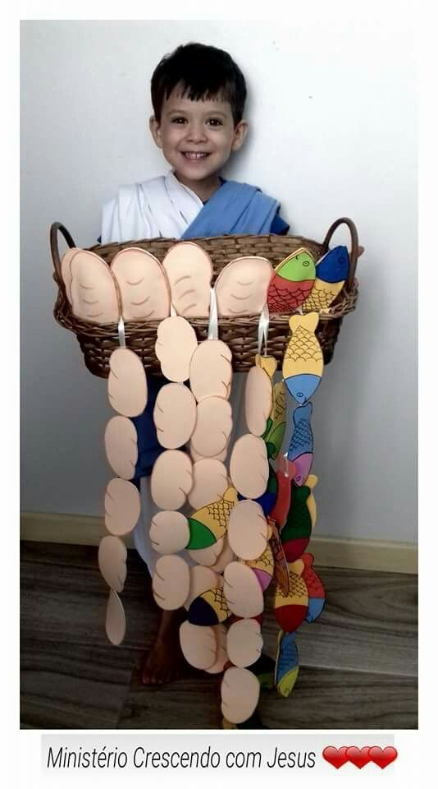**Media possibilities:** [“LUMO Project: Mark 6: 30-44.”](https://www.bible.com/videos/25013-mark-6-30-56?collection=20) Length: 2:11. Cost: Free. Web license: Yes. Visual liturgy.

**Children’s Time illustration 🡪 🡪 🡪**

**Music:** *Eat This Bread, Drink This Cup* (UMH 628), *Take Our Bread* (UMH 640), Through I All (UMH 507)

*Where Is Bread?*

ABBOT'S LEIGH 8.7.8.7 D ("God Is Here!")

"Where is bread?" the great crowd murmured —  
Thousands strong, yet all in need.  
"Where is bread?" your people wondered,  
Faced with such a crowd to feed.  
Who, Lord Jesus, could have guessed it?  
One small boy brought food to share.  
Taking what he gave, you blessed it;  
All were fed, with much to spare.

Where is bread? We know their yearning;  
Every day, we wish for more.  
God, in time, we're slowly learning:  
All we own can make us poor.  
Our possessions can possess us,  
Leaving hunger deep inside.  
Christ our Bread, come now and bless us;  
At your feast, we're satisfied.

"Where is bread?" the call is rising;  
Millions cry who must be fed.  
God, your answer seems surprising:  
"You, my Church, you give them bread."  
Bread to fill each hungry spirit,  
Bread for hungry stomachs, too!  
Give us bread and help us share it.  
Richly blest, may we serve you.

Biblical References: John 6:1-15; Matthew 14:13-21; Mark 6:32-44; Luke 9:10-17  
Tune: Cyril Vincent Taylor, 1941, copyright renewed 1970 Hope Publishing Company ("God Is Here!")  
Text: Copyright © 2000 by Carolyn Winfrey Gillette. All rights reserved.

**Children’s time:**

**Social media:**

**Discussion points:**

* This is the only miracle that appears in all four gospels; this version doesn’t include a little boy. It is literal in the sense that everyone had something with them (they all traveled from some distance) and shared – a big charcuterie board.
* Enough: You have what you have. God blesses it. There is more than enough. We have trouble figuring out what “enough” looks like.
* What can we give? What can God do with it?
* Given their culture of hospitality, everyone would expect to share.
* What does this say about God? Jesus is patient with his disciples. He has compassion on the crowd.
* What does this say about us? Are we willing to share? What do we miss when we don’t? Sharing is a response to God’s goodness and grace. Even secular culture recognizes the value of serving and giving to others.
* Everyone has someone who has helped them. Who help us? Who have we helped.
* Jesus instructed the crowd to sit in groups of 50-100 to eat, a sign that eating in community is important.