‘Inside Out 2’ Review: Pixar’s Vision of Teenage Turmoil

The animation studio’s sequel to its 2015 hit returns to the mind of a girl, where new emotions—like anxiety, envy and ennui—have taken the stage.
By Kyle Smith June 13, 2024 2:31 pm ET | Wall Street Journal

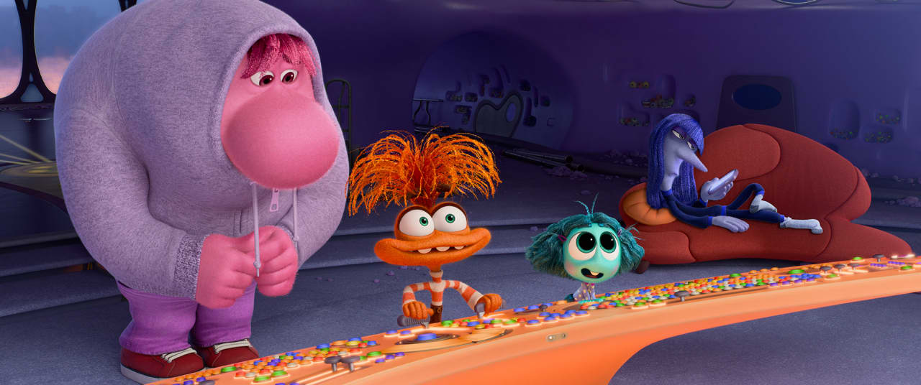Embarrassment (voiced by Paul Walter Hauser), Anxiety (Maya Hawke), Envy (Ayo Edebiri) and Ennui (Adèle Exarchopoulos) in ‘Inside Out 2.’ Photo: PIXAR
In “Inside Out,” a pre-teen girl named Riley hosted five emotions in the form of adorable animated figures, four of which were negative. In “Inside Out 2,” four new ones form a rival group, and all of them are bad: Anxiety, Envy, Ennui and Embarrassment. At age 13, Riley is dealing with an 8-to-1 ratio of unpleasant emotions overwhelming the ever-optimistic Joy. To observers of teen girls, that sounds about right.
Some sequels amount to trying to get one more watery cup of coffee out of the pot. But as directed by Kelsey Mann in his feature debut, Pixar’s follow-up to its 2015 Oscar winner burrows more deeply into a clever idea. As she prepares to attend hockey camp, the mostly stable Riley (voiced by Kensington Tallman) enters puberty, and to the whimsical characters living inside her brain this amounts to literally smashing an alarm button that supercharges every emotion. All forces seek the upper hand, and calm rationality is no longer available. It’s like going to sleep in Kansas and waking up in Oz, if Oz were a war zone or a lunatic asylum or a cable-news channel.
The puberty alarm is one of many ideas that combine the fanciful with an underlying consideration of the rough patches in human nature. Unlike its sibling Disney Animation Studios, which has gotten sidetracked on poorly conceived projects such as “Wish” and “Strange World,” Pixar continues to be a cultural leader in emotionally rewarding serious comedy. The company can now boast of six first-rate offerings in the Covid-19 era alone, with this sequel joining “Onward,” “Soul,” “Luca,” “Turning Red” and “Elemental” in a class of imaginative and evocative animated features.
Rejecting all Hollywood trends pointing the other way, “Inside Out 2” goes for the penetrating over the shallow every time, never allowing the premise to devolve into a mere gimmick. If anything, it is so attuned to wrenching experiences that it’s almost too gloomy, and probably could have used a few more moments of bright silliness like its amusing scenes that parody “Blue’s Clues” and “Dora the Explorer.”
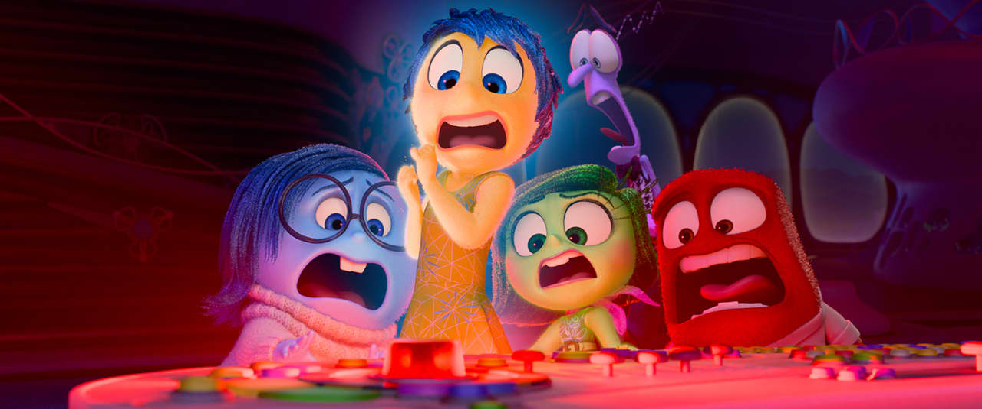Sadness (Phyllis Smith), Joy (Amy Poehler), Disgust (Liza Lapira), Fear (Tony Hale) and Anger (Lewis Black). Photo: PIXAR
Unless all of the magazines and newspapers are wrong, young people, especially teen girls, are navigating stormy weather these days, and the situation seems to have worsened since the previous film came out. “Inside Out 2” uses a superficially wacky character to discuss a genuine and alarming trend when a crazy-eyed orange creature called Anxiety (Maya Hawke) marches into Riley’s psyche, boots Joy to the side and takes over the controls. Riley is in an ostensibly exciting, but actually nerve-grating, new situation: At hockey camp, she is so awestruck by the glamour of an older, cooler girl named Val (whose voice is provided by Lilimar) and her clique that she betrays her best friends and even herself to fit in. Somewhere deep inside her, there’s a defining voice saying, “I’m a good person,” but a craving for acceptance is causing it to be drowned out by self-doubt and its destructive impulses.
Riley’s turn to a familiar defense mechanism generates an especially ingenious visual idea: the Sarchasm. When the kid affects an ironic tone, the ground opens up around Joy (Amy Poehler) and her fellow emotions Sadness (Phyllis Smith), Anger (Lewis Black), Fear (Tony Hale) and Disgust (Liza Lapira). Anxiety and her cohort—teen standbys Embarrassment (a blundering pink fellow in a hoodie, voiced by Paul Walter Hauser), Ennui (played perfectly with an I’m-so-bored French accent by Adèle Exarchopoulos) and Envy (Ayo Edebiri)—push one bad decision after another to Riley, who becomes rude, abrasive, selfish, aggressive and generally awful. (Note to the writers of all those boringly powerful and self-confident Disney women and girls these days: Flaws make a character live.)
The film is mature enough to note that unwelcome emotions can sometimes be useful—Fear is the only one who carries a parachute—as well as wise enough to depict, in gruelingly plausible detail, how the storms gather inside the seemingly privileged Riley, who lives in San Francisco with loving parents (Diane Lane, Kyle MacLachlan). At one point, Anxiety commands a nerd army of cubicle workers to dream up every possible adverse scenario in the future, sending Riley into a crisis of panic. The image is a little cute, but it’s mostly disturbing.
The most accurate cinematic depiction of the behavior of girls in Riley’s age group remains the 1973 documentary “The Exorcist,” but “Inside Out 2” is a sagacious successor, a pointedly funny and observant parable of teen angst that has a lot to say about the state of youth today. The way Anxiety et al. seize authority might even help your kids understand the tricks emotions play. For the price of a movie ticket, they’ll get a remarkably useful therapy session.

