christianitytoday.com
Poor in Spirit
Compiled by Richard A. Kauffman | June 27, 2007

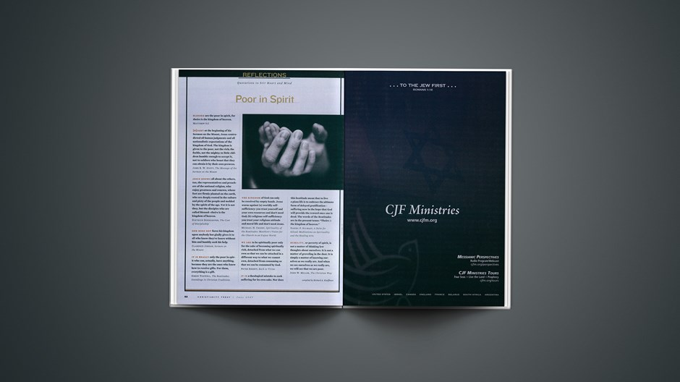
BLESSED are the poor in spirit, for theirs is the kingdom of
heaven.
Matthew 5:3

RIGHT at the beginning of his Sermon on the Mount, Jesus
contradicted all human judgments and all nationalistic expectations
of the kingdom of God. The kingdom is given to the poor, not the rich; the feeble, not the mighty; to little children humble enough to accept it, not to soldiers who boast that they can obtain it by their own prowess.
John R. W. Stott, The Message of the Sermon on the Mount

JESUS KNOWS all about the others, too, the representatives and preachers of the national religion, who enjoy greatness and renown, whose feet are firmly planted on the earth, who are deeply rooted in the culture and piety of the people and molded by the
spirit of the age. Yet it is not they, but the disciples who are called blessed—theirs is the kingdom of heaven.
Dietrich Bonhoeffer, The Cost of Discipleship

GOD DOES NOT force his kingdom upon anybody but gladly gives it to all who know they're losers without him and humbly seek his help.
Clarence Jordan, Sermon on the Mount

IT IS REALLY only the poor in spirit who can, actually, have anything, because they are the ones who know how to receive gifts. For them, everything is a gift.
Simon Tugwell, The Beatitudes: Soundings in Christian Traditions

THE KINGDOM of God can only be received by empty hands. Jesus warns against (a) worldly self-sufficiency: you trust yourself and your own resources and don't need God; (b) religious self-sufficiency: you trust your religious attitude and moral life and don't
need Jesus.
Michael H. Crosby, Spirituality of the Beatitudes: Matthew's Vision for the Church in an Unjust World

WE ARE to be spiritually poor only for the sake of becoming spiritually rich, detached from what we can own so that we can be attached in a different way to what we cannot own, detached from consuming so that we can be consumed by God.
Peter Kreeft, Back to Virtue

IT IS a theological mistake to seek suffering for its own sake. Nor does this beatitude mean that to live a pious life is to embrace the ultimate form of delayed gratification—suffering now in the hope that God will provide the reward once one is dead. The words of the Beatitudes are in the present tense: "Theirs is the kingdom of
heaven."
Daniel P. Sulmasy, A Balm for Gilead: Meditations on Spirituality and the Healing Arts

HUMILITY, or poverty of spirit, is not a matter of thinking low thoughts about ourselves. It is not a matter of groveling in the dust. It is simply a matter of knowing ourselves as we really are. And when we see ourselves as we really are, we will see that we are poor.
John W. Miller, The Christian Way

Copyright © 2007 Christianity Today.

