Worship Brainstorming Summary
Discipleship: The United Methodist 10
Mon., July 24, 2023
August 20-October 29, 2023 (10 weeks)

Members present: Chris Beaudoin, Mark Erbes, Pastor Mary, Dave Booth, Jean Kelly, Paul Powers, Sue Baranowski, Ed Baranowski, Jim Post, Marie Kordecki, Karen Post, Karen Booth, Vicki Zuker, Ron Zuker, Ruth McPhail Ubaldo, Thomas McPhail Ubaldo, Ezra; Niki Epplett (via email), Annette Erbes (via written notes)

“The worship we hope to develop will be rooted in Scripture, centered on Christ, and empowered by the Holy Spirit. It will be relevant to local and emerging culture, while addressing the needs of believers and unbelievers alike. Above all, it will intentionally engage people physically, emotionally, intellectually, and soulfully.”

Felt needs: What physical, emotional, intellectual, or spiritual need are we addressing in this service so that worship is engaging and a means of making disciples? What question needs to be posed/answered so that we are making disciples?
2023 Theme: Jesus is Our Past, Present, and Future Hope

Key verse: ³⁸ For I am convinced that neither death nor life, neither angels nor demons, neither the present nor the future, nor any powers, ³⁹ neither height nor depth, nor anything else in all creation, will be able to separate us from the love of God that is in Christ Jesus our Lord. Romans 8: 38-39 (NIV)
More information is available on our website. Scan this QR code with your smart phone.

Major spoken/unspoken needs:
- It is so easy to not attend church when I can watch it online. Worship is for God, not us. Convenience vs. sacrifice. Logistics vs. routine.
- Pastoral care, especially around losses: Grief. Family. Division. Addiction. Unrealized dreams. Financial woes. Abortion. Open marriages.
- Relationships. Reconciliation.
- Fear and regret

Social justice issue for August 2023: Racism
Social justice issue for September 2023: Voting rights
Social justice issue for October 2023: Gender violence/rights of women

2023 theme connection: Our faith has a history that should inform our present actions and what we believe about the future.

Series synopsis: Too often, our only introduction to the specific beliefs of the United Methodist Church is in a “new member” class. Some folks seek membership and many seek clarity about the denomination’s distinctiveness and beliefs. This series will offer insight to those who have been in the church for a long time as well as those who are new to the UMC.

Resources:
- Hacking Christianity’s The United Methodist 10
- Ministry Matters: Ditching Our Stewardship Campaign – for Discipleship
- Media: The Faith We Grow – Celebrating Discipleship
- Chuck Knows Church videos
- John Wesley quotes and sermons
- Three Simple Rules by Reuben Job. In Three Simple Rules, Rueben Job offers an interpretation of John Wesley's General Rules for today's readers. For individual reading or group study, this insightful work calls us to mutual respect, unity and a deeper daily relationship with God. This simple but challenging look at three commands, "do no harm, do good, stay in love with God."
- Revival: Faith as Wesley Lived It by Adam Hamilton. Join Adam Hamilton for a six-week journey as he travels to England, following the life of John Wesley and exploring his defining characteristics of a Wesleyan Christian. Wesley’s story is our story. It
defines our faith and it challenges us to rediscover our spiritual
passion. Comments: Mark found this to be one of the most helpful resources to better understand Wesley’s life and how it impacted his theology.
- A Disciple's Path by James Harnish. Prayers, presence, gifts, service, and witness…this is what we commit to when we become members of The United Methodist Church, and it’s a big step. But A Disciple’s Path helps us look beyond membership, presenting an engaging approach to discipleship from a distinctly Wesleyan perspective.
- 30 Days with E. Stanley Jones: Global Preacher, Social Justice Prophet by John (Jack) Harnish. In his introduction to these 30 stories, Harnish writes, "From Jones' life and work, we can hear a word which is as relevant today as it was 75 years ago. In a day when tensions between races and religions are on the rise globally and the message of the Christian faith seems to be either weak or aligned with a political agenda, the voice of a true World Christian needs to be heard once again."
- Five Means of Grace: Experience God's Love the Wesleyan Way by Elaine Heath. These five means or channels are:1) Prayer. 2) Searching Scripture. 3) Receiving the Lord’s Supper. 4) Fasting. 5) Conferencing (communion, fellowship).
- Five Marks of a Methodist: The Fruit of a Living Faith by Steve Harper. 1. A Methodist Loves God 2. A Methodist Rejoices in God 3. A Methodist Gives Thanks 4. A Methodist Prays Constantly 5. A Methodist Loves Others
- Unrelenting Grace: A United Methodist Way of Life by Bishop Kenneth H. Carter, Jr. United Methodist people long to love God and serve their neighbors. Unrelenting Grace by Bishop Ken Carter shows us how to come together and embrace grace, seek holiness, and build meaningful connections promoting strength and healing. Unrelenting Grace evokes insights and courage to overcome feelings of isolation, loneliness, and alienation.
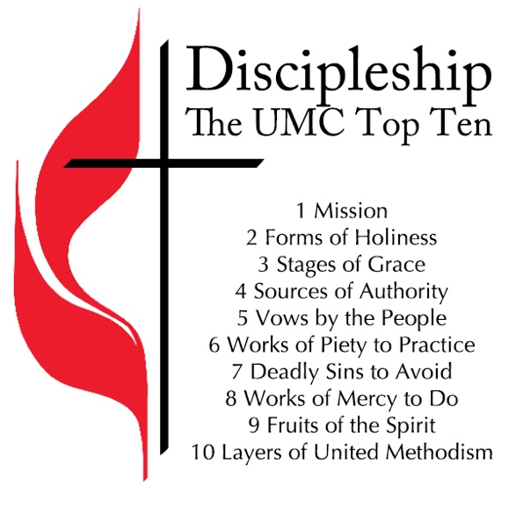
- www.umc.org

Anchor image/Visuals:
- Cross and flame. For a totally different take on the meaning on the UM cross and flame logo click here.
- UMC
- Above the ledge: DISCIPLESHIP
- Plants growing

Hands-on item: Photo card with Wesley quote(s). Ichthus sticker/tattoo. Hand sanitizer.

Music: Charles Wesley hymns and hymns written by UMC leaders. Related media: “Chuck Knows Church (John Wesley).” Length: 5:54.

Children’s Time:

General discussion points:
- Big questions: Why are you a United Methodist? Why Lake Harbor, not another church?
- There has been a trend to look at discipleship (whole package), not stewardship.
- Global Methodists follow the same tenets as United Methodists.
- Denominations based on John Wesley’s teaching: United Methodist Church, Wesleyan Church, Church of the Nazarene, African Methodist Episcopal Church, Pentecostals, and more.
- Is there a place in this series to explore the denomination’s history a bit?
- Disciple Bible – could we offer it again? There are shorter courses now. It is also online.
-------------------------------------------
August 20, 2023: “One Mission Together” – Pentecost 12
One Mission

Scripture: Matthew 28: 16-20 (NIV) “The Great Commission”
¹⁶ Then the eleven disciples went to Galilee, to the mountain where Jesus had told them to go. ¹⁷ When they saw him, they worshiped him; but some doubted. ¹⁸ Then Jesus came to them and said, “All authority in heaven and on earth has been given to me. ¹⁹ Therefore go and make disciples of all nations, baptizing them in the name of the Father and of the Son and of the Holy Spirit, ²⁰ and teaching them to obey everything I have commanded you. And surely I am with you always, to the very end of the age.”

Synopsis: All Christians share a common mission that Jesus gives after the resurrection -to make disciples. Discipleship is the ongoing process of learning and growing in faith, and it must be intentional. How are we living our Christ’s call to be disciples who make disciples?
Felt need: To claim/reclaim the Great Commission

Visuals: To make disciples of Jesus Christ for the transformation of the world. Stop light.
Hands-on item:
Activity:
Media possibilities:
- “The Commission.” Length: 1:06. Cost: Free with subscription. Web license. Yes. Based on Matthew 28: 18-20.
- “Chuck Knows Church: Episode 83 | Great Commission.” Length: 3:11.
Music: #2239 “Go Ye, Go Ye into the Word”
Children’s time:
Social media: #BeUMC videos
John Wesley quotes:
- The best thing of all is God is with us. (P. Mary)
- The church changes the world not by making converts, but by making disciples. (KWB)
Resources:
- https://www.umnews.org/en/news/united-methodist-mission-statement-revised
- https://www.umc.org/en/content/book-of-discipline-120-ff-section-1-the-churches

A Companion Litany to Our Covenant for the Worldwide United Methodist Church
Leader: In covenant with God and each other, we affirm our unity in Christ.
People: We will take faithful steps to live as a worldwide church in our mission to make disciples of Jesus Christ for the transformation of the world.
Leader: In covenant with God and each other, we commit ourselves to be in ministry with all people.
People: In faithfulness to the gospel, we will cross boundaries of language, culture, social or economic status as we grow in mutual love and trust.
Leader: In covenant with God and each other, we participate in God’s mission as partners in ministry.
People: We share our God-given gifts, experiences, and resources recognizing that they are of equal value, whether spiritual, financial, or missional.
Leader: In covenant with God and each other, we commit ourselves to full equality.
People: We uphold equity and accountability in our relationships, structures, and responsibilities for the denomination.
Leader: In covenant with God and each other, we enter afresh into a relationship of mutuality.
People: With God’s grace, we joyfully live out our worldwide connection in our mission to make disciples of Jesus Christ for the transformation of the world.
From The Book of Discipline of The United Methodist Church – 2016. Copyright 2016 by The United Methodist Publishing House. Used by permission.

Discussion points:
- The UM mission statement was developed in 2008.
- We seek to be ecumenical, i.e., we work with other denominations.
- What would Wesley say today? He did not intend to start a new denomination, but to revive the Anglican Church and reclaim the Great Commission. Resource: See page 2 and image, right.
- Connection church: Jimmy was able to secure housing for the kids while on their way to St. Louis through other UM churches.
- A yellow light indicates that we should be cautious and slow down. Red means “stop,” and green, “go.” If a stop light as a metaphor for making disciples, we should be thinking green, not yellow. Our group had some other ideas about stop lights: Yellow means speed up or watch out. Never be the first to go through a green light.
- “Go and make disciples” is in the form of a command, not a suggestion.
------------------------------------------------------
August 27, 2023: “Be Holy” - Pentecost 13
Two Forms of Holiness

Scripture: Matthew 5: 43-48 (NIV) “Love for Enemies”
⁴³ “You have heard that it was said, ‘Love your neighbor and hate your enemy.’ ⁴⁴ But I tell you, love your enemies and pray for those who persecute you, ⁴⁵ that you may be children of your Father in heaven. He causes his sun to rise on the evil and the good, and sends rain on the righteous and the unrighteous. ⁴⁶ If you love those who love you, what reward will you get? Are not even the tax collectors doing that? ⁴⁷ And if you greet only your own people, what are you doing more than others? Do not even pagans do that? ⁴⁸ Be perfect, therefore, as your heavenly Father is perfect.

Scripture: Romans 12: 1-2 (NIV) “A Living Sacrifice”
12 Therefore, I urge you, brothers and sisters, in view of God’s mercy, to offer your bodies as a living sacrifice, holy and pleasing to God—this is your true and proper worship. ² Do not conform to the pattern of this world, but be transformed by the renewing of your mind. Then you will be able to test and approve what God’s will is—his good, pleasing and perfect will.

Scripture: I Peter 1: 13-16 (NIV) “Be Holy”
¹³ Therefore, with minds that are alert and fully sober, set your hope on the grace to be brought to you when Jesus Christ is revealed at his coming. ¹⁴ As obedient children, do not conform to the evil desires you had when you lived in ignorance. ¹⁵ But just as he who called you is holy, so be holy in all you do; ¹⁶ for it is written: “Be holy, because I am holy.”

Synopsis: Holiness is what we seek as people who follow God in Christ. Though we hear the word closely connected to perfection, we hear the call to be holy as a constant encouragement to love God and love neighbor.
Felt need: To understand that our faith is both personal and social - loving God and loving neighbor

Visuals: Ichthus – it could be Niki’s car idea, below (opting in, not out).
Hands-on item: Ichthus stickers or tattoos. Hand sanitizer to signify that we try to purify ourselves (Annette)
Activity:
Media possibilities: “United Methodist Beliefs: Social Holiness.” Length: 1:54. Cost: Free. Web license: Yes. Rev. Susan Henry-Crowe, Board of Church and Society explains social holiness.
Music: #3149 “A Place at the Table”
Children’s time: Blessing of the Backpacks
Social media:
John Wesley quote: “Holy solitaries” is a phrase no more consistent with the Gospel than holy adulterers. The Gospel of Christ knows no religion but social; no holiness, but social holiness.” (KWB)
Resources: https://www.umcdiscipleship.org/blog/no-holiness-but-social-holiness

From Niki Epplett: It feels like believers and non-believers can get hung up on the idea of "being perfect" and that somehow being a believer we're all lumped into that category. I hold the same sentiment that Pastor Mary has said in a sermon, I also don't have an ichthus on my car anywhere for fear of messing up while driving and then being judged because I'm not "perfect" while having that symbol on my car.
So my idea is this. During the service, we have selected people, to use white thin window markers and go to each car in the parking lot and draw a 2-inch ichthus in the back corner of everyone's car window.
In Mary's message, she says something like, how will we Be Holy, to show Christ to people? To be brave while doing that etc., then let everyone know what is on their car. Now they have a decision. How will they be different? Will they remove it quickly? Will they keep it on there and be challenged in this way of displaying their faith?
(We can supply baby wipes or wipes we have, for people to remove it quickly if they would like.) Related video: “Chuck Knows Church (Sign of the Fish).” Length; 2:34.

Discussion points:
- Matthew 5: 48: Be perfect, therefore, as your heavenly Father is perfect. (NIV)
  - Other translations make it clearer that we should seek holiness, not perfection.
  - Wesley talked about Christian perfection, holiness, and sanctification interchangeably, and meant that we continue to grow in knowledge and love of God.
  - Growing in perfection vs. perfectionism
- Love God and love neighbor.
- Jean finds the quotes for September 10 and 17 particularly meaningful.
- “In essentials, unity; in non-essentials, liberty; in all things, charity,” is an aphorism variously attributed to St. Augustine of Hippo (354 – 430), John Wesley (1703 – 1791), and to a number of theologians in between them. Another possible source: Rupert Meldenius, an otherwise undistinguished German Lutheran theologian of the early seventeenth century. The phrase occurs in a tract on Christian unity written (circa 1627) during the Thirty Years War (1618–1648), a bloody time in European history in which religious tensions played a significant role.
- Reasons people cite for decreasing church attendance:
  - Members are hypocritical and judgmental.
  - General distrust of authority (church, business, government).
  - Karen Booth: If you have 25 minutes, it is worth listening to this UMC sponsored podcast, "Seven Reasons Why People Are Leaving Church":
    - Changing relationships
    - Teenage phase is a societal construct with implications for the church.
    - Prevent abuse through policies, training, and transparency.
    - Limited faith leaves people seeking answers on the internet.
    - Some churches’ slow embrace of technology (like bibles on phones).
    - Preaching the gospel of sin avoidance, rather than a gospel of grace.
    - Features (style of music, visuals, fancy coffee, type of space, etc.) over (authentic) worship experiences.
- Tribalism: We need to less afraid of interacting with those who are different. Listen without judging. Leave them with the impression that someone heard and validated them. We are more alike than different. The direct mission of “fishing for people” comes later and not necessarily through us. (Chris)
- People seek community. Church can provide that.
  - We know people who attend church who probably would not identify as Christian. They didn’t necessarily grow up with any expectation of ever going to church, et they still show love for God and neighbor by caring for the least of these.
  - How many of our youth come to youth group strictly for community? Do they find continue to find community in the church as they become young adults or do they find it elsewhere?
------------------------------------------------------
September 3: “Amazing Grace” - Pentecost 14
Labor Day weekend - One worship service at 10:00 a.m.
Three Stages of Grace

Scripture: John 1: 1-17 (NIV) “The Word Became Flesh”
1 In the beginning was the Word, and the Word was with God, and the Word was God. ² He was with God in the beginning. ³ Through him all things were made; without him nothing was made that has been made. ⁴ In him was life, and that life was the light of all mankind. ⁵ The light shines in the darkness, and the darkness has not overcome it.
⁶ There was a man sent from God whose name was John. ⁷ He came as a witness to testify concerning that light, so that through him all might believe. ⁸ He himself was not the light; he came only as a witness to the light.
⁹ The true light that gives light to everyone was coming into the world. ¹⁰ He was in the world, and though the world was made through him, the world did not recognize him. ¹¹ He came to that which was his own, but his own did not receive him. ¹² Yet to all who did receive him, to those who believed in his name, he gave the right to become children of God— ¹³ children born not of natural descent, nor of human decision or a husband’s will, but born of God.
¹⁴ The Word became flesh and made his dwelling among us. We have seen his glory, the glory of the one and only Son, who came from the Father, full of grace and truth.
¹⁵ (John testified concerning him. He cried out, saying, “This is the one I spoke about when I said, ‘He who comes after me has surpassed me because he was before me.’”) ¹⁶ Out of his fullness we have all received grace in place of grace already given. ¹⁷ For the law was given through Moses; grace and truth came through Jesus Christ. ¹⁸ No one has ever seen God, but the one and only Son, who is himself God and is in closest relationship with the Father, has made him known.

Scripture: Ephesians 2: 1-10 (NIV)
2 As for you, you were dead in your transgressions and sins, ² in which you used to live when you followed the ways of this world and of the ruler of the kingdom of the air, the spirit who is now at work in those who are disobedient. ³ All of us also lived among them at one time, gratifying the cravings of our flesh and following its desires and thoughts. Like the rest, we were by nature deserving of wrath. ⁴ But because of his great love for us, God, who is rich in mercy, ⁵ made us alive with Christ even when we were dead in transgressions—it is by grace you have been saved. ⁶ And God raised us up with Christ and seated us with him in the heavenly realms in Christ Jesus, ⁷ in order that in the coming ages he might show the incomparable riches of his grace, expressed in his kindness to us in Christ Jesus. ⁸ For it is by grace you have been saved, through faith—and this is not from yourselves, it is the gift of God— ⁹ not by works, so that no one can boast. ¹⁰ For we are God’s handiwork, created in Christ Jesus to do good works, which God prepared in advance for us to do.

Synopsis: God’s grace is a gift to us, and we experience God’s grace throughout our lives as a movement - working in us even before we understand it, bringing us to faith in Jesus, and continuing to guide us as we seek to follow Jesus every day.
Felt need: To be more aware of God’s grace in our lives - and tell the story of God’s grace leading us every day

Visuals: Explanation of prevenient, justifying, and sanctifying grace
Hands-on item:
Activity: Holy Communion. Could we use the sung Communion setting, #2257abcd?
Media possibilities:
- “Your Past Your Future – Grace.” Length: 2:31. Cost: $19.99. Web license: Yes. Sometimes we obsessively focus on the mistakes of our past. Jesus Christ paid the penalty for our sins. Salvation through grace gives us righteous standing before God. This video reminds us that God has declared us righteous and through his grace he is building in us a bright future. Comment: Might make a good closing video.
- “Grace.” Length: 3:09. Cost: Free with subscription. Web license: Yes. We all have messed up along the way, but God extends his grace to us all, no matter how much trouble we think we’re in. Comment: Clearly shows the moment that the boys received their father’s grace.
- “Chuck Knows Church: Episode 67 | Grace.” Length: 3:51.
Music: Amazing Grace, Love Divine, All Loves Excelling, In Christ Alone
Children’s time: Grace/gift boxes (Mark) – what would you put inside to symbolize grace? Paper hearts? Related scripture: 2 Cor. 8 (the grace of giving).
Social media:
John Wesley quote: I felt I did trust in Christ, Christ alone for salvation, and an assurance was given me that he had taken away my sins, even mine, and saved me from the law of sin and death. (P. Mary)
Resources: https://www.resourceumc.org/en/content/a-wesleyan-understanding-of-grace
The Methodists gathered in small groups of classes and bands to "watch over one another in love," to support one another in growing in grace by avoiding evil, doing good and practicing "means of grace." These means of grace are named in the General Rules:
- The public worship of God
Grace is not paid back; it is passed along.
- The ministry of the Word, either read or expounded
- The supper of the Lord
- Family and private prayer
- Searching the scriptures
- Fasting or abstinence
Additional resource: “What We Mean by ‘Means of Grace’” by Philip J. Brooks

Discussion points:
- Prevenient grace (a.k.a. “preventing” grace) is a distinctly Methodist belief and is the reason we practice infant baptism.
- Pastor Mary: Grace is not “fluffy love” stuff. It is the power of God working in you. You become a different person. It may be a quote from Will Willimon. Here is more from Willimon:
"I hear in much of Methodist parlance, grace is some sort of affirmative, positive approval by God of us as we are. I think that is a bad misunderstanding of Wesleyan grace," Willimon said… In the Wesleyan tradition, grace can be defined as the power of God working in you to give you a transformed life… Wesleyan grace is more than ‘you can be better,'" he said. "God's power can be better than your sins and limitations."
- It is more accurate to talk about the movement of grace, rather than stages. God is not finished with us yet.
- Sanctifying grace was a distinctive concept in Wesley’s time. It refers to Christian maturity.
- What do you think of when you hear the term “grace”? What did you feel the moment you realized you experienced it in a profound way? How did you feel afterwards? What about when you gave it to someone else?
  - Several of us have equated grace with forgiveness, rather than undeserved kindness or God’s unmerited favor.
  - The prodigal son’s father runs to greet him when he returns.
  - Pastor Mary’s mom was overwhelmed by the cards, texts, and prayers she received from people she didn’t even know. She felt very loved and supported in the middle of her health issues.
  - Grace is experienced in community.
  - Prayer, is one means of grace.
  - Receiving help in the midst of difficult times. Knowing that you can never repay their kindness, nor do you need to.
  - A few years ago, during Lent, Karen Post had received news of potential liver problems and was very upset. Jim encouraged her to go to church with him one evening. He had told a few friends about her news. After church, they had just gotten to Ross Park, when Karen felt the weight of the world lifted off of her. She knew she had people praying for her.
- Movie: “Dead Man Walking.” 1995. As death row inmate Matthew Poncelet (Sean Penn) nears his execution date, he calls upon Sister Helen Prejean (Susan Sarandon) to help him with one last appeal, maintaining that he is innocent of the murders of a young couple. Poncelet begins to form a bond with Prejean, and she visits both his family and the relatives of the victims, hoping to learn more about the case. As things begin to look bleak for Poncelet, Prejean does all that she can to comfort and console the hardened convict.
- On PBS, Sundays at 9:00 pm: “Grantchester.” Set in the 1960s. There’s no shortage of murder, mystery, and mayhem in the Cambridgeshire village of Grantchester — but Detective Geordie Keating and motorcycle riding vicar Will Davenport are always on the case. In Season 8, Will is happy, and Geordie and Cathy content in their relationship. But an accident and shocking announcements threaten the stability and happiness found by Grantchester’s vicar and police detective duo. Exploring faith, forgiveness, and redemption, this explosive season of Grantchester tests Will and Geordie to the limit. From season 8, episode 2: Will tells someone who killed another while riding a motorcycle, “God still loves you.” This is a great example of grace.
- Quote: Grace for all. Grace in all.
------------------------------------------------------
September 10, 2023: “For the Bible Tells Me So” - Pentecost 15
Four Sources of Authority
God-breathed means “inspired”

Scripture: II Timothy 3: 14-17 (NIV)
¹⁴ But as for you, continue in what you have learned and have become convinced of, because you know those from whom you learned it, ¹⁵ and how from infancy you have known the Holy Scriptures, which are able to make you wise for salvation through faith in Christ Jesus. ¹⁶ All Scripture is God-breathed and is useful for teaching, rebuking, correcting and training in righteousness, ¹⁷ so that the servant of God may be thoroughly equipped for every good work.

Scripture: Hebrews 4: 12-13 (NIV)
¹² For the word of God is alive and active. Sharper than any double-edged sword, it
penetrates even to dividing soul and spirit, joints and marrow; it judges the thoughts and attitudes of the heart. ¹³ Nothing in all creation is hidden from God’s sight. Everything is uncovered and laid bare before the eyes of him to whom we must give account.

Synopsis: Our faith journey begins with Scripture, but we also bring ourselves to the reading and understanding of Scripture, including our reasoning and experience and the traditions of the church over the ages. How do we understand Scripture as a story of faith that guides us today?
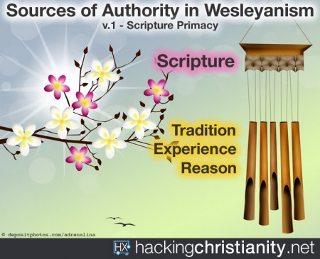
Felt need: To remember that Scripture is the foundation of our faith - and it’s informed by reason, tradition, and experience

Visuals: wind chime as an illustration of Wesleyan quadrilateral
Hands-on item:
Activity:
Media possibilities: “Chuck Knows Church: Episode 81 | Wesleyan Quadrilateral.” Length: 5:14.
Music: Jesus Loves Me
Children’s time: Bible Sunday (?), Commissioning of Christian Education leaders
Social media:
John Wesley quote:
- Think and let think. (Pastor Mary)
- Condemn no man for not thinking as you think. Let every one enjoy the full and free liberty of thinking for himself. Let every man use his own judgment, since every man must give an account of himself to God. Abhor every approach, in any kind or degree, to the spirit of persecution, if you cannot reason nor persuade a man into the truth, never attempt to force a man into it. If love will not compel him to come, leave him to God, the judge of all. (Pastor Mary)
- People who wish to be offended will always find some occasion for taking offense. (KWB)
Resources:
- https://www.umc.org/en/content/theological-guidelines
- https://hackingchristianity.net/2016/07/chiming-in-on-the-wesleyan-quadrilateral.html
- https://www.umc.org/en/who-we-are/what-we-believe/our-social-positions
- https://www.umc.org/en/content/glossary-wesleyan-quadrilateral-the

Discussion points:
- The Wesleyan Quadrilateral – a term first coined by Albert Outler – is distinctively Methodist. We looked at during our series on Half Truths.
- A fifth component of the quadrilateral (which would make it a pentagon), is talking to each other. (Chris)
- Wesley was a thinking person which explains why “reason” was important. It also explains why he promoted free public education and small group learning.
- Experience is significant. Vocations, careers, families, trauma, etc. all impact us.
- Question to pastors: Do you preach the bible? Response: Yes. Related question to church goers: Do you go to a bible believing church? Response: Yes. These questions make us wonder if they are asking about something else (a literal reading of the bible; its inerrancy; our own political views). We believe that the Bible:
  - Is the inspired word of God and is still living and active.
  - Is a story of faith through the ages that informs our faith today. You must look at the context in which it was written before understanding how it applies today. Kim Bos’ July 23 message on not committing adultery is a good example of a careful reading.
  - It is not a science book.
  - Is not meant to be read literally. It is not inerrant. There are contradictions.
  - Is a book of grace, faith, and covenant (Jim).
- The Bible has become an idol for some people.
- Paul came from a very conservative tradition. Mary Oakes, a member of Central UMC in Muskegon, encouraged him to read the bible less literally, something he found very freeing.
------------------------------------------------------
September 17, 2023: “Promises to God and Each Other” - Pentecost 16
Five Vows of the People

Scripture: Mark 1: 14-20

“Jesus Announces the Good News”
¹⁴ After John was put in prison, Jesus went into Galilee, proclaiming the good news of God. ¹⁵ “The time has come,” he said. “The kingdom of God has come near. Repent and believe the good news!”

“Jesus Calls His First Disciples”
¹⁶ As Jesus walked beside the Sea of Galilee, he saw Simon and his brother Andrew casting a net into the lake, for they were fishermen. ¹⁷ “Come, follow me,” Jesus said, “and I will send you out to fish for people.” ¹⁸ At once they left their nets and followed him.
¹⁹ When he had gone a little farther, he saw James son of Zebedee and his brother John in a boat, preparing their nets. ²⁰ Without delay he called them, and they left their father Zebedee in the boat with the hired men and followed him.

Scripture: Luke 9: 18-20 “Peter Declares that Jesus Is the Messiah”
¹⁸ Once when Jesus was praying in private and his disciples were with him, he asked them, “Who do the crowds say I am?”
¹⁹ They replied, “Some say John the Baptist; others say Elijah; and still others, that one of the prophets of long ago has come back to life.”
²⁰ “But what about you?” he asked. “Who do you say I am?”
Peter answered, “God’s Messiah.”

Scripture: Acts 2: 42-47 We might not use this reading until next week
“The Fellowship of the Believers”
⁴² They devoted themselves to the apostles’ teaching and to fellowship, to the breaking of bread and to prayer. ⁴³ Everyone was filled with awe at the many wonders and signs performed by the apostles. ⁴⁴ All the believers were together and had everything in common. ⁴⁵ They sold property and possessions to give to anyone who had need. ⁴⁶ Every day they continued to meet together in the temple courts. They broke bread in their homes and ate together with glad and sincere hearts, ⁴⁷ praising God and enjoying the favor of all the people. And the Lord added to their number daily those who were being saved.

Synopsis: We make promises to important people and about important aspects of our lives. In the church, we take membership vows as a way to profess our faith in Christ and be accountable to others in the Body of Christ. Committing our prayers, presence, gifts, service, and witness to the church is a touchpoint of our relationship to God and each other.
Felt need: To commit/recommit ourselves to Christ and the Body of Christ

Visuals:
Hands-on item:
Activity: Use Apostles’ Creed
Media possibilities:
Music: I Have Decided to Follow Jesus
Children’s time:
Social media:
John Wesley quote: Though we cannot think alike, may we not love alike? May we not be of one heart, though we are not of one opinion? Without all doubt, we may. Herein all the children of God may unite, notwithstanding these smaller differences. Money never stays with me. It would burn me if it did. I throw it out of my hands as soon as possible, lest it should find its way into my heart.
Resources: https://www.umc.org/en/content/our-united-methodist-vows
From Niki Epplett:
Felt Need: Let's talk about what it means in today's world to "fish." What does that look like? Sitting at a small table over coffee and conversation? Or sitting at the bar with a glass of wine? Or in the library with books? In line at the grocery store checkout aisle? (So many visuals are available to use for any of these examples.)
Visuals: Anything from above. Fishing poles/nets/gear
Hand out items: Fish Crackers, Swedish Fish

Related discussion: Our God moments are a powerful form of witness. What would we say to others when asked why our faith is important (our elevator pitch)? It must be personal.
- Karen Booth: Community – no matter what happens to me or my family, I know my church friends will be there for me.
- Positive Christian FaceBook posts matter. Jim Post is good at this.
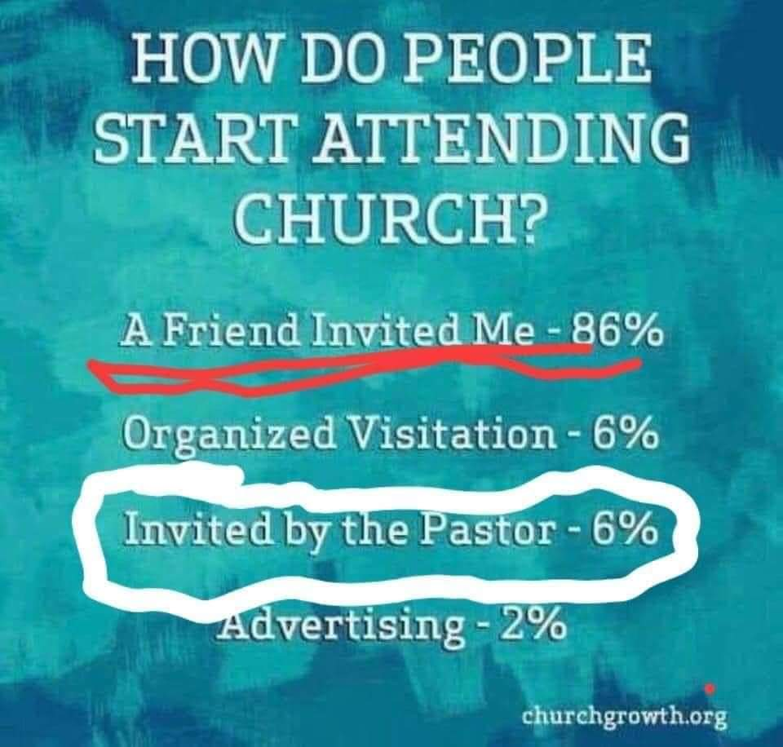
- Always be prepared to give an answer to everyone who asks you to give the reason for the hope that you have. But do this with gentleness and respect. 1 Peter 3: 15

Discussion points:
- Pastor Mary found this graphic about how people start attending church interesting. On a related note, Marie tells people, “there is always a seat beside me.”
- Membership vows are made to God and church community. Vows are meant to be kept. We are accountable to both.
- Apathy:
  - Involvement vs. membership: Far more people are willing to come to church, than become members today than thirty years ago. If you are not a member, do you feel freer to say “no” to doings things or helping out.
  - It is hard to get people to commit in other organizations too. Examples: Lions Club, Rotary.
  - Relationships: Living together vs. getting married.
- Presence: In-person vs. online
  - Being told, “There is probably someone who is counting on me to be here in church,” is very powerful and true. (Pastor Mary)
  - There is a special feeling when you are physically present with others. (Many)
  - It is very easy to be distracted while online. (Many)
- Jean was confirmed in the Methodist Church in eighth grade. She was expected to give, attend youth group, and volunteer at church and in community activities alongside adults – all important to her faith formation.
- We appreciate youth serving in the control booth. Pastor Mary appreciates that she has kids who choose to be confirmed rather parents making them.
- Jean noted that just 35% of high schoolers now have a summer job, compared to 50% just a few years ago. Some high schools require community service before graduation.
------------------------------------------------------
September 24, 2023: “Stay in Love with God” - Pentecost 17
Six Works of Piety

Scripture: Acts 2: 42-47 “The Fellowship of the Believers”
⁴² They devoted themselves to the apostles’ teaching and to fellowship, to the breaking of bread and to prayer. ⁴³ Everyone was filled with awe at the many wonders and signs performed by the apostles. ⁴⁴ All the believers were together and had everything in common. ⁴⁵ They sold property and possessions to give to anyone who had need. ⁴⁶ Every day they continued to meet together in the temple courts. They broke bread in their homes and ate together with glad and sincere hearts, ⁴⁷ praising God and enjoying the favor of all the people. And the Lord added to their number daily those who were being saved.

Synopsis: In order to attend upon all the ordinances of God, or stay in love with God, we have to be intentional about attending to our spiritual lives. A relationship with God is nurtured through time spent with God and others.
Felt need: To be intentional about our personal relationship with God

Visuals: Slide with list - Prayer, Scripture study, Holy Communion, fasting, Christian community, healthy living
Hands-on item:
Activity:
Media possibilities: “The Book of Acts: An Introduction.” Length: 3:51. Cost: $19.98. Web license: Probably not. The book of Acts details the birth and spread of the church. Comments: It might work for August 20, one mission. A lot going on – maybe too much to understand why we are using it.
Music: #618 “Let Us Break Bread Together”
Children’s time:
Social media:
John Wesley quote: Catch on fire and people will come for miles to see you burn.
Resources: Wesley’s Primitive Physic: An Easy and Natural Method of Curing Most Diseases. The customer reviews offer insight to the book’s contents and historical significance. Comments: It is interesting to see how Wesley connected healthy living to his faith.
Discussion points:
- The works of piety cultivate personal holiness and are signs of a passionate faith.
- Annette: How do we spend our time? How much is devoted to intentional faith development? Make a list of all the things we do each day. Create a pie or circle graph to visualize how we spend our time. What could we give up so that we have more time for intentional faith development?
- Staying in love with God requires community
--------------------------------------------------------------
October 1, 2023: “Do No Harm” – Pentecost 18
Seven Deadly Sins to Avoid

Scripture: Romans 3: 19-24
¹⁹ Now we know that whatever the law says, it says to those who are under the law, so that every mouth may be silenced and the whole world held accountable to God. ²⁰ Therefore no one will be declared righteous in God’s sight by the works of the law; rather, through the law we become conscious of our sin.

“Righteousness Through Faith”
²¹ But now apart from the law the righteousness of God has been made known, to which the Law and the Prophets testify. ²² This righteousness is given through faith in Jesus Christ to all who believe. There is no difference between Jew and Gentile, ²³ for all have sinned and fall short of the glory of God, ²⁴ and all are justified freely by his grace through the redemption that came by Christ Jesus.

Synopsis: Though it’s easy to look at the sins of others, sin is pervasive and very much alive in us, too. In order to do no harm, we have to be honest about our struggle with sin and seek to fight its power in our lives.
Felt need: To understand the power of sin in our lives

Visuals: Slide with list – pride (humility), envy (kindness), anger/wrath (forgiveness), sloth/apathy (diligence), greed (generosity), gluttony (moderation), lust (purity)
Hands-on item:
Activity: Holy Communion, CROP Walk
Media possibilities:
- “Clean the Cup.” Length: 2:45. Cost: $15.00. Web license: Probably not. Are you more concerned about what people think, or what God thinks?
- “Consuming Fire.” Length: 3:05. Cost: $20.00. Web license: Yes. What would it look like to use fire to represent the blood of Christ cleansing of sin? Comments: Using media that includes addiction as a sin is not helpful.
Music:
Children’s time:
Social media:
John Wesley quotes:
- We should be rigorous in judging ourselves and gracious in judging others.
- Vice does not lose its character by becoming fashionable.
- I the chief of sinners am, but Jesus died for me.
Resources: Summer 2015 worship series – “Sinning Like a Christian” We included short vignettes/monologues to illustrate the “sin of the week.”
Discussion points:
- Understanding the power of sin and reason to avoid it.
- Medical students take some version of the Hippocratic oath upon graduation from medical school. It typically includes, “First, do no harm” – or at least it used to. The oath has changed over time.
- Pointing out sin: When you point one finger at a person, three point back to you (Annette).
------------------------------------------------------
October 8, 2023: “Do Good” - Pentecost 19
Eight Works of Mercy To Do

Scripture: Matthew 25: 34-40
³⁴ “Then the King will say to those on his right, ‘Come, you who are blessed by my Father; take your inheritance, the kingdom prepared for you since the creation of the world. ³⁵ For I was hungry and you gave me something to eat, I was thirsty and you gave me something to drink, I was a stranger and you invited me in, ³⁶ I needed clothes and you clothed me, I was sick and you looked after me, I was in prison and you came to visit me.’
³⁷ “Then the righteous will answer him, ‘Lord, when did we see you hungry and feed you, or thirsty and give you something to drink? ³⁸ When did we see you a stranger and invite you in, or needing clothes and clothe you? ³⁹ When did we see you sick or in prison and go to visit you?’
⁴⁰ “The King will reply, ‘Truly I tell you, whatever you did for one of the least of these brothers and sisters of mine, you did for me.’

Scripture: Romans 12: 9-21 “Love in Action”
⁹ Love must be sincere. Hate what is evil; cling to what is good. ¹⁰ Be devoted to one another in love. Honor one another above yourselves. ¹¹ Never be lacking in zeal, but keep your spiritual fervor, serving the Lord. ¹² Be joyful in hope, patient in affliction, faithful in prayer. ¹³ Share with the Lord’s people who are in need. Practice hospitality.
¹⁴ Bless those who persecute you; bless and do not curse. ¹⁵ Rejoice with those who rejoice; mourn with those who mourn. ¹⁶ Live in harmony with one another. Do not be proud, but be willing to associate with people of low position. Do not be conceited.
¹⁷ Do not repay anyone evil for evil. Be careful to do what is right in the eyes of everyone. ¹⁸ If it is possible, as far as it depends on you, live at peace with everyone. ¹⁹ Do not take revenge, my dear friends, but leave room for God’s wrath, for it is written: “It is mine to avenge; I will repay,” says the Lord. ²⁰ On the contrary:
“If your enemy is hungry, feed him;
if he is thirsty, give him something to drink.
In doing this, you will heap burning coals on his head.”
²¹ Do not be overcome by evil, but overcome evil with good.

Synopsis: To do good is more than simply being good. It requires us to pay attention to the needs around us and reach out to people who are hurting - physically, emotionally, and spiritually - and work for the Kingdom of God here and now.
Felt need: To be intentional about doing good in God’s name

Visuals: Slide with list -

- Doing good works
- Visiting the sick
- Visiting those in prison
- Feeding the hungry
- Giving generously to the needs of others
- Seeking justice
- Ending oppression and discrimination
- Addressing the needs of the poor

Hands-on item: Photo card with Wesley’s quote, “Do all the good you can, by…”
Activity:
Media possibilities:
Music: #434 “Cuando El Pobre (When the Poor Ones); #2176 “Make Me a Servant”
Children’s time:
Social media:
John Wesley quotes:
- Do all the good you can, by all the means you can, in all the ways you can, in all the places you can, at all the times you can, to all the people you can, as long as ever you can.
- Do you not know that God entrusted you with that money (all above what buys necessities for your families) to feed the hungry, to clothe the naked, to help the stranger, the widow, the fatherless; and, indeed, as far as it will go, to relieve the wants of all mankind? How can you, how dare you, defraud the Lord, by applying it to any other purpose?
Resources:
Discussion points:
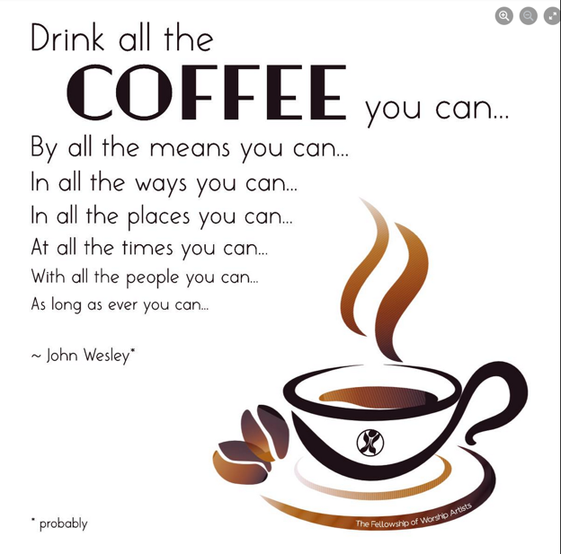
- The focus is on doing good, not being good. God extends his grace to us. We are called to be intentional in doing good acts in God’s name and bring his Kingdom on earth now.
- We may use just one reading.
- Meme, right, is related to Wesley’s quote.
- Pastor Mary attended Philip Chapel AME this past week. The pastor preached on Matthew 25. She noted that they also read the Ten Commandments together each Sunday in worship.
- Pastor Mary may invited a local mission to share during worship.
------------------------------------------------------
October 15, 2023: “Bearing Good Fruit” - Pentecost 20
Nine Fruit of the Spirit

Scripture: Galatians 5: 13-26 (ref. to John 15) “Life by the Spirit”
¹³ You, my brothers and sisters, were called to be free. But do not use your freedom to indulge the flesh; rather, serve one another humbly in love. ¹⁴ For the entire law is fulfilled in keeping this one command: “Love your neighbor as yourself.” ¹⁵ If you bite and devour each other, watch out or you will be destroyed by each other.
¹⁶ So I say, walk by the Spirit, and you will not gratify the desires of the flesh. ¹⁷ For the flesh desires what is contrary to the Spirit, and the Spirit what is contrary to the flesh. They are in conflict with each other, so that you are not to do whatever you want. ¹⁸ But if you are led by the Spirit, you are not under the law.
¹⁹ The acts of the flesh are obvious: sexual immorality, impurity and debauchery; ²⁰ idolatry and witchcraft; hatred, discord, jealousy, fits of rage, selfish ambition, dissensions, factions ²¹ and envy; drunkenness, orgies, and the like. I warn you, as I did before, that those who live like this will not inherit the kingdom of God.
²² But the fruit of the Spirit is love, joy, peace, forbearance (patience), kindness, goodness, faithfulness, ²³ gentleness and self-control. Against such things there is no law. ²⁴ Those who belong to Christ Jesus have crucified the flesh with its passions and desires. ²⁵ Since we live by the Spirit, let us keep in step with the Spirit. ²⁶ Let us not become conceited, provoking and envying each other.

Synopsis: Freedom in Christ isn’t license to do whatever we want, but a call to love and serve one another. Our faith shows (or doesn’t show) in the fruit we bear and is a witness to others of the faith we claim.
Felt need: To live out the fruit of the Spirit

Visuals:
Hands-on item:
Activity:
Media possibilities:
- “The Fruit of the Spirit.” Length: 1:15. Cost: Free with subscription. Web license: Yes.
- “Fruit of the Spirit Intro.” Length: 0:51. Cost: $14.95. Web license: No.
Music:
Children’s time: The fruit basket mix up game (ask Annette Erbes for details)
Social media:
John Wesley quote:
Resources:
- Summer 2021 series – “Empowered: Fruit of the Spirit”
- Feb. 9, 2020 message “Growing Fruit of the Spirit” based on “A Beautiful Day in the Neighborhood”
Discussion points:
- The fruit we bear matters.
- “In essentials, unity; in non-essentials, liberty; in all things, charity.” (repeated from page 7).
------------------------------------------------------
October 22, 2023: “Deep and Wide” - Pentecost 21
Ten Layers of United Methodism (7 rings and 3 branches)

Scripture: Romans 12: 3-8 “Humble Service in the Body of Christ”
³ For by the grace given me I say to every one of you: Do not think of yourself more highly than you ought, but rather think of yourself with sober judgment, in accordance with the faith God has distributed to each of you. ⁴ For just as each of us has one body with many members, and these members do not all have the same function, ⁵ so in Christ we, though many, form one body, and each member belongs to all the others. ⁶ We have different gifts, according to the grace given to each of us. If your gift is prophesying, then prophesy in accordance with your faith; ⁷ if it is serving, then serve; if it is teaching, then teach; ⁸ if it is to encourage, then give encouragement; if it is giving, then give generously; if it is to lead, do it diligently; if it is to show mercy, do it cheerfully.

Synopsis: “The United Methodist Church structure is like a pebble dropped in still water with concentric rings embracing more and more churches and people.” There’s no place where Jesus isn’t needed, and God’s love knows no bounds. The connection is a vital part of our identity, including other local churches and educational and healthcare institutions.
Felt need: To recognize and celebrate the connections we have as a global church

Visuals: Church structure
- Local Church (Charge Conference)
- City/Town/Cluster (common context)
- Community network (District). Related media: “Chuck Knows Church (DS).” Length: 3:43.
- Regional network (Annual Conference)
- Multi-state network (Jurisdictional Conference) or multi-country network (Central Conference)
- Affiliation networks
- Global network (collaborations across official and unofficial lines, such as educational networks and many global initiatives by the General Agencies/Commissions)

PLUS our global connection has three branches, like the US Government:
- General Conference serves as the Legislative Branch, creating doctrine and polity every four years.
- The Bishops and General Agencies/Commissions serve as the executive branch, putting into action the will of General Conference. Related media: “Chuck Knows Church (Bishops).” Length: 4:07.
- The Judicial Council serves as the judicial branch, ensuring the constitutionality of General Conference’s doctrines and general church decisions.
Hands-on item:
Activity:
Media possibilities: “Clayride: A Gallop through United Methodist Church.” Length: 4:18 (can be trimmed to 4:00). Cost: Free. Web license: yes.
Music: #2236 “Gather Us In”
Children’s time:
Social media:
John Wesley quote: I look upon the whole world as my parish.
Resources: https://www.umc.org/en/who-we-are/structure
Discussion points:
- In a connectional church:
  - Pastors are appointed, so you are never without one. You also have help if the pastor/ congregation fit doesn’t work out.
  - Mission trip participants have been able to stay at other UM churches.
  - Wesley Foundation, camp, institutions of higher education
  - Hospitals (Bronson in Kalamazoo)
- In congregational churches, the pastors are called (hired). They may have a consistory as their governing body, which is less transparent and more powerful than our Administration Board/Council.
- Relationships with other local churches: We have other local UM churches that we work with. How churches work together varies from community to community, especially if there is a liberal/conservative divide. Note from Karen: This is probably not the best way to describe the issue, but it is all I could come up with while writing.
- Disaffiliation: It has been difficult navigating this, especially when the pastor and congregation are not on the same page.
- There are still lots of questions about how the Global Methodist Church will be structured. Will it participate in some UM missions like UMCOR?
- Blessings of a connectional system:
  - Churches are assigned a pastor so you are never without.
  - Laity – the local church is the church because of its members. It is not/should not be all pastor led. Laity are very involved.
  - UMCOR
  - Ad Board vs. a Consistory (see p. 22, above)
  - It is a democratic system, with three branches.
  - We have a “big tent” – there is room for individuality.
  - There are resources from the district – VCI, committee training, help with a merger, conflict resolution, etc.
  - Accountability – clergy, finances
- Sin: Is our focus on sin or grace?
------------------------------------------------------
October 29, 2023: “A Faith Commitment” - Pentecost 22, All Saints Day

Scripture: Psalm 34 (MSG) - use recording from 2018 or make a new recording?
34 I bless God every chance I get;
my lungs expand with his praise.
² I live and breathe God;
if things aren’t going well, hear this and be happy:
³ Join me in spreading the news;
together let’s get the word out.
⁴ God met me more than halfway,
he freed me from my anxious fears.
⁵ Look at him; give him your warmest smile.
Never hide your feelings from him.
⁶ When I was desperate, I called out,
and God got me out of a tight spot.
⁷ God’s angel sets up a circle
of protection around us while we pray.
⁸ Open your mouth and taste, open your eyes and see—how good God is.
Blessed are you who run to him.
⁹ Worship God if you want the best;
worship opens doors to all his goodness.
¹⁰ Young lions on the prowl get hungry,
but God-seekers are full of God.
¹¹ Come, children, listen closely;
I’ll give you a lesson in God worship.
¹² Who out there has a lust for life?
Can’t wait each day to come upon beauty?
¹³ Guard your tongue from profanity,
and no more lying through your teeth.
¹⁴ Turn your back on sin; do something good.
Embrace peace—don’t let it get away!
¹⁵ God keeps an eye on his friends,
his ears pick up every moan and groan.
¹⁶ God won’t put up with rebels;
he’ll cull them from the pack.
¹⁷ Is anyone crying for help? God is listening,
ready to rescue you.
¹⁸ If your heart is broken, you’ll find God right there;
if you’re kicked in the gut, he’ll help you catch your breath.
¹⁹ Disciples so often get into trouble;
still, God is there every time.
²⁰ He’s your bodyguard, shielding every bone;
not even a finger gets broken.
²¹ The wicked commit slow suicide;
they waste their lives hating the good.
²² God pays for each slave’s freedom;
no one who runs to him loses out.

Scripture: I John 3: 1-3 (NIV)
3 See what great love the Father has lavished on us, that we should be called children of God! And that is what we are! The reason the world does not know us is that it did not know him. ² Dear friends, now we are children of God, and what we will be has not yet been made known. But we know that when Christ appears, we shall be like him, for we shall see him as he is. ³ All who have this hope in him purify themselves, just as he is pure.

Synopsis: Discipleship is our intentional commitment to Christ, and it shows in how we live. We celebrate those who have lived their faith and now rest in God’s perfect peace, as we commit to living out our faith within a community.
Felt need: To remember the faith of the saints and make a faith commitment for 2024

Visuals:
Hands-on item:
Activity: Remembering the saints
Media possibilities: “Generosity.” Length: 1:40. Cost: $19.99. Web license: Yes. This mini-movie reminds us of how Christ calls us to bless others with what we have been given.
Music: Hello, My Name Is
Children’s time:
Social media:
John Wesley quote: The best thing of all is God is with us.
Resources:
Discussion points:

