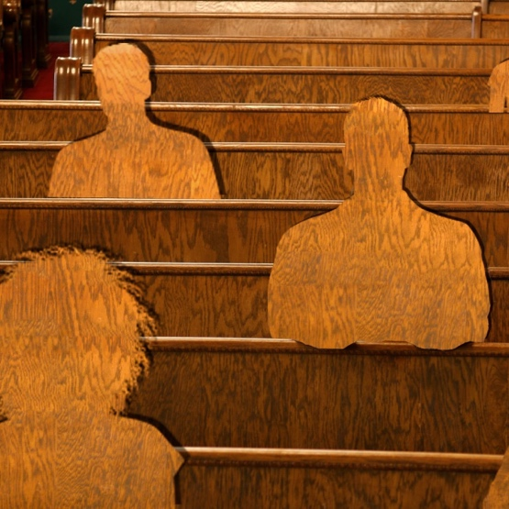
Why Middle-Aged Americans Aren’t Going Back to Church
Clare Ansberry, Aug. 1, 2021, Wall Street Journal

Church attendance for Gen Xers has dropped off more dramatically than other age groups.
Americans in their 40s and 50s often identify with a religion, but they’re also in the thick of raising kids, caring for aging parents and juggling demanding jobs that spill into the weekend. During the pandemic, many got out of the habit of going regularly to religious services and didn’t resume. Some had been drifting away before or became disillusioned by church scandals or positions on social issues in recent years.
The percentage of people ages 39 to 57 who attended a worship service during the week, either in person or online, fell to 28% in 2023, down from 41% in 2020, according to a survey this year. This was the largest percentage-point drop of all age groups examined in the survey of 2,000 adults conducted by the Cultural Research Center at Arizona Christian University.
Marlon Eddins, 45 years old, who lives in Memphis, Tenn., and works in the automotive industry, attends church about half as often as he did before the pandemic. “I got into the habit of not going,” says the father of a 25- and 19-year-old. “I go to church, but not as often as I probably should.”
He and his family changed churches and now attend a nondenominational church, rather than the Baptist church of his youth. “There’s a different vibe and a culture shift,” he says, adding that he retains his core Baptist beliefs. “When you got faith, you got faith. I just don’t think going every Sunday makes you who you are.”
The percentage of Gen Xers who worship weekly is now as low as millennials, according to the Cultural Research Center survey. Baby boomers and people ages 77 and older had the highest attendance rates, at 38% and 53% respectively.
“No generation endured greater spiritual turbulence than Gen X during the pandemic,” says George Barna, director of research at the Cultural Research Center, which also found drops in other religious practices and beliefs among Gen Xers.
Church attendance levels have been declining for decades across generations, with less than half of U.S. adults belonging to houses of worship in 2020, compared with 70% in 1999, according to Gallup.
The drop-off for those in their 40s and 50s has been building, says Josh Packard, a 45-year-old sociologist of religion, who has researched changing forms of religious expression. Parents often attend church or temples to get their kids through certain religious milestones, including confirmation and bat mitzvahs, Packard says. “Then, after that, it starts to wane more every year,” he says.
Trisha Taylor, 59, an ordained minister and church consultant in Houston, said people in their 40s and 50s often grew up in one church and never questioned going until the pandemic, which gave them time to examine their beliefs and practices. Some are disenchanted by polarization within churches and positions over many issues, including gay rights, which may affect their children.
John Newman, 41, no longer attends or donates to church, but will still respond “Catholic” on a survey and supports Catholic schools and their sports programs. Newman, who went to Catholic schools, stopped going to church in his 30s, when he says that a new priest marginalized people who were gay, living out of wedlock or divorced.
“I’m not interested in hearing those sermons,” says Newman, who lives in the Chicago area.
Some people who study religion liken the drop-off in attendance and involvement to the workplace phenomenon called quiet quitting.
While average attendance, including online, has rebounded from the pandemic in many congregations, deeper participation is still lagging, says David Brubaker, a professor at Eastern Mennonite University and organizational consultant. Volunteering fell to about 20% of church membership in March 2022 from about 40% in early 2020, according to the Hartford Institute for Religion Research.
“Congregants may show up on a Saturday or Sunday but are less apt to jump in and help,” he says, adding that members will stay and engage if they find meaning and connection.
People remain on membership rolls, but stop volunteering, says Packard. In many cases, they continue making donations until their credit card expires. If asked, they continue to describe themselves as Protestant, Jewish or another denomination.
“It’s not like they are walking away, saying, ‘I’m now an atheist and don’t believe,’” he says. “They still believe in a God and live life with purpose but are done with the institutional church.”
Ginger Harris, 51, a nonprofit executive and former Southern Baptist missionary, stopped attending her Southern Baptist church over changes including restrictions on women ministers. She’s not sure she would have been able to leave a church, where she was actively involved, hosting Bible study groups in her home, at a younger age.
“I was at a place of maturity and was able to let go of that rigidness,” says Harris, who now attends weekly Zoom services from an Episcopal church and gatherings in the home of a local progressive Baptist pastor.
Many Gen Xers say going to church remains a priority. Jeannetta McElroy, 44, attends services regularly at a nondenominational church in Chicago. “It’s like my family,” says McElroy, whose two sons, 24 and 17, often join her.
McElroy returned to in-person services in January and before then had been participating online. She feels it’s important to be there in person, but she has noticed some friends her age going less often. “Their lives are just busy with jobs and kids,” says McElroy.
Nicole Nuehring, 44, of Utah, sees many Latter-day Saint friends stepping away, which she attributes to disillusionment over scandals that they read about on social media and time away from church services during the pandemic to question why they were going in the first place. “It was easier to quiet-quit,” says Nuehring, who doesn’t attend church and didn’t as a child.
Many of her peers are exhausted from hectic work and family lives, she says. While older generations also went through demanding stages of life, they remained more involved in their churches.
“Church was an anchor, where it’s not anymore,” she says.
Write to Clare Ansberry at clare.ansberry@wsj.com
Copyright ©2023 Dow Jones & Company, Inc. All Rights Reserved. 87990cbe856818d5eddac44c7b1cdeb8

