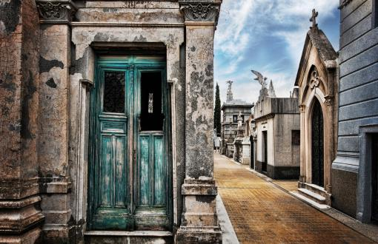
Moving Out of Scare City

Do not worry about anything, but in everything by prayer and supplication with thanksgiving let your requests be made known to God. And the peace of God, which surpasses all understanding, will guard your hearts and your minds. — Philippians 4: 6-7

The sense that there is not enough drives greed, fear, and exclusionary behavior. We begin to live in “Scare City” where it seems that death, starvation, feelings of being overwhelmed and swallowed up can lurk around every corner. The Good News is that this is an illusion. A spiritual journey into the truth of abundance of all that we need offers us an alternative vision of where to live our lives. This series will have us “Moving Out of Scare City” and traveling to the vast, open habitats of God’s grace.

Week One — Towers of Power

Then they said, “Come, let’s build ourselves a city and a tower that reaches Heaven. Let’s make ourselves famous so we won’t be scattered here and there across the Earth.” God came down to look over the city and the tower those people had built. God took one look and said, “One people, one language; why, this is only a first step. No tellling what they’ll come up with next — they’ll stop at nothing…” — Genesis 11: 1-9

More, more, more! Like skyscrapers that begin to loom over us casting a shadow below, our quest for “more” power, prestige, wealth, and domination have created a culture of oppressive “not enough-ness.” We are overwhelmed, overworked, and overstressed. Our perspective of how much we actually have is skewed by the immensity of images of what we “ought to have.” In this first week of our series, we begin to confront the myth of scarcity and focus on abundance.

Week Two — Around Every Corner

“Don’t fear, because I am with you;
don’t be afraid, for I am your God.
I will strengthen you, I will surely help you;
I will hold you with my righteous strong hand.”
— Isaiah 41:10

We are often surrounded by messages that encourage feelings of scarcity and fear. What “makes news” heaps images and stories of what might happen to us. Like walking down dark, winding and narrow alleyways in Scare City, we can move through our lives in fear of what might be lurking around every corner. This week we discover what trust in the presence of God can do to shift our fear to curiosity and assurance that we are never alone.

Week Three — The Other Side of the Tracks

God, who knows people’s deepest thoughts and desires, confirmed this by giving them the Holy Spirit, just as he did to us. He made no distinction between us and them, but purified their deepest thoughts and desires through faith. — Acts 15 :8-9

In Scare City, people are divided in fear of the “other.” This makes us over-protective fence-builders and hoarders. Is this any place to live? Rather than offering safety and freedom, we find ourselves trapped. The walls we build to protect become our own prisons. This week we will discover the abundance that comes when we draw the circle wide.

Week Four — Altars Everywhere

Tell them to do good, to be rich in the good things they do, to be generous, and to share with others. When they do these things, they will save a treasure for themselves that is a good foundation for the future. That way they can take hold of what is truly life. — 1 Timothy 6: 18-19

The irony in Moving Out of Scare City is that we don’t have to pack up and go anywhere. Rather, we are called to transform the places within and around us with the evidence of God’s love and grace. We are called to build “altars everywhere” to show forth the gifts of abundance to a hungry world. How can we offer radical generosity to transform the places where we are?

