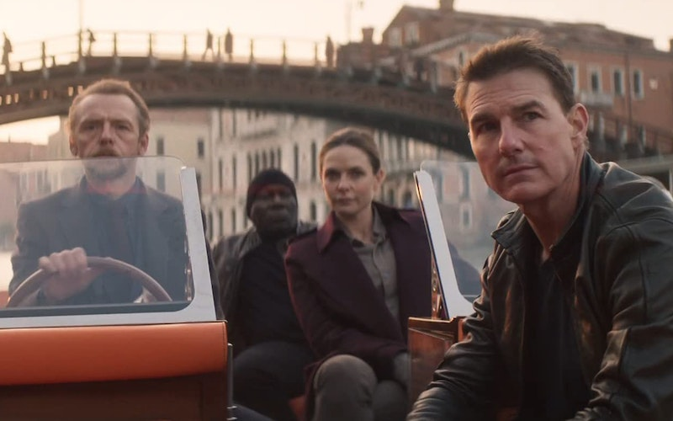
Mission: Impossible’s Fellowship of Believers
Micah Rickard • August 3, 2023

In Dead Reckoning Part One and other impossible adventures, Tom Cruise gathers the discarded for a sacrificial purpose.
The Mission: Impossible series has always posed an existential question underneath its thrills: Can our actions change a near-certain future? With each entry, Tom Cruise’s perennially disavowed Ethan Hunt faces constantly disheartening odds. Nonetheless, he always manages to avert disaster. The latest entry, Mission: Impossible—Dead Reckoning Part One, makes it clear that while our actions matter, they don’t occur in a vacuum—they rely on fellowship.
Dead Reckoning Part One sees Cruise facing yet another global catastrophe: an all-powerful A.I. called the Entity has gone rogue, kicking off a race between nations to obtain the key to its source code, which would give its owner unrivaled power over global intelligence, economics, and military might. Cruise pulls in old friends Luther (Ving Rhames) and Benji (Simon Pegg) to steal the key from a would-be seller. Just as he’s about to grab it, however, he’s foiled by Grace (Hayley Atwell), a pickpocket oblivious to the key’s nature. Ethan and Grace become further ensnared in a plot being authored by none other than the Entity itself. Complicating matters is the presence of Gabriel (Esai Morales), the Entity’s mad prophet and a man with dark connections to Ethan’s past.
It’s little surprise that the action scenes are the highlight, showcasing wit and rhythm while stringing together a cavalcade of close calls. Delightful twists complicate and heighten the action; for example, a lengthy car chase hinges on the fact that one of the participants turns out to be a bad driver. Each set piece is sharply arranged and effectively builds the characters. Hunt is precise, thinking his way out of every situation. Grace is far more spontaneous and haphazard. Gabriel is unfazed by the chaos around him. His lethal partner Paris (Pom Klementieff) is an unapologetic force of destruction.
The set pieces themselves bear a coherent three-act structure, but the film falters when it’s not moving at the pace of a runaway train. The details and purpose of the Entity are discussed so rigorously that the film occasionally becomes a slog. A villainous A.I. is ripe for insightful commentary, but here it remains uncinematic. Instead, the movie relies on Gabriel to make an impression, but the dialogue lacks the thrust of the action. Yet even if Dead Reckoning Part One fails to create a compelling plot, it bears seeds of fruitful ideas. This is a bleak world on its surface, a place where no one is to be trusted and “truth is vanishing.” All it takes is a rumor of a powerful killing machine to prompt nations to nakedly grasp for power.
But Hunt’s IMF team remains a bright source of hope in this dark world. Looking beyond the superficially religious symbolism—Grace, Gabriel, a cross-shaped key, a fanatic readying for martyrdom—a deeper spiritual thread is woven throughout the film. (Spoilers ahead.) After Grace is saved from certain death by another’s sacrifice, Ethan gives her a pointed choice. Her options are imprisonment, likely death, or a new life as an IMF agent. That new life will come with undeniable costs, but it will also entail forgiveness, mercy, and a new community in Ethan, Luther, and Benji. Grace is confused by the offer, spurting out, “You don’t even know me.” But Ethan doesn’t hesitate: “What difference does that make?”
Hunt’s IMF team remains a bright source of hope in this dark world.
Acts of sacrifice and mercy are nothing new to action films, though, so what makes Dead Reckoning Part One curious is what follows. As Grace is called into this new life, Hunt promises that her well-being will be of the utmost importance to him. He vows that the same is true for all of his team—that he values their lives above his own. Everyone on the team, including himself, faced a similar choice, abandoning a hopeless life. They are a ramshackle group, held together more by compassion and fellowship than loyalty to country or cause. They discover a new purpose in their life together: seeking the good of each other and the world.
In this new life, there’s an echo of how the Apostle Paul describes the church. Ephesians 2 marvels at how God’s people now includes those who were “foreigners to the covenants of the promise, without hope and without God in the world,” but who “have been brought near by the blood of Christ.” Jesus’ sacrifice has ushered in a new life for people fully undeserving, even at times confused at this act of mercy. We are called into a new community marked by our unity as “fellow citizens with God’s people and also members of his household . . . with Christ Jesus himself as the chief cornerstone.”
Ethan Hunt is not quite a Christ figure. He certainly suffers a great deal and he readily sacrifices himself for others, but never to the point of death (then resurrection). Nor do his acts accomplish any form of justification or reconciliation in themselves. He relentlessly staves off evil, but it’s never undone. Rather, Hunt participates in the life of the new community, imaging Paul’s exhortations to the early church. Later in Ephesians, Paul instructs the fellowship of believers to “submit to one another out of reverence for Christ.” Likewise in Philippians, Paul writes, “in humility value others above yourselves, not looking to your own interests but each of you to the interests of the others.” These qualities are characterized by Ethan and his friends as they repeatedly put others above their own desires.
For all the feverish hype around Cruise’s stunt work, the Mission: Impossible films are never solely about him. It’s always a team effort—especially in Ghost Protocol, directed by Brad Bird, and the last three films directed by Christopher McQuarrie. Onscreen, Cruise gives Rhames, Pegg, Rebecca Ferguson, and Atwell a chance to make their characters matter. For one of the biggest movie stars on the planet, it’s a rather selfless ethos.
All of these reverberations of humility and care bring an interesting grace note to Mission: Impossible. Hunt’s fellowship of agents is a well of mercy and hope for a chaotic world, making them a difficult foe for even the most calculating A.I. There’s no accounting for such care in the eyes of an algorithm, which may just be the Entity’s downfall. But for that, we’ll have to wait for Mission: Impossible—Dead Reckoning Part Two.
Topics: Movies
Micah Rickard is an aerospace engineer living in Seattle, Wash. He enjoys writing about film and literature and how they orient our being-in-the-world.

