wsj.com

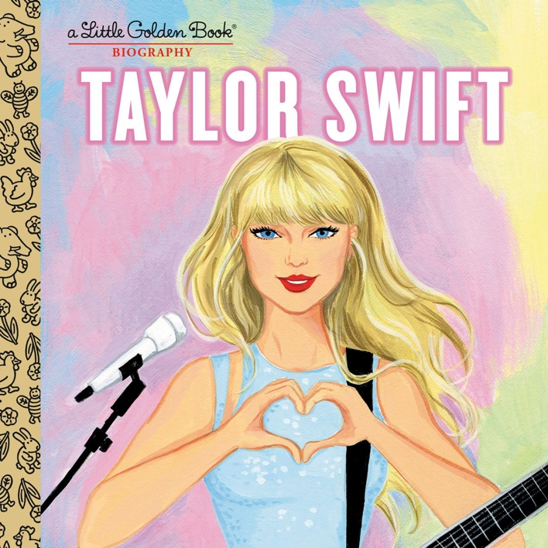
The Latest Must-Have Taylor Swift Merch Is This Children’s Book
Jeffrey A. Trachtenberg | June 18, 2023

Little Golden Books are aimed at children ages 4 to 8, but don’t tell that to the buyers of “Taylor Swift: A Little Golden Book Biography.”
“I felt I had to have it,” says Danielle Maxwell Curtis, a 25-year-old studying for a Ph.D. in chemistry at the University of Michigan. “My husband and I read it together on the couch.”
That the 24-page mini-biography is ostensibly aimed at children wasn’t off-putting in the least, she said. “The illustrations are great, and it does a good job of walking me through her life.”
Such is the power of Taylor Swift. In her roughly two decades of stardom, the prolific musician has cultivated a devout base of fans—known as “Swifties”—who are hungry for concert tickets, merchandise and other material about the star.
The book, published May 2, sold 170,000 copies in its first four weeks and has gone through multiple print runs because of strong reader demand, according to publisher Random House Children’s Books. The average first four-week sales of the other 28 titles in the Little Golden Book biography series is 4,900 copies, the company said.
“Judging from Instagram and TikTok, we’ve attracted a crossover audience,” that spans many age groups, said Barbara Marcus, president and publisher of Random House Children’s Books, a division of Penguin Random House. “We didn’t realize how popular it would be.”
The subjects of other Little Golden Book biographies include pop star Beyoncé, former President Barack Obama, and the late actress Betty White. Little Golden Books are known for their signature gold bindings.
Book tracker Circana BookScan said 103,000 titles across all genres were published between Jan. 1 and June 3, of which only three—including the Taylor Swift Little Golden Book—sold at least 170,000 copies in their first four weeks. The other two titles were Prince Harry’s memoir “Spare” and Dav Pilkey’s graphic novel “Dog Man: Twenty Thousand Fleas Under the Sea.”
The Taylor Swift title was released as she travels the country on her Eras Tour, delivering hourslong concerts in stadiums packed with fans.
Book sales might also have benefited from fan curiosity in early May, after speculation emerged online that Swift was the author of a coming book. Following several days of conjecture, that book’s publisher disclosed the new title is actually about K-pop band BTS.
The Little Golden Book, written by Wendy Loggia and illustrated by Elisa Chavarri, features a series of vignettes intended to give readers a sense of Swift’s childhood as well as her professional life.
A country music fan, Swift, with her family, visited Music Row in Nashville, Tenn., where the 11-year-old handed out CDs of her music to record labels, the book recounts. Later, when she was 13, RCA Records expressed interest in working with her, and her family moved to Nashville.
Rather than focus on other writers’ songs, as the record company recommended, Swift decided to perform her own music as well as that of others. She was later spotted by a different music executive, with her first album, “Taylor Swift,” going on sale when she was 16.
“When you’re Taylor Swift, the sky’s the limit!” Loggia wrote in the book.
“I knew how fervent her fan base was and I wanted to get every detail right,” said Loggia, a self-described Swiftie and an editor at Penguin Random House’s Delacorte Press. Loggia didn’t request an interview with the singer, but said she knew many of the facts of the singer’s career and “have listened to all of her songs on repeat.”
Much like Swift’s music, the book has attracted an international audience. Irene Rodríguez, a 26-year-old psychologist from San Marcos, Nicaragua, said she learned about it from a Swift-related account she follows on Twitter.
Rodríguez in April traveled from Nicaragua to Tampa, Fla., to attend Swift’s Eras Tour, ordered the title on Amazon and then waited three weeks for it to arrive.
“I try to get any merchandise that is affordable and easy to ship to my country, and since I’m a big bookworm, I found the book to be a perfect fit,” she said.
Write to Jeffrey A. Trachtenberg at Jeffrey.Trachtenberg@wsj.com
Copyright ©2023 Dow Jones & Company, Inc. All Rights Reserved. 87990cbe856818d5eddac44c7b1cdeb8
Appeared in the June 20, 2023, print edition as 'Taylor Swift Kids Book Is a Smash'.

