Barbie and Taylor Swift Are Bringing Us Together
Beyond hot pink and bejeweled outfits, they showcase a deeper desire for community and collective joy.
Beth Felker Jones|August 16, 2023

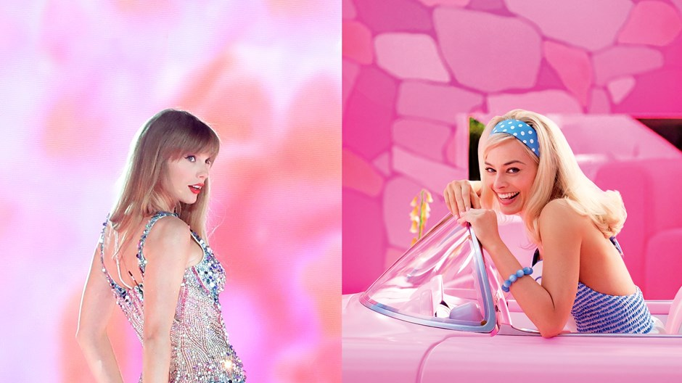
Image: Edits by CT / Swift: John Medina / Stringer / Getty / Barbie: Courtesy of Warner Bros. Pictures
Taylor Swift (left) and Barbie (Right)
The “epic trifecta” of Greta Gerwig’s Barbie, Beyoncé’s Renaissance Tour, and Taylor Swift’s Eras Tour (all raking in millions of dollars) are taking over social media—having grown adult women reliving their youth in a “Tween Girl Summer.”
But the enthusiasm and participation are no less among actual young people.
Both my 18-year-old son and my 16-year-old daughter—despite never having played with Barbies as children and being on the younger end of the age spectrum for Taylor Swift fans—are all in.
There’s a cultural conversation here about the “spending power of women” and the “female dollar,” and there’s plenty to be said for this: Barbie, Swift, and Beyoncé are enormous capital successes.
Barbie and Swift’s Eras Tour in particular open up dialogue about what Michelle Goldberg at The New York Times calls “entertainment that channels female angst,” awakening a “seismic shift for women” in “helping women reclaim girlhood without rescinding power.”
These cultural artifacts draw on the ambiguities of the female experience, celebrating the feminine while honestly addressing the difficulties of being a woman in a male-oriented world. And certainly, these events are occasions for women to enjoy this together.
For me, though, it’s the “together” more than the dollars, and the hope more than the “angst,” that I notice when I try to see this summer through my children’s eyes.
The pandemic interrupted my kids’ lives at a crucial developmental point. For them, there’s almost no “before” the pandemic in their teen years—there’s only the newly opening of the after. And in that wake, what if what my kids want is communal meaning—the kind that is supposed to mark our local churches?
As Justine McDaniel pointed out, the “Barbie-Taylor-Beyoncé summer offers a release of pandemic emotions”—exposing a hunger, Goldberg said, that is “a palpable longing for both communal delight and catharsis.”
Today, there’s church versions of the kind of transportive singing experience shared by those who attend concerts like Swift’s—where everyone is on their feet, some with hands in the air, some with tears on their cheeks. Many Christians are cynical about this, but Swift concertgoers and Barbie moviegoers are not.
Powerful communal experience can be manipulated, but it doesn’t have to be manipulation. When a song or movie tells the truth, it can be joyful and even transformative.
As Russell Moore recently wrote in response to the skepticism around emotional worship experiences, “transformative change happens at a much deeper level than intellect or willpower.”
And in a world that has known few mass cultural events since COVID-19, my kids are in on shared Barbie viewings and Swiftie togetherness. They’re in on gathering for these events, and they’re in on these female-identified celebrations of what it means to be human together.
Movie theaters are full of families and groups of friends, dressed in pink and laughing together; the country’s biggest stadiums are packed out with a tiny slice of those who would have come to see Swift perform, had more tickets been available.
For both my son and daughter, Taylor Swift is at the top of their playlists. When this summer’s tour was announced, our family spent several angsty days in online lotteries trying to score the chance to purchase tickets for the Eras Tour. We failed, but then a kind friend landed two tickets and took my daughter with her to the concert.
The COVID era loomed large in my kids’ adolescence—they exchanged in-person school for hours-long Zoom meetings, hanging out with friends for lonely texting, and church for a streaming service viewed on the sofa. All these changes still feel immediate.
Now they’re hungry for togetherness. They’re hungry for large-scale shared cultural events and wearing dress-up clothes in public.
Many in their generation are cynical, broken by the pandemic and cultural polarization, and so maybe my view of their enjoyment of Barbie and Swift is too much optimism. You’ll forgive me, perhaps, for being tempted to hope that what they’re charmed by is precisely the shared group experience of hope.
The kids are hungry, but they’re not in when the church fails to tell the truth. Like Barbie and Swift, they’re sharp-eyed and good at spotting a false god.
Sasha (Ariana Greenblatt) is their generational representative in Barbie. On meeting Barbie (Margot Robbie), Sasha unleashes a teenage diatribe, calling Barbie a “fascist” and accusing her for being responsible for almost everything wrong with the world, particularly all that’s wrong for women.
But my kids seem to be more in alignment with Sasha’s conversion than her denunciation—with her reconciliation with her mother as well as to a Barbie-versioned celebration of the female.
“I liked how the Kens were metaphors for women in the real world,” said my son.
From my daughter: “You don’t expect a Barbie movie to be about deep existential meaning.”
My son doesn’t seem put off by the feminine in these events. He’s not losing sleep over the purported feminization of the culture or the accusation that Barbie is demeaning of men. He’s never even heard of the supposed feminization of the church, nor do I think he’s ever considered the idea that such a thing might be a threat to him.
What he wants is to be with his people, seeing a good movie, listening to good music—aware of what’s wrong with this world but, maybe, hoping for something better.
Barbie is full of theological themes, and, while I wouldn’t presume to know her faith, Swift has expressed public frustration with ways American Christianity has been attached to partisan politics.
And that “existential meaning” my daughter noted in Barbie is about what it means to be human, what it means to live the good life together. The same goes for many of Swift’s smartest lyrics and the very human feelings that come with singing them out loud.
My daughter, who is sometimes more reserved, was on her feet, singing all-out, for the whole three hours that Swift was on stage. She picked out her outfit months in advance—an homage to Swift, a way to place her body within the event. She took photos, which she says she’s “never letting go.”
She has gone from a school COVID-19 era of eating her lunch at a solitary table to raising her voice at Soldier Field in Chicago, united with 55,000 other people who know every word to every song.
Of course, she wants this full-bodied, communal, ecstatic experience.
Barbie and Swift are about the lived experience of embodied life together. Barbie (spoiler for the movie) leaves her plastic world behind and, in the words of Amy Peeler writing at the Holy Post, “takes on a real body, including sexual organs, experiences the devolution of the body, and becomes a mortal woman. She does this to experience the deeper beauty of imperfection.”
Katelyn Beaty writes about the film as an affirmation of female embodiment: “It’s through our bodies” that we “experience both common and supernatural grace.”
Swift, too, invites her fans into her own embodied life as she sings unabashedly of emotion and relationship and loss. We humans are embodied creatures, and we need life in the body together.
And that’s what church is. It’s life in the body together, the people gathered around the one who is the truth, who gives life meaning, who knows our embodied longings because he took on flesh for our sake.
The kids want communal meaning. So I’m going to keep hoping—hoping that, maybe, what they want is the body of Christ.
Beth Felker Jones is professor of theology at Northern Seminary. She is the author of many books and writes regularly at Church Blogmatics.

