2024 Worship
“Following the Jesus Way”
Updated September 27, 2023

Members at the planning retreat: Pastor Mary, Paul Powers, Betty Kinney, Vicki Zuker, Rose Emmons, Karen Booth, Sue Baranowski, Ed Baranowski, David Booth, Ruth McPhail Ubaldo, Marie Kordecki, Diane Thompson, Jim Post, Karen Post (Friday), Jean Kelly

2024 Theme: Following the Jesus Way

Inspiration: The Jesus Way by Phil Wickham

If you curse me, then I will bless you
If you hurt me, I will forgive
And if you hate me, then I will love you
I choose the Jesus way

If you're helpless, I will defend you
And if you're burdened, I'll share the weight
And if you're hopeless, then let me show you
There's hope in the Jesus way

I follow Jesus
I follow Jesus
He wore my sin, I'll gladly wear His name
He is the treasure
He is the answer
Oh, I choose the Jesus way

If you strike me, I will embrace you
And if you chain me, I'll sing His praise
And if you kill me, my home is heaven
For I choose the Jesus way

I follow Jesus
I follow Jesus
He wore my sin, I'll gladly wear His name
He is the treasure
He is the answer
Oh, I choose the Jesus way

And I choose surrender
I choose to love
Oh, God my Savior, You'll always be enough
I choose forgiveness
I choose grace
I choose to worship, no matter what I face…

Related songs: I Have Decided to Follow Jesus

Key verse: John 13: 34 – A new commandment I give to you, that you love one another: just as I have loved you, you also are to love one another.

Major spoken/unspoken needs:
- Carrying the weight of unforgiveness
- Apathy
- Loneliness. Relationships or lack thereof.
- Lack of manners
- Self-medication – escape problems, extend life, idol
- Aging. Caregiving.
- The church: What it is vs. what it should be. Its future. Non-believers’ assumptions.
- Technology – the pace of change, its role in our lives, ethics
- Fear, anxiety, anger, violence

----------------------------------------------------------

“The Gift of Being Present”
Based on a series by Marcia McFee
November 26 – December 31, 2023
(4 weeks of Advent plus Blue Christmas, Christmas Eve,
and New Year’s Eve/Christmas 1)
Brainstorming: Week of November 5, 2023

Synopsis: Advent can be filled with worry about finding the perfect Christmas gifts. Deep down we want people in our lives to know they are special and that we love them. But sometimes we overlook the greatest gift of all… our very presence. Our spiritual ancestors were also worried – often about survival in the midst of political occupation. And the response of the scriptures is “the Holy Living One is with you.” Like a shepherd who never leaves the flock, we are held close. This season, we are invited to be the gift of presence for our loved ones, for our communities, for those who need it most.
2024 theme connection: It is easy to feel alone in our struggles. Only Jesus, who was and is fully present with everyone he encounters, can help us be the gift of presence for others.

Resources: The Precious Present by Spencer Johnson

Advent 1 – November 26: “Being Present with Hope”
Scripture: Psalm 80: 1-2; 1 Corinthians 1: 4-7; Mark 13: 37
Synopsis: Our spiritual ancestors cried out in the midst of their political occupations: “Save us!” The idea of a Messiah went hand-in-hand with the need for God to help them in their distress. The Roman occupation of Jesus’ time and of the early Christian community is expressed with a sense of waiting, watching, and anticipation of restoration to freedom. All this points to the presence of hope, essential to survival in difficult times. Let us be present with hope to those who need it most.

Advent 2 – December 3: “Being Present with Peace”
Scripture: Isaiah 40: 1; 2 Peter: 3: 13-14a; Mark 1: 2-3
Synopsis: Preparing the way for new beginnings, fresh starts, a clear path, is a classic theme in the faith narrative and in our own lives Life can contain many chapters. The Good News is that the Holy One is continually making a way for do-overs. In this we can find peace, even when life doesn’t feel so peaceful. This week we focus on what it means to be a gift of non-anxious presence for those who need it most.

Advent 3 – December 10: “Being Present with Joy”
Scripture: Isaiah 61: 1-3a; Psalm 126: 1-3; Luke 1: 46-49
Synopsis: The words of the prophet Isaiah offer a prophetic vision that Jesus will also claim in his ministry. Likewise, we are called to claim the gift of being fully present with all people – those who mourn, those who grieve, those who have suffered indignity and oppression. Mary’s Magnificat is prophetic as well. She claims the overturning of injustice even before it has come to pass. Joy is not the equivalent of happiness, but rather the deep conviction that we are called to be present in the work of bringing about “great things” – a better world for those who need it most.

Blue Christmas

Advent 4 – December 17: “Being Present with Love”
Scripture: 2 Samuel 7: 8-9a; Psalm 89: 1-4; Luke 1: 26-31
Synopsis: The faith narrative is careful to show us a lineage from King David to Jesus. It is no ordinary lineage, it is one that began in the shepherding of sheep, of leading and delivering the people in search of a home. Mary’s womb becomes part of that lineage of love, offering the world the gift of God’s presence “in the flesh.” As we enter the story of the birth of Love Among Us, we are invited to be present in love with those that need it most.

Christmas Eve – December 24 (10:00 am & ___ pm): “Being Present with Light”
Scripture: Isaiah 9:2; Luke 2: 8-12
Synopsis: It is the night we celebrate the opening of the most precious gift of presence we know – the birth of the Christ Child, the Light of the World. As we light our candles, we open our hearts to becoming part of the gift of light in the world. Like the choice the shepherds face, will we live in the shadows of fears, or will we dare to run to the manger to know and believe the Good News of new possibility for all who need it most?

Christmas 1 – December 31 (10:00 am): “Being Present with Assurance”
Scripture: Isaiah 62: 2-3; Galatians 4: 4-6; Luke 2: 25-32
Synopsis: The overwhelming message of the Christmas story is the assurance that we, too, are children of the Holy One. In this, our very presence is gift if we will only allow the Spirit to move in and through us. Every day of our ordinary lives, we can show up – be present – and proclaim the assurance of hope, peace, joy, and love to those who need it most.
-------------------------------------------------------------------
“My Story – Faith in Film 2024”
January 7 – February 11, 2024
(6 weeks)
Brainstorming: Week of December 3 or 10, 2023

Synopsis: Our faith in Jesus Christ is grounded in Scripture. Telling our own faith story is a powerful witness to others, influencing how we think about, understand, and follow God. The same can be said of the arts, including literature and films. When characters long for something or yearn for something, when they celebrate, all these moments can be viewed through a lens of prayer, even those the characters may not address God directly. (Josh Larsen)

2024 theme connection: Characters, setting, plot, conflict, and a resolution are the basis of good stories. Over the next six weeks, we’ll hear stories of how God has transformed lives of our own members and characters in four different films.

Resource: Books and videos by Josh Larsen of Think Christian

Baptism of the Lord – January 7: “My Story – The Jesus Way”
Scripture: Mark 1: 4-11
Synopsis: We all have faith stories. Here are three approaches to telling it. The first is what we discussed at the planning retreat:
- Here’s my faith story (focus on times of joy, challenges, and/or gratitude)
- What does Jesus mean to me?
The second way looks at three “chapters” of your story:
- My life before turning to Christ.
- How I met Christ.
- My life with Christ.
The second approach might not fit the experience of many deeply committed and growing Christians. This approach might work better:
- Early Christian influences in my life.
- Making faith my own.
- My life with Christ today.
People who might tell their story: Ron Zuker, Ruth McPhail Ubaldo, Bev Layman, Sheryl Thompson, Jan Pascavis, Jessica Keever, Jan Justus, Jim Grace.

Epiphany 2 – January 14
The Hill (Aug. 25, 2023) PG
The true story of Rickey Hill, the son of a traveling pastor who overcomes physical obstacles to pursue his dream of playing baseball in the major leagues.
- Actor Dennis Quaid shares all about his Christian faith and his new faith-based movie

Epiphany 3 – January 21
Barbie (2023) PG 13
Barbie and Ken are having the time of their lives in the colorful and seemingly perfect world of Barbie Land. However, when they get a chance to go to the real world, they soon discover the joys and perils of living among humans.
- “Barbie and Ken Go East of Eden” by Hannah Anderson, Think Christian
- “Barbie and Our Reason for Being” by Roslyn Hernández, Think Christian
- “Barbie and Taylor Swift Are Bringing Us Together” by Beth Felker Jones, Wall Street Journal (planning retreat website).

Epiphany 4 – January 28, 2024
White Bird (Aug. 25, 2023) PG 13
Julian has struggled to belong ever since he was expelled from his former school for his treatment of Auggie Pullman. To transform his life, Julian's grandmother finally reveals her own story of courage. During her youth in Nazi-occupied France, a boy shelters her from mortal danger. Together, they find first love in a stunning, magical world of their own creation, while the boy's mother risks everything to keep her safe.

Epiphany 5 – February 4, 2024
Elemental (June 2023). Animated (Pixar & Disney).
In a city where fire, water, land, and air residents live together, a fiery young woman and a go-with-the-flow guy discover something elemental: how much they actually have in common.

Transfiguration – February 11, 2024: “My Story – The Jesus Way”
Scripture: Mark 9: 2-9
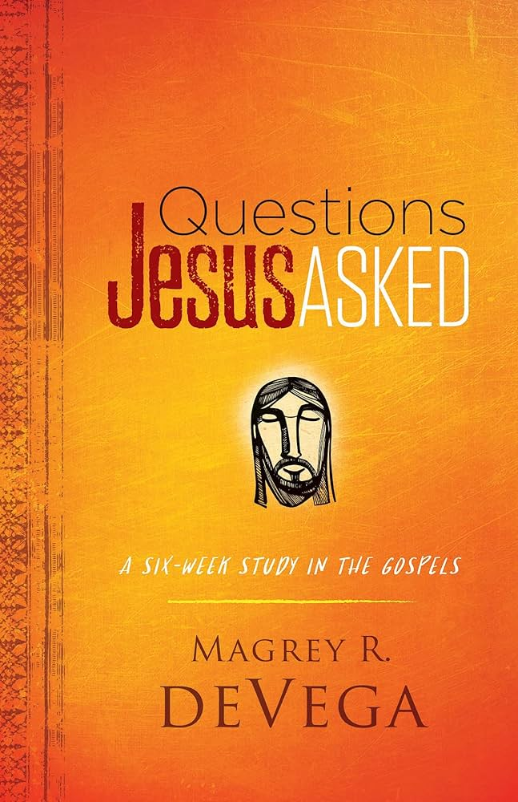
Synopsis: See January 7 for ideas.
-------------------------------------------------------------------
“Questions Jesus Asked”
Based on a book of the same name by Magrey deVega
February 18 – March 31, 2024
(5 weeks of Lent, Holy Week, Easter)
Brainstorming: Week of January 29, 2024

Synopsis: Jesus was fond of asking questions, many of which cut right to the heart of what it means to be human. Author Magrey deVega explores six of the most provocative questions Jesus posed to others and guides us in answering them for ourselves.
Related video: Book intro by the author

2024 theme connection: Asking these questions takes courage. Not only do they reveal what Jesus really cares about, they open a window into our hearts. We all have questions for God, but growth happens when we turn things around and as what Jesus wants to know about us. When we dare raise them, these questions bring us a fuller appreciation for the wisdom, power, and presence of God in our lives. Are you willing to step out into faith? Are you ready to answer the questions Jesus asked?

Lent 1 – February 18: “Who Do You Say I Am?”
Scripture: Luke 9: 18-27 (Matthew 16: 13-19; Mark 8: 27-29)
¹⁸ When Jesus was alone praying, his disciples came to him, and he asked them, “What do people say about me?”

Lent 2 – February 25: “Why Are You Afraid?”
Scripture: Matthew 8: 23-27 (Mark 4: 35-41; Luke 8: 22-25)
²³ After Jesus left in a boat with his disciples, ²⁴ a terrible storm suddenly struck the lake, and waves started splashing into their boat.

Lent 3 – March 3: “Why Are You Anxious?”
Scripture: Luke 12: 25-31
²⁵ Can worry make you live longer? ²⁶ If you don't have power over small things, why worry about everything else?

Lent 4 – March 10: “What Do You Live For?”
Scripture: Mark 8: 34-38
³⁴ Jesus then told the crowd and the disciples to come closer, and he said:
If any of you want to be my followers, you must forget about yourself. You must take up your cross and follow me.

Lent 5 – March 17: “Whom Will You Love?”
Scripture: Luke 6: 27-36
²⁷ This is what I say to all who will listen to me:
Love your enemies, and be good to everyone who hates you.

Palm Sunday – March 24: “What Are You Looking For?”
Scripture: John 1: 35-38
³⁵ The next day, John was there again, and two of his followers were with him. ³⁶ When he saw Jesus walking by, he said, “Here is the Lamb of God!” ³⁷ John's two followers heard him, and they went with Jesus.
³⁸ When Jesus turned and saw them, he asked, “What do you want?”

Holy Thursday – March 28: “Why Have You Forsaken Me?”
Scripture: Matthew 27: 45-46
⁴⁵ At noon the sky turned dark and stayed that way until three o'clock. ⁴⁶ Then about that time Jesus shouted, “Eli, Eli, lema sabachthani?” which means, “My God, my God, why have you deserted me?”

Good Friday – March 29:

Easter – March 31: “Who Are You Looking For?”
Scripture: John 20: 15-23
¹⁵ Jesus asked her, “Why are you crying? Who are you looking for?”
She thought he was the gardener and said, “Sir, if you have taken his body away, please tell me, so I can go and get him.”

-------------------------------------------------------------------
“Forgiveness”
April 7 - 28, 2024
(4 weeks and Children’s Sunday)
Brainstorming: Week of March 4, 2024

Synopsis: If you ask children what they want to be when they grow up, they are unlikely to say, “angry, bitter, and unforgiving.” We see the physical, emotional, and spiritual effects of unforgiveness in ourselves and those around us. Forgiveness doesn’t come naturally. How can we learn to ask for and receive forgiveness?

2024 theme connection: Many people treated Jesus poorly. He had many reasons to hold a grudge, but he chose to forgive. Following Jesus means learning how to ask for and receive forgiveness. Consider the second and third verses of our theme song, “The Jesus Way”:

If you curse me, then I will bless you
If you hurt me, I will forgive
And if you hate me, then I will love you
I choose the Jesus way

If you strike me, I will embrace you
And if you chain me, I'll sing His praise
And if you kill me, my home is heaven
For I choose the Jesus way
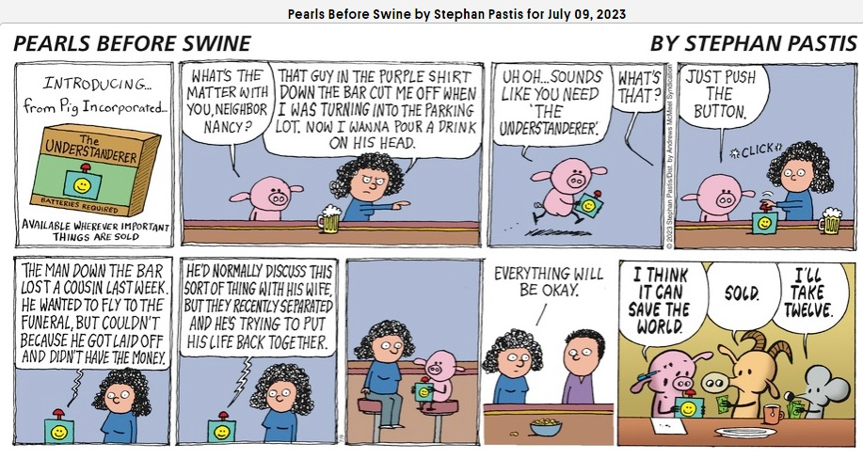
Point to consider:
- Learn to ask for and receive forgiveness?
- Family dynamics – chaos, lack of positive modelling, character formation
- 8 steps to healing
- Laying the groundwork so it is easier to forgive
- Not excusing bad behavior
- Pearls Before Swine cartoon, 7-9-23
- “What We Can Learn from Ted Lasso” by Chase Crickenberger. Excerpt: The proverbial strings began to connect for me about halfway through the series finale when Roy Kent, my personal favorite, finally asked to join the inner sanctum we’d come to know as “The Diamond Dogs.” After a curse-filled rant about wanting to be a different person, he posed a simple question: “Can a person change?” Assistant Coach Beard said (slightly paraphrasing here), “There are perfect movies, perfect foods, perfect trees … but perfection in people is not possible.” Then Leslie, the docile assistant to the club owner, responded, “The best you can do is to keep asking for help and accepting it when you can. And if you keep on doing that, you’ll always be moving toward ‘better.’”

Easter 2 – April 7:

Scripture: 1 John 1:1-2:2 - 1 John 1:9 “If we confess our sins, he is faithful and just to forgive us our sins and to cleanse us from all unrighteousness.” (lectionary)

Easter 3 – April 14:

Easter 4 – April 21:

Easter 5 – April 28:

Children’s Sunday – May 5 (10:00 am):

Resources:
- My Father’s Violin (2022) Through their shared grief and connection to music, an orphaned girl bonds with her emotionally aloof, successful violinist uncle and he learns more about his brother, his life of sacrifice, and forgiveness.
- Pearls Before Swine comic, July 9, 2023
- Excerpt from The Lord of the Rings

-------------------------------------------------------------------
“The Beatitudes”
May 12 – July 7, 2024
(9 weeks)
Brainstorming: Week of April 15, 2024

Synopsis: Jesus’ description of the Kingdom of God and what it means to be “blessed” turns our world upside-down.
If you curse me, then I will bless you
If you hurt me, I will forgive
And if you hate me, then I will love you
I choose the Jesus way

2024 theme connection: Studying the Beatitudes helps us follow Jesus’ counter-cultural way of living and loving others.

Scripture: Matthew 5: 1-12 (CEV)
5 When Jesus saw the crowds, he went up on the side of a mountain and sat down.
Jesus' disciples gathered around him, ² and he taught them:
Note from Rabbi Alpert:
This is good stuff, but from my perspective, Jesus takes it a bit too far.
³ God blesses those people who depend only on him.
They belong to the kingdom of heaven!
⁴ God blesses those people who grieve.
They will find comfort!
⁵ God blesses those people who are humble.
The earth will belong to them!
⁶ God blesses those people who want to obey him more than to eat or drink.
They will be given what they want!
⁷ God blesses those people who are merciful.
They will be treated with mercy!
⁸ God blesses those people whose hearts are pure.
They will see him!
⁹ God blesses those people who make peace.
They will be called his children!
¹⁰ God blesses those people who are treated badly for doing right.
They belong to the kingdom of heaven.
¹¹ God will bless you when people insult you, mistreat you, and tell all kinds of evil lies about you because of me. ¹² Be happy and excited! You will have a great reward in heaven. People did these same things to the prophets who lived long ago.

Resources:
- The Miracles of Jesus by Tomie dePaola
- “A Christian Vocabulary for an Exhausted Age” by Russell Moore | Christianity Today, August 25, 2023. Reclaiming the culture wars requires reclaiming wonder. Maybe if more of us were struck by just how strange and astounding these truths are, we would find the world around us startled by them too. This wouldn’t make people like us anymore—that’s not the point. The point is that people should hate us for the right reason.
When we reclaim a vocabulary of wonder, perhaps more of our neighbors will gasp when people become Christians in order to say, “Can any good thing come out of Nazareth?” (John 1:46).
And we will respond with what he taught us to say from the beginning: “Come and see.”

Easter 7 – May 12: “Blessed Are the Poor in Spirit”

Pentecost – May 19: “Blessed Are Those Who Mourn”

Trinity Sunday – May 26: “Blessed Are the Meek”

Pentecost 2 – June 2: “Blessed Are Those Who Hunger and Thirst after Righteousness”

Pentecost 3 – June 9: “Blessed Are the Merciful”

Pentecost 4 – June 16: “Blessed Are the Pure in Heart”

Pentecost 5 – June 23: “Blessed Are the Peacemakers”

Pentecost 6 – June 30: “Blessed Are Those Who Are Persecuted”

Pentecost 7 – July 7: “Blessed Are Those Whose Are Insulted Unjustly”
-------------------------------------------------------------------
“Overcoming Apathy”
July 14 – July 28 or August 4, 2024
(3 or 4 weeks)
Brainstorming: Week of June 17, 2024 – plan for “God, Technology, and the Christian Life” at the same time

Synopsis: Jesus is/was anything but apathetic and as his followers, we should be passionate for the same things that made him passionate. So why do we struggle to care?
If you're helpless, I will defend you
And if you're burdened, I'll share the weight
And if you're hopeless, then let me show you
There's hope in the Jesus way

2024 theme connection: Although apathy has been a problem for many years, it seems to have gotten worse since the pandemic. Loneliness and mental health troubles have increased as our sense of community changed. Employers complain of a poor work ethic. Volunteer organizations struggle finding committed helpers. This is in stark contrast to the dedication and sacrifice we see from Olympic participants.

Resource:
- Overcoming Apathy: Gospel Hope for Those Who Struggle to Care by Uche Anizor examines the nature and experience of apathy, drawing insights from Scripture, theology, popular culture, and more. Identifies seven causes as well as healthy habits to fight against indifference. A great guide for high school and college student and those who counsel them; youth and young adult pastors; teachers; and anyone struggling with apathy or who know someone who is. Chapters:
  - A Show about Nothing (Seinfeld): Our Culture of Apathy. Apathy vs. passion/zeal in culture, the church, and our own lives.
  - The Noonday Demon: On the Concept of Apathy. Apathy (acedia) as a vice (sloth, indifference). Relationship to its cousin, depression (p. 57).
  - Everyone’s Got a Story: Seven Deadly Causes of Apathy. Doubt (p. 69), grief (p. 74), triviality (p. 77), feelings of inadequacy (p. 82), lack of discipline (p. 85), fragility (p. 89), lack of purpose (p. 92)
  - O Love That Wilt Not Let Me Go: The Cure for Apathy.
    - …the gospel tells us about what’s really real. The drama of God’s commitment to his creation is the truest think about our world and the truest thing about our lives. Yes, our struggle against apathy is real. (p. 110)
    - We rise to the level of whom we perceive ourselves to be. If we see ourselves as weak, displeasing to God, stuck, and powerless, that self-image will become a self-fulfilling prophecy. (p. 111)
    - Our “why bother?” is met with God’s “you matter.”
  - Wax On, Wax Off: Ways to Combat Apathy. Developing a new way of living, thinking, and feeling by cultivating mission, meaning, generosity, and fortitude.
- Spectickles comic, right
- Movie: “Campeones (The Champions)” (2018). A basketball coach is sentenced to community service, forced to work with a team of mentally disabled players, which changes all of their lives. Note: This Spanish film has English subtitles.
- Movie: “The Swimmers” (2022). From war-torn Syria to the 2016 Rio Olympics, two young sisters embark on a harrowing journey as refugees, putting both their hearts and champion swimming skills to heroic use. Based on a true story.
- “The Rise of the ‘Umms’” by Mike Moore. Unlike many “Nones” and “Dones,” many church-adjacent Christians want to return to a local body – but they feel stuck.

Current event: Summer Olympics (July 26-Aug. 11). Tour de France. Related discussion:
- Olympic motto: Faster, Higher, Stronger – Together (together added in 2021)
- Brings the world together, closer. Also brings athletes together in the Olympic village.
- Hearing stories of discipline, commitment, sacrifice, developing God-given talents, setting goals
- Stories of support behind and between the athletes
- Scripture: Paul’s letters – running the race

Pentecost 8 – July 14:

Pentecost 9 – July 21:

Pentecost 10 – July 28:

(Pentecost 11 – August 4):

-------------------------------------------------------------------
“God, Technology, and the Christian Life”
August 4 (or 11) - 25, 2024
(3 or 4 weeks)
Brainstorming: Week of June 17, 2024 –
plan for “Overcoming Apathy” at the same time

2024 theme connection: Technology is pervasive. Adapting these new powers to human flourishing always lags behind technological discovery, production, and adoption. It can in fact, offer another way to love our neighbors. After all, God is in technology. We just have to take time to look.

Synopsis: Jesus’s commandment is to love one another as he has loved us. How does that work when we sometimes pay more attention to our devices than the people around us? Whether we realize it or not, technology has been around throughout history. Rather than assigning moral labels to technology, let’s find out what God has to say about it and how to live the Christian life without fear.

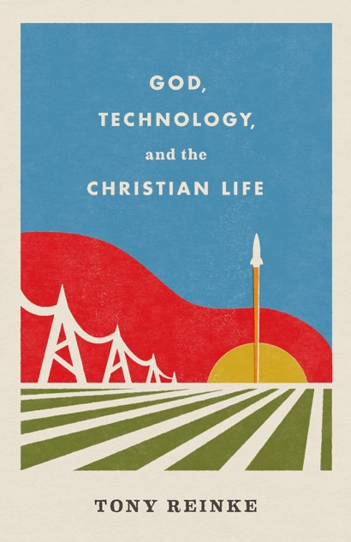
Resources:
- God, Technology, and the Christian Life by Tony Reinke. By turning to nine key passages and engaging with several theologians and thinkers, Reinke seeks to dismantle twelve common myths Christian often hold about technology, helping them understand the story of where human innovation came from and to embrace the church’s essential role in it.
  - Related videos: 1) John Piper 2) Tony Reinke
  - Each chapter focuses on a single question:
    - What is technology? It is something that amplifies human energy and power.
    - What is God’s relationship to technology?
      - God is not at the periphery of Silicon Valley; he’s over it. (p.54)
      - Any engineering feat of man can be squelched by God. (p. 55)
      - God governs even over technologies of destruction. (p. 59)
      - Energy for human innovation comes from the Spirit. (p. 63)
      - Each innovator exists by divine appointment. (p. 65)
      - God reigns over technologies that heal. (p. 69)
      - God focuses his attention on the actors of technology. (p. 69)
      - God’s governance over all human innovation is meant to comfort. (p. 70)
    - Where do our technologies come from? God.
    - What can technology never accomplish? The need for the Gospel and relationships. The Gospel vs. the Gospel of Technology.
    - When do our technologies end? p. 217-222
    - How should we use technology today? God’s wisdom.
- “I Write Algorithms for a Living. God Doesn’t Want Me to Quit.” Colin Prather, a data scientist for iRobot, offers a brief, yet complete overview Reinke’s book. Note from Karen: Read this for an excellent summary of the book.
- 26 Bible Verses About Technology | Tithe.ly Jesse Wisnewski offers a relatively short, yet very thoughtful overview of technology as it relates to our lives and the church. She concludes with 26 verses “about technology, examples, and how you should consider relating to technology.”

(Pentecost 11 – August 4): “Since the Beginning: Technology in the Bible”
- Process theology – co-creation
- Examples: Cain (city), Tubal-Cain (metal working), Noah (ark), Tower of Babel, King Solomon’s temples, Jesus (carpenter), Paul (letters)…
- Pace of technological change has accelerated
- The Evolution of Technology (2014). This video takes you on a journey from 1964 to 2014, showing old technologies and their progression until they finally converge into one device, and seamlessly integrate themselves into our life. Pertinent term: Technium
- Longing for the “good old days” – forgetting that technology has helped (fertilizer, clean water, medicine, communication, etc.)

Pentecost 12 – August 11: “The Gospel or the Gospel of Technology?”
- This is the human dilemma. Human innovation is a wonderful gift, but a disappointing god. We cannot save ourselves. In the end, our innovations leave hearts unsatisfied, souls lost, and bodies cold in the grave.
- Addressing the question: What can technology never accomplish?
- “Evan Almighty.” (2007) Newscaster Evan Baxter (Steve Carell) leaves Buffalo behind when he wins a seat in Congress. Moving his wife (Lauren Graham) and family to northern Virginia, he seems to have it made, then God (Morgan Freeman) throws a crisis of biblical proportions at his feet: The Lord wants him to build an ark and line up all the animals two-by-two in preparation for a flood. From a reviewer: Evan didn’t believe in God and God showed him who he was and how powerful he is. From Karen Booth: There are two tech references, to the biblical Noah and contemporary failing dams.

Pentecost 13 – August 18: “Technology: Where Does It End?
- Cities may try to silence Christianity, but God has the last word. (p. 205)
- Cities: Concentration of human innovation and human arrogance (p. 297)
- New Jerusalem p. 217-222

Pentecost 14 – August 25: “How Then Shall We Live?”
- Reinke offers fourteen ethical convictions to consider.
- Ethics, technology, and medicine: God uses chronic pain and weakness, along with other sorts of affliction, as his chisel for sculping our souls. – James Packer (p. 269)
- Related video/skit: “God’s Chisel.”
-------------------------------------------------------------------
“Real Life, Real Faith”
Based on a 2016 series developed at Pastor Camp
September 1-29, 2024
(5 weeks)
Brainstorming: Week of August 4, 2024

Synopsis: Joseph is one of the few biblical characters whose whole life is recorded in the bible. His story affirms that God loves us in all seasons of life and faith and is a good example of the lifelong journey of faith and spiritual maturity.

2024 theme connection: Joseph’s family dynamics and faith journey are messy.

Resources:
- Genesis 37-50 Joseph’s story
- Psalm 20, Psalm 40
- “Joseph and the Amazing Technicolor Dreamcoat”
- Sold into Egypt: Journey into Human Being by Madeleine L’Engle. Is Joseph – the deserted son of Jacob from the Old Testament – relevant in our modern age? For Madeleine L’Engle, the answer is a resounding yes; not solely because Joseph is an important historical character, but primarily because his experiences of disenfranchisement, tragedy, and profound betrayal resonate within our own society. These thoughtful mediations on obedience, prophecy, forgiveness, and compassion are masterfully woven to bridge gaps of belief, politics, education, and even faith. In this, L’Engle’s third book of her Genesis Trilogy, the author draws on the death of her husband to provide comfort and inspiration to those who suffer grief, loneliness, and doubt.
- Related review of Sold into Egypt: In this analysis of the Old Testament's Joseph and his eleven brothers, one of my favorite authors from childhood (A Wrinkle In Time) has pursued a line of questions worthy of a family therapist. L'Engle essentially explores the patriarchal legacy of Jacob and his sons on a level that blurs the line between spiritual and psychosocial development. She expresses faith that God knows where He is headed with Joseph, yet allows plenty of room for us to enjoy how much these biblical characters resemble our own families. Jealousy, murderous intrigue, envy, revenge, retribution, redemption, and forgiveness all are present. Sexual politics in a two-wife family (not so different from today's divorced, blended, and/or affair-tainted marriages) and the complicated half-sibling relationships that result are clearly presented.

Pentecost 15 – September 1: “Childhood Dreams”
Stage of faith: Childhood
Scripture: Genesis 37
Synopsis: Joseph is treated as loved and special, which sustains him throughout his life. We tell our kids that they’re loved and special, which is vital to faith development. As parents, we’re going to mess up (Jacob wasn’t perfect), but the love we convey helps move our children from being self-centered to later (hopefully) finding a balance between God’s love for us and for everyone else.

Pentecost 16 – September 8: “Great Temptations”
Stage of faith: Adolescence
Scripture: Genesis 39
Synopsis: Like Joseph, all of us are tempted. God sees that his heart is good when he refuses to yield to Potiphar’s wife. What he doesn’t see yet, is his current situation improving. Are we willing to do the right thing and maintain our integrity even when we don’t see our life turning around?
- Even if you do the right thing and maintain your integrity, life can still suck.

Pentecost 17 – September 15: “Life in the Pits”
Stage of faith: Young adult
Scripture: Genesis 40-41
Synopsis: Joseph experiences the best of discovering, claiming, and using his gifts (dream and interpretation of dreams) and the worst (being in prison and trapped). Young adulthood is a stage of self-discovery and growing into self-awareness.
- As a young adult, we start to wrestle with the question, “Are we where we thought we’d be?”

Pentecost 18 – September 22: “Adulting”
Stage of faith: Adult/middle age
Scripture: Genesis 42-43
Synopsis: Joseph is put in charge of Pharoah’s kingdom and uses his power to bless others, those in Egypt, and those outside of Egypt, including his family. He doesn’t use his power in (ultimately) selfish ways. How do we live in God’s grace and respond to God’s grace in life-giving ways?
- In this stage, we’re planning for today and tomorrow. We find ourselves planning for others’ good (family and community) – and perhaps even seeking to bless our enemies.
- Our Methodist heritage lifts up “grace and responsibility” as a way of life.
- What does this look like today. “Adulting” has become a popular verb, especially on social media.

Pentecost 19 – September 29: “And in the End…”
Stage of faith: Older adult/Twilight
Scripture: Genesis 50
Synopsis: Joseph experiences reconciliation with his family and is able to affirm God’s purpose and promise through his life. His words about, “you meant this for evil, but God meant it for good,” are a powerful witness to a life of faith.
- Wisdom from life experience
- Looking back like a rearview mirror, reflecting on life, and finding clarity
- Work of Hospice and/or end of life care – working to bring reconciliation for people and families
-------------------------------------------------------------------
“The Miracles of Jesus”
October 6-24, 2024
(4 weeks)
Brainstorming: Week of September 9 or 16, 2024

Synopsis: Did Christ actually work the miracles that the Gospels record? What do we learn from them? What is their significance? Does our cultural bias keep us from seeing modern day miracles? In our modern-day western culture, how does our skepticism blind us to ancient and modern miracles?

2024 theme connection: Jesus’ miracles show who he is and God’s plan for redeeming the world. Focus on abundance.

Ideas to explore:
- What is a miracle? What do Jesus’ miracles tell us about him?
- World view: Faith vs. Science
- What is luck? Luck of the draw? Are we willing to hold ourselves accountable?
- Quote from Betty’s coach friend: As long as there is breath, there is a possibility of a miracle.

Resources:
- “The Miracles of Christ.” An essay by Vern Poythress of The Gospel Coalition.
- The Miracles of Jesus by Tomie dePaolo. After Jesus of Nazareth was baptized, he began his public life, and he performed many miracles. Inspired by Romanesque art, Tomie dePaola brings the New Testament to life as he retells the stories of twelve miracles in the Bible. The Miracles of Jesus begins with "the Wedding at Cana," the first miracle, when Jesus turned water into wine at a wedding feast. This is followed by other miracles Jesus performed, such as his calming of a storm, walking on water, and raising the dead to life. This delightful collection filled with memorable illustrations is perfect for sharing and reading aloud.

Pentecost 16 – October 6: “It’s Not about the Wine”
Scripture: The wedding at Cana – turning water into wine (John 2: 1-11)
Synopsis:
- “The Miracle at Cana: It Wasn’t Really About the Wine”
- Verse 6: “Now there were six stone waterpots set there for the Jewish custom of purification, containing twenty or thirty gallons each.” (NASB) The water stands for the old religion; the wine stands for the new.
- You would generally only find stone pots in the homes of the priests. Jesus show Himself to be the ultimate High Priest and the sacred space in which work is done.
- Jesus show Himself to be the ultimate bridegroom. (verse 9-10)

Pentecost 17 – October 13:
Scripture: A healing story (Luke 13: 12); Jesus instructs his disciples to heal (Matthew 10: 7-8)
Synopsis:
- God is willing to heal even the most hopeless situation. He’s willing to upset the norm to do it as well. The story of Jesus healing the crippled woman in Luke 13 is evidence of these facts. For eighteen years, this woman suffered not just physical pain but from judgment and scorn. The holy men around her were of no help to her, and they treated her poorly. Jesus, on the other hand, stepped in with love. He saw her condition, but he also saw here. This is encouraging news to anyone struggling with illnesses and addictions that have formed over time. People may no longer see you as you want them to. Instead, all they can see is the sickness. There is still hope for healing in Jesus. Whether it’s been eighteen year, thirty years, or fifty years. Whatever your weakness, illness, or disease, Jesus can remove it from your life and bring you back to full health.

Pentecost 18 – October 20:
Scripture: Lazarus (John 11: 1-44)
Synopsis:

Pentecost 19 – October 27: “Be Satisfied”
Scripture: Feeding the 5000 (Matthew 14: 13-21) and feeding the 4000
Synopsis:
- Both stories tell us that the crowds “ate and were satisfied.” No one is left wanting.
- Jesus chooses to use people and their ordinary gifts to do something extraordinary.
- Jesus is patient with his disciples.
- Jesus has a tender heart. He knows what it is like to hunger and thirst, physically and spiritually.
-------------------------------------------------------------------
“Gratitude”
November 3-24, 2024
(4 weeks)
Brainstorming: Week of October 7 or 14, 2024

Synopsis: It is easy to be “stuck” in a downward spiral of negativity. Developing an attitude of gratitude may not change our circumstances, but it does change our way of thinking.

2024 theme connection:

Current event: 2024 election

Resources:

Pentecost 20 – November 3:
All Saints Day

Pentecost 21 – November 10:

Pentecost 22 – November 17:

Pentecost 24 – November 24:

