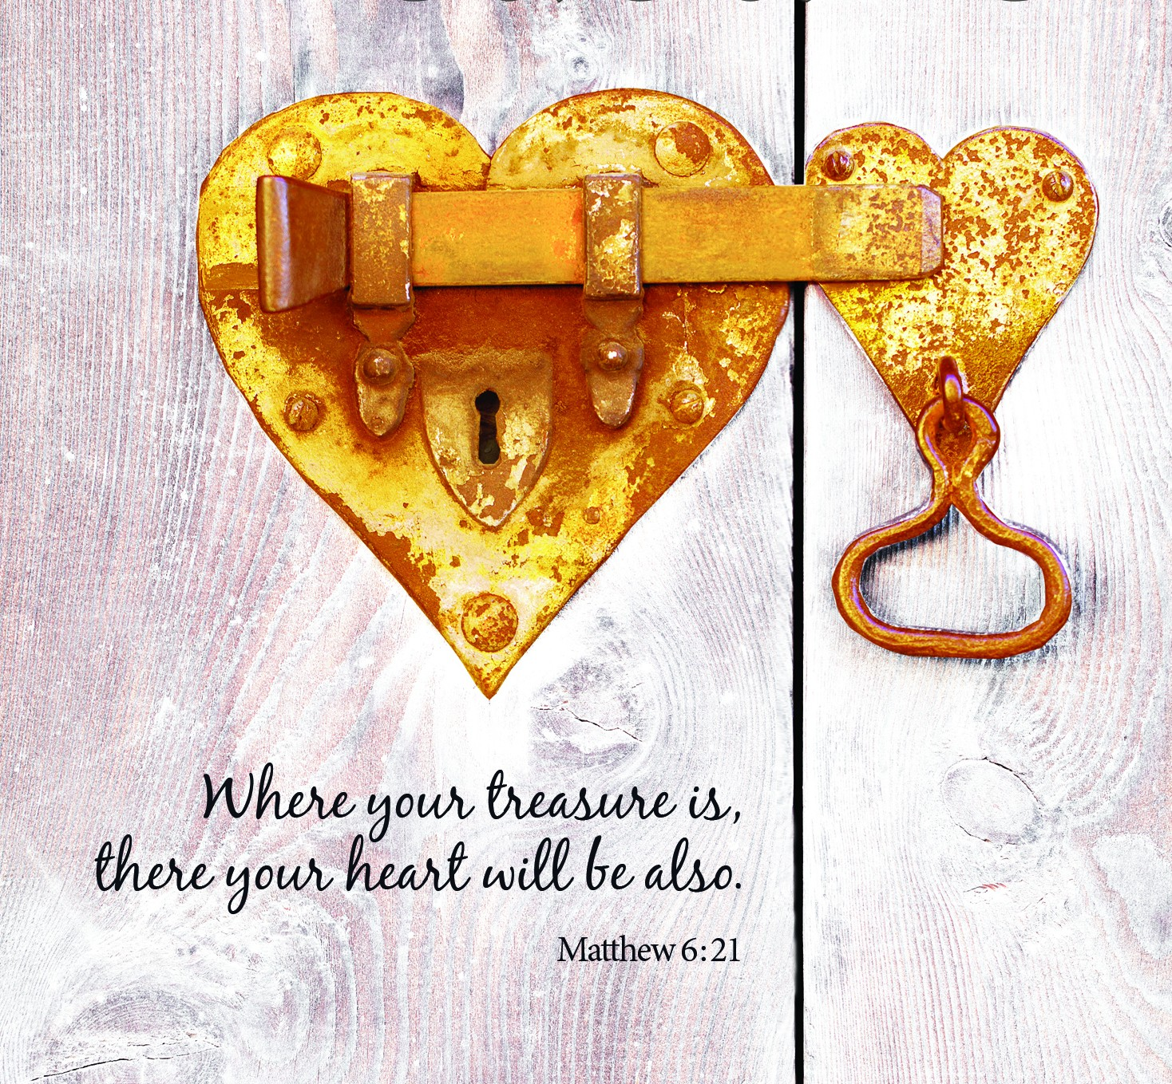Worship Brainstorming
“Treasure”
Tues., September 20, 2022 at LHUMC
12:00 p.m. Potluck
12:45-2:30 p.m. Brainstorming for Worship
October 9-30, 2022 (4 Sundays)

The worship brainstorming for this series will be held either in the Lounge or Fellowship Hall. Members of all ages and backgrounds are invited to participate in the one-time commitment. The ideas generated at the brainstorming are used in worship.
We will have a potluck at 12:00 p.m. Please bring a dish to share. Brainstorming is from 12:45-2:30 p.m.
More information is available at church and on our website. Please pick up the brainstorming packet at church or find it online, read the Scripture reading and Pastor Mary’s message synopses, and preview videos when they become available.
RSVPs are helpful but not mandatory. Sign up at church or contact the church office (213-798-2181 or Office@LakeHarborUMC.org) or Karen Booth (231-798-8431 or 231-557-1069 or kwbooth@comcast.net). Please read the Scripture and message synopses and preview the videos before we gather if at all possible.

2022 Theme: The Spiritual Journey Continues…
- Picking up the pieces
- Connecting the pieces
- Transformation
- Serving others (passionately)

Stewardship helps us recognize the relationship we have with God and our “stuff,” including the Good News (yes – evangelism aka the “E” word). How does our faith in Jesus show in our caring for God’s gifts as stewards?

2022 theme connection: The pieces of our lives will never fit together into the whole without generosity in its many forms.

Synopsis: Using a part of Jesus’ Sermon on the Mount in Matthew 6, we’ll explore the challenge of his words, “Where your treasure is, there your heart will be also.” Does our treasure follow our hearts, or does our heart follow our treasure? We’d like to think that our hearts do the leading, but usually it’s the other way around. How do we invest our gifts in the things that last and matter?

NOTE: We used this resource in 2018. What’s different now?
- We’re further into the future as a merged congregation.
- We’ve received a legacy gift from a community member/steward that will bless us far into the future. We’ve always been stewards of God’s gifts, but this gift calls us to be faithful stewards on behalf of someone who was a faithful steward.
- We’ve navigated through a global pandemic without major financial struggles. How is that possible? There has to be a high level of trust, commitment, connection, and community for faithful stewardship to continue. Generosity is a core value, and sharing financial information freely is helpful.
- We’re in the middle of concerns around the economy. How do those concerns stand up against Biblical wisdom to trust in God rather than money? How do we fight the temptation to hoard rather than to cultivate generosity?

Resources
Treasure by Jacob Armstrong and online resources like www.umc.org
- When the shovel finally hits something solid, will all the time, energy, and money spent to find the treasure uncover our heart’s desire?
- Jesus cares most about our hearts, and he knows that our treasure is directly related to where are hearts are.
- Our hearts always follow our treasure. Jesus cared about our treasure because he cared about our hearts.
- We have to talk about finances if we want to talk about faith; they are connected.
- What do you want to invest in? What are you invested in?
- How do we find contentment?

The Sower: Redefining the Ministry of Raising Kingdom Resources
by R. Scott Rodin & Gary G. Hoag
- Shift from transaction to transformation
- Move from two-kingdom bondage to one-Kingdom freedom
- Focus on cultivating hearts that will joyously become stewards
  - From the owner to the steward
  - Relationship with God, self, neighbor, and creation
- Grow as a sower

Definition of stewardship: reflecting our Creator God through whole, redeemed relationships (with God, self, neighbor, and creation), and glorifying God by practicing in each [relationship] the ongoing work the steward.
- Can Jesus liberate us from the love of money? How do we find joy in generosity?
- Giving is a spiritual discipline.
- Adam Morris says, “Generous giving is a result of God’s work in people…true generosity flows from transformed hearts as they are conformed to the image of Christ who is generous.” We want to move from transaction to transformation. We don’t have to master the practice of generosity before we experience the rewards. Sometimes it means starting small – and being intentional and regular in our giving. (A good image is a mosaic – small pieces make something beautiful.)
- We plant the seeds, but God makes things grow. I Corinthians 3: 1-9
- How do we become rich toward God?
- Stewardship and sanctification go together – growing in holiness of heart and life. God is concerned with who we are and how we’re growing in faith and trust. Faithful stewardship draws us closer to God.
- How many of us spend time praying and seeking God in the area of giving and/or making a faith commitment?
- Stewardship invites us to participate in involvement, instruction, intercession, and investment.
- Richard Foster: “God’s ownership of everything also changes the kind of question we ask in giving. Rather than ‘How much of my money should I give to God?’ we learn to ask ‘How much of God’s money should I keep for myself?’ The difference between these two questions is of monumental proportions.”

Stages of Giving from Wesley K. Willmer:
- Imitator – childlike, mimic examples of giving when shown or instructed
- Modeler – takes beliefs and moral values literally with perception of God formed by friends, sporadic giving with an example to follow
- Conformer – faith is basis for love, acceptance, and identity, giving shaped by relationships, giving is the thing to do with some benefits (recognition, taxes, personal gain)
- Individual – begins to own faith and personally examine/question beliefs, proportional giving, can be a danger in pride and wondering why others don’t give more
- Generous Giver – has an individualized faith and practice of giving and is interested in developing faith in others, recognizes that all we have is from God, joyful giving
- Mature Steward – focuses on God in giving and recognizes role as a steward of God’s gifts, treasures in heaven, daily bread

The Spirituality of Fund-Raising by Henri J.M. Nouwen
- How do we invite people to invest energy, prayers, and money in our mission, vision, and values? This is not begging, but inviting people others to join in God’s work with us.
- This is a change (maybe even a conversion) in how we understand and relate to our resources.
- Our family life has influenced our relationship with money. Did we ever talk about it?
- Gratitude flows from the recognition that who we are and what we have are gifts to be received and shared.

Related ideas
Social media posts – tweets:
- #1 - We often think our treasure follows our hearts. Jesus says the opposite! Our hearts will follow our treasure. #treasure
- #2 - Where do you want to invest your treasure (your time, energy, and money)? Where are you currently investing? #treasure
- #3 - You can’t serve God and money. How many masters are you serving? #treasure
- #4 - Investing our treasure in the things of God allows us to be a part of things bigger than ourselves. #treasure
- #5 - The closer we get to God, the more we are compelled to give away. #treasure
- #6 - Jesus sings his “don’t worry song” over us. #treasure

Visuals: Treasure map, treasure chest, lock and key

Media:
- There are short worship videos available to use each week (less than 1 minute). Graphics from 2018 are also available with each week’s video.

  - Promo video
  - Week #1
  - Week #2
  - Week #3
  - Week #4
- “All Saints.” The movie is based on the inspiring true story of salesman-turned-pastor Michael Spurlock (John Corbett), the tiny church he was ordered to shut down, and a group of refugees from Southeast Asia. Together, they risked everything to plant seeds for a future that might just save them all.
- Do we want to have a movie night in October?

Activities: Five Small Steps Toward Generosity are from The ReImagine Group, 16 Creative Ways to Think about Stewardship and Generosity, No Offering Plate Required (available as a PDF on our website).
- Make a Blessings Tree: Encourage our community to think about resources we can give other than money. Provide “leaves” for them to write the resource on and hang from a branch.
- Give a Weekly Challenge to Live Generously: Print simple acts of service as a challenge each week to take a small step toward thinking more generously including some specific to our community. Other, more general challenges can be used; such as, open the door for someone, look someone in the eyes, smile and say “hello,” take a neighbor a baked treat, or invite someone you would not usually to dinner.
- Random Acts of Kindness Card: Consider sharing stories on FaceBook.
- Encourage individuals and/or families to take a life inventory by asking “How could God better use our resources?”

Music: Change My Heart, O God (FWS 2152); Freely, Freely (UMH 389); Seek Ye First (UMH 405); Everything and Nothing Less

Social Justice Issue for October 2022: Gun Violence
----------------------------------------------------
October 9, 2022: “Where Is Your Treasure?”
18th Sunday after Pentecost

Scripture: Matthew 6: 19-21 (MSG)

A Life of God-Worship
¹⁹⁻²¹ “Don’t hoard treasure down here where it gets eaten by moths and corroded by rust or—worse!—stolen by burglars. Stockpile treasure in heaven, where it’s safe from moth and rust and burglars. It’s obvious, isn’t it? The place where your treasure is, is the place you will most want to be, and end up being.

Synopsis: Sometimes the things we value and love most get the least of our time, attention, and money. Jesus said that our hearts follow our treasure – not the other way around! How do we find true contentment, making sure that our time, energy, and money are invested in ways that connect us to God?
Felt need: To rethink our relationship to what we have and how we spend our time, energy, and money
Visuals: Beach (from the Treasure – Week 1 video)
Hands-on item:
Activity:
Media possibilities:
- “Generosity Prayer.” Length: 1:50. Cost: Free with subscription. Web license: Yes. May we pursue righteousness and Godliness, for our hope is not in wealth. Our hope is in God, our provider. https://www.playbackmedia.com/mini-movies/119443/generosity-prayer
- “A Sound Investment.” Length: 3:32. Cost: $19.99. Web license: Probably not. It’s a usual day at the financial planning office… until a man comes in looking for investments that will last for eternity. https://www.sermonspice.com/sermon-illustrations/49539/a-sound-investment
- “Today We Give.” Length: 1:25. Cost: Free with subscription. Web license: Yes. Using scripture from Matthew 6: 19-21, this reflective mini-movie is a statement from us to God expressing the heart behind why we give. https://www.playbackmedia.com/mini-movies/63990/today-we-give
Music:
Children’s Time:
Social media:

From Elizabeth Krogh:
One lesson from Mary Poppins is knowing the difference between the value of money and its worth. We don't often stop to think about "value," but it is explained brilliantly to young Michael Banks by Mr. Northbrook who, during a chance encounter at the bank, gives Jane and Michael each a coin:
Michael: I know the value of this: sixpence.
Northbrook: No, that's its worth. Its value's in how you spend it. Do good, and may you have good luck.
It's easy to forget that we are sending daily messages about what we value based on where and how we spend our money. If no one valued that morning cup of coffee, there would be no Starbucks. If no one valued entertainment, there would be no movie theaters, no Hollywood, no Netflix. Open your last bank statement (a novel concept in our paperless/ online world). What messages are you sending based on how and where you spend your money? Are those the messages you intended to send?

NOTES: Storing up treasure on earth is opposite of being rich toward God. (See Luke 12: 13-21 and I Timothy 6: 17-19). Heavenly treasure doesn’t decline in value.
----------------------------------------------------------
October 16, 2022: “The Problem with Two Masters”
19th Sunday after Pentecost

Scripture: Matthew 6: 24 (MSG)
²⁴ “You can’t worship two gods at once. Loving one god, you’ll end up hating the other. Adoration of one feeds contempt for the other. You can’t worship God and Money both.

Synopsis: We often feel conflicted in our lives because so many things seek our attention and our devotion. Jesus said you can’t serve two masters. Most of us are trying to serve a lot more than two! How can we serve God well so that other things fall into place and our hearts find true rest? Are we willing to let go of money in order to follow God?
Felt need: To put God first and follow the command to avoid idolatry
Visuals: City backdrop (from Treasure – Week 2 video).
Hands-on item:
Activity:
Media possibilities:
- “God and Money: Who Rules Your Heart?” Length: 2:12. Cost: $20.00. Web license: Yes. The purpose of the mini-movie is to ask questions that get people thinking about their money and why they give. https://www.sermonspice.com/sermon-illustrations/49385/god-and-money-who-rules-your-heart
- “The Truth about Money.” Length: 3:03. Cost: $19.99. Web license: Probably not. Culture has a lot to say about money, but what does the Bible have to say? https://www.sermonspice.com/sermon-illustrations/60874/the-truth-about-money
- “American Nightmare.” Length: 3:02. Cost: Free with subscription. Web license: Yes. A spoken word rap that presents a powerful message about the meaning of success and the daters of falling in love with wealth and riches. Based on I timothy 6: 6-10. https://www.playbackmedia.com/mini-movies/33785/american-nightmare
- “Meet the Sanders: Bailout.” Length: 2:36. Cost: $16.99. Web license: Yes. Jim and Joweena Sanders are broke and up to their eyeballs in debt. Here’s what not to do during an economic crisis. https://skitguys.com/videos/meet-the-sanders-the-bailout
Music:
Children’s Time:
Social media:
NOTES: Rick Warren: “Money has the greatest potential to replace God in your life…When Jesus is your Master, money serves you, but if money is your master, you become its slave.” (And it becomes an idol. – added by Pastor Mary)
Henri Nouwen: We cannot find security if our heart is divided.
----------------------------------------------------

October 23, 2022: “Giving Our Treasure Back to God”
20th Sunday after Pentecost
Pulpit Swap – Rev. Tim Dibble (White Lake UMC)

Scripture: Matthew 6: 1-6 (MSG)

The World Is Not a Stage
6 “Be especially careful when you are trying to be good so that you don’t make a performance out of it. It might be good theater, but the God who made you won’t be applauding.
²⁻⁴ “When you do something for someone else, don’t call attention to yourself. You’ve seen them in action, I’m sure—‘playactors’ I call them—treating prayer meeting and street corner alike as a stage, acting compassionate as long as someone is watching, playing to the crowds. They get applause, true, but that’s all they get. When you help someone out, don’t think about how it looks. Just do it—quietly and unobtrusively. That is the way your God, who conceived you in love, working behind the scenes, helps you out.

Pray with Simplicity
⁵ “And when you come before God, don’t turn that into a theatrical production either. All these people making a regular show out of their prayers, hoping for fifteen minutes of fame! Do you think God sits in a box seat?
⁶ “Here’s what I want you to do: Find a quiet, secluded place so you won’t be tempted to role-play before God. Just be there as simply and honestly as you can manage. The focus will shift from you to God, and you will begin to sense his grace.

Synopsis: We earn, spend, and (sometimes) save money. We also want to give, but sometimes giving is the last thought rather than our first. How do we hear Jesus’ call to humility in living and giving?
Felt need: To hear Jesus’ call to humility in living and giving
Visuals: Leaves for the “treasure tree.”
Hands-on item:
Activity:
Media possibilities:
- “Giving Inspiration.” Length: 2:10. Cost: Free with subscription. Web license: Yes. Living a life that is committed to giving is a powerful concept, especially when it’s focused on more than just money. https://www.playbackmedia.com/mini-movies/86705/giving-inspiration-20
- “Tithing.” Length: 1:57. Cost: $15.00. Web license: Probably not. This is a video promoting the people to give back to God what He has giving to us. Tithing is an act of worship. https://www.sermonspice.com/sermon-illustrations/43604/tithing
Music:
Children’s Time:
Social media:
NOTES: Stewardship and sanctification go together – growing in holiness of heart and life. God is concerned with who we are and how we’re growing in faith and trust. Faithful stewardship draws us closer to God.
-------------------------------------------------

October 30, 2022: “Don’t Worry ‘bout a Thing”
21st Sunday after Pentecost

Scripture: Matthew 6: 25-34 (MSG)
²⁵⁻²⁶ “If you decide for God, living a life of God-worship, it follows that you don’t fuss about what’s on the table at mealtimes or whether the clothes in your closet are in fashion. There is far more to your life than the food you put in your stomach, more to your outer appearance than the clothes you hang on your body. Look at the birds, free and unfettered, not tied down to a job description, careless in the care of God. And you count far more to him than birds.
²⁷⁻²⁹ “Has anyone by fussing in front of the mirror ever gotten taller by so much as an inch? All this time and money wasted on fashion—do you think it makes that much difference? Instead of looking at the fashions, walk out into the fields and look at the wildflowers. They never primp or shop, but have you ever seen color and design quite like it? The ten best-dressed men and women in the country look shabby alongside them.
³⁰⁻³³ “If God gives such attention to the appearance of wildflowers—most of which are never even seen—don’t you think he’ll attend to you, take pride in you, do his best for you? What I’m trying to do here is to get you to relax, to not be so preoccupied with getting, so you can respond to God’s giving. People who don’t know God and the way he works fuss over these things, but you know both God and how he works. Steep your life in God-reality, God-initiative, God-provisions. Don’t worry about missing out. You’ll find all your everyday human concerns will be met.
³⁴ “Give your entire attention to what God is doing right now, and don’t get worked up about what may or may not happen tomorrow. God will help you deal with whatever hard things come up when the time comes.

Synopsis: Worries about money are nothing new. Jesus knew that when he called us to stop worrying and remember that God cared for and provides for us. Do we trust God’s way of providing and willingly invest in God’s Kingdom work as a witness to the world?
Felt need: To offer our faith commitments with joy for 2023
Visuals: Birds. Lilies. A waterfall of worry (from the Treasures – Week 4 video).
Hands-on item:
Activity:
Media possibilities:
- “Do Not Worry.” Length: 1:56. Cost: Free with subscription. Web license: Yes. Worry… In times like these, it seems so easy to be consumed by it. But what did Jesus say about worrying? Matthew 6: 25-33. https://www.playbackmedia.com/mini-movies/13284/do-not-worry
- “Birds and Flowers.” Length: 2:55. Cost: $15.00. Web license: Probably not. Jesus invites us to fend off worry by looking at the birds of the air and the flower of the field. https://www.sermonspice.com/sermon-illustrations/61849/birds-and-flowers
Music:
Children’s Time:
Social media:
NOTES: Do we give out of our surplus – or do we give sacrificially?

