2022 Worship Theme:
The Spiritual Journey Continues…
Updated September 27, 2021

Members at the planning retreat: Dave Booth, Vicki Zuker, Jan Justus, Diane Thompson, Barb Gripton, Karen Post, Jim Post, Lynne Richmond, Marie Kordecki, Larry Jorgenson, Betty Kinney, Rose Emmons, Jimmy Epplett, Brad Hilleary (Friday), Michael Boersma (Saturday), Pastor Mary Ivanov, Karen Booth

Theme: The Spiritual Journey Continues…
- Picking up the pieces
- Connecting the pieces

- Transformation
- Serving others (passionately)

Metaphors:
- Puzzle/puzzle pieces – making a new picture. Related hands-on item: puzzle piece with scripture reference.
- Mosaic – creating something beautiful from broken pieces

Major spoken/unspoken needs:
- Dealing with fear, which often presents itself as anger and rage. One antidote to fear is serving.
- Peace, sense of belonging, safe communities, coming together, compassion
- Finding a new normal – less busy, better sense of priorities, greater gratitude, increased resilience
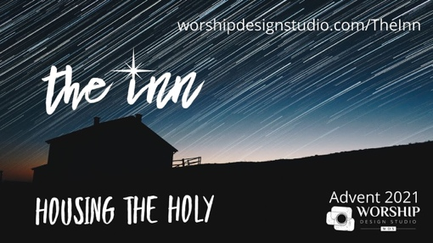
---------------------------------------------------
“The Inn: Housing the Holy”
Based on a series by Marcia McFee
November 29, 2021 – December 26, 2021
(5 weeks plus Blue Christmas and Christmas Eve)
Brainstorming: Week of Nov. 1 or 8, 2021

Synopsis: The pandemic has laid bare, and widened, economic disparity locally and globally. As we enter the Advent season, how can our churches become houses where the Holy will be born anew – offering respite, sustenance and care, opening the doors ever wider to those seeking shelter from the onslaught of life? No one church can do it all, but each can do something. As we study the biblical prophets that call us to care for our neighbors and “make room in the inn,” the lonely and frightened spaces within us are filled with the light of Hope, Peace, Joy, and Love.

2021 theme connection: Hope and renewed community are born again when we practice radical hospitality.
Original music: “Hope Waits for Us at Christmas” by Amada Udis-Kessler, “The Manger is Stranger” (for choir), “Make of My Heart a Stable” (prayer song)
Intro video: https://lksadzj0.pages.infusionsoft.net/
Resource: We Aren’t Broke by Mark Elsdon

Advent 1 – Nov. 29: “Making Room” (Hope). We usually associate fasting with Lent, but the Eastern Church observes a “Nativity Fast” in preparation for the birth of Christ, understanding fasting as a way to “make more room” for the Holy and sift our focus to care of the neighbor. In a time when so many are suffering the economic consequences of the pandemic, we are invited this year to create more hope in the world as we learn to reallocate and multiply resources in ways that are just and right. Scripture: Jeremiah 33: 14-16 and Psalm 25: 4-5
Advent 2 – Dec. 5: “A Place at the Table” (Peace). Like the childhood game of “musical chairs,” we are convinced that there are not enough places at the table. And so, we shrink the guest list just in case there is not enough, and we scramble to occupy the chairs first. And yet our sacred texts invite us to imagine and make real the gathering of all people to the table, robed in the garments of a peace that comes with justice. This is what really matters – this is the fruit of what is right and good. Scripture: Baruch 5: 1-5 and Philippians 1: 9-11.
Advent 3 – Dec. 12: “How Much Is Enough?” (Joy). As John baptized new converts, he invited them to live with “changed hearts and lives.” When asked how to do that, his answers all point to making sure no one is cheated or left without the basic necessities of life, including the right to not be harassed. A full life of joy, which the prophet Isaiah describes as an ever-flowing spring, is the birthright of all children of God. May we act to make it so. Scripture: Isaiah 12: 2-6 and Luke 3: 10-14.
Advent 4 – Dec. 19: “A Room with a View” (Love). This has been an Advent season of prophets: Jeremiah, Baruch, Isaiah, Micah. And now the prophet is Mary – the woman who was the original house for the holy. She was “the inn,” her womb gestating love for the world. With all her hearts, she proclaims that the lowly are lifted, the hungry are fed, mercy reigns. Like Mary, we must envision, must see, must prophesy and act on that vision for the world that God continues to call us to co-create. What is the view from the room that God has prepared? Scripture: Micah 5: 2-5a and Luke 1: 46-55.
Christmas Eve – Dec. 24: “The Inn.” The Inn is now open for business. The long-awaited Messiah has been born and on him the light shines. We have only to open the doors of our lives and to say “welcome.” Our Advent journey has led us to this moment when the light shining through a closed door becomes one opened to new possibilities, new relationships. What a poignant moment for us this year as the light – the hope, peace joy, and love – multiples from one illuminated heart and hand to another. Scripture: Isaiah 9: 2-7 and Luke 2: 1-7 (8-20).
Sunday after Christmas – Dec. 26: “Dwelling.” Developed in the 14th century, the word “dwell” became known as a “lingering” or “abiding.” It had connections to “In-habit” – another word developed at that time. After an Advent/Christmas season of focusing on housing the holy, how will we linger and abide in this habit of hospitality? What habits did you invite into your heart in this season that you desire to take with you into the new year? How might we sustain the dwelling places that feed, house, clothe those who need it most? Scripture: Colossians 3: 12-17 and Luke 2: 41-52
------------------------------------------------
“The Walk: Five Essential Practices of the Christian Life”
Based on a book by Adam Hamilton
January 2 – 30, 2022 (5 weeks)
Brainstorming: Week of December 12, 2021

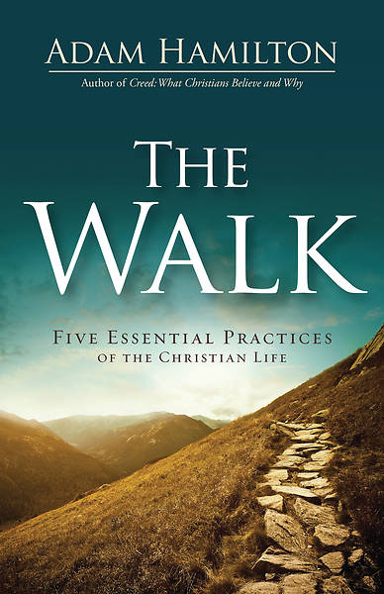
Note: Pastor Mary is taking a four-week renewal leave in January and will ask members of the Men’s Group to preach in her absence.

Synopsis: How do we walk with Christ – daily follow him, grow in him, and faithfully serve him? Discover five essential spiritual practices rooted in Jesus’ own walk with God. In the Gospels, Jesus modeled for us the Christian spiritual life. The apostles taught it in their writings. And the Church has, through the last 2,000 years, sought to pursue this Christian spiritual life. In each chapter, Hamilton explores ones of these practices – each of which is intended to be part of our daily walk with Christ – its New Testament foundation, and its potential effect on our personal lives and our lives together as the church. https://my.amplifymedia.com/amplify/series/unitedmethodistpublishinghouse/29224-the-walk

2021 theme connection: Spiritual disciplines are part of our journey. Adam Hamilton is a biblically grounded and accessible author whose centrist approach can help us on our walk.
Promotional video: https://www.youtube.com/watch?v=SEjpOgGoEWs
Related ideas:
- Wear an invitation (t-shirt that acts as a conversation starter). Stewardship.
- Consider offering a small group study using Hamilton’s book as a resource.
Music: “Holy Spirit” by Jesus Culture (https://www.youtube.com/watch?v=ktsPuZvH-rQ)

Week 1 – Jan. 2: “Worship and Prayer: A Living Hallelujah.” Hamilton discusses the importance of worshiping regularly with gratitude and invites us to pray.
Week 2 – Jan. 9: “Study: The Importance of Listening and Paying Attention.” Hamilton reminds us of the importance of listening to God’s voice, and explores various ways God speaks to us, including general revelation such as nature and special revelation such as Scripture.
Week 3 – Jan 16: “Serve: Here I Am, Lord, Send Me.” The call to follow Jesus is fundamentally a call to service, which we do both individually and together in our church.
Week 4 – Jan. 23: “Give: Where Your Treasure Is.” The way we spend our money is a kind of “selfie” that shows us our priorities, and identifies gratitude and generosity as keys to living a good life. He calls us to invest in God’s kingdom rather than possessions.
Week 5 – Jan. 30: “Share: Going fishing, Reflecting Light.” We are called to bear witness to Christ by sharing our faith with others, which we do by letting our light shine and by using words to tell people what Jesus means to us.
------------------------------------------
“The Faith of a Mockingbird”
Based on a book by Matt Rawle
February 6-27, 2022 (4 weeks)
Brainstorming: Week of January 10 or 17, 2021
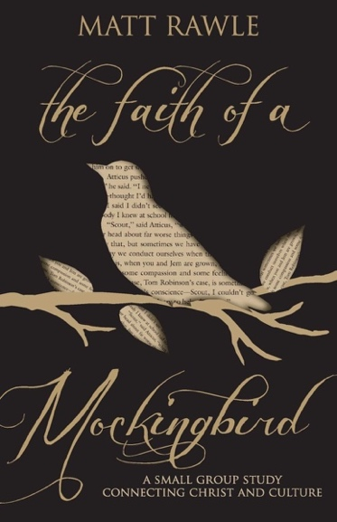
Synopsis: Pastor and author Matt Rawle sees Christ all around him – in books, movies, TV shows, rock music – and he want to share what he sees. As Matt says, “God offers the raw ingredients, and ‘culture’ is whatever we cook up.”
In The Faith of a Mockingbird, Matt Rawle uses Harper Lee’s beloved characters from To Kill a Mockingbird to explore Christian faith, theology, and ethics. Join Scout, Atticus Finch, Boo Radley, and Tom Robinson in the four-week study considering God’s world and what it all means.

2021 theme connection: Transformation. We don’t have to learn everything first-hand. Literature is a great resource for seeing how characters are transformed by events and their interactions with each other.
Series promotional video: https://www.youtube.com/watch?v=dHJkAkHGnYA
Movie trailer: https://www.youtube.com/watch?v=KR7loA_oziY
Related interview: Reconciliation with God & Others. https://www.youtube.com/watch?v=8_643qTmuck

Week 1 – Feb. 6: “Scout Finch: Telling Your Story.” Using the song of the mockingbird, Matt Rawle describes how cultural movements affect the church and church life challenges culture, like the movements of a Spirit-inspired dance.
Week 2 – Feb. 13: “Atticus Finch: When Your Story Is Change.” Rawle uses Atticus Finch to describe the difference between a hero and a saint, and how Christ calls us to put aside our heroic aspirations for a saint’s holy calling.
Week 3 – Feb. 20: “Tom Robinson: When Challenge Is Defining.” In order to explain the difficulty of recognizing systemic racism, Matt Rawle uses a how a choir stays in tune to show how easy it is for a system to miss the mark.
Week 4 – Feb. 27: “Boo Radley: Defining a Mystery.” Using the mystery of Boo Radley, Matt Rawle explains how the more we practice God’s will, the more our holy imagination can capture who God is and what God is doing in the world.
------------------------------------------
“Selah: Life in a Minor Key”
March 2 – April 17, 2022
(Ash Wednesday and 7 weeks of Lent)
There are no Holy Week plans in the series as originally designed
Brainstorming: Week of February 7

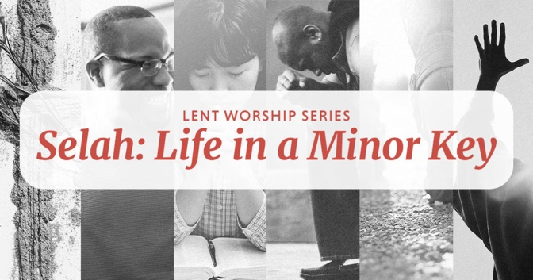
Synopsis: The theme for this Lenten series comes from an obscure, but often repeated word in various psalms: Selah. There is much debate as to what the word means, whether it is instruction, description, or simply a punctuation of some kind.

2021 theme connection: The Psalms are full of examples of people who cry out to God for help and praise him through life’s challenges.
Resource: Based on a Discipleship Ministries lectionary series https://www.umcdiscipleship.org/worship-planning/selah-life-in-a-minor-key
Holy Week: From Discipleship Ministries: Even though Palm Sunday is part of Lent, we’ve chosen to deal with it separately, as a part of the Holy Week/Easter commemoration and celebration. Therefore, this week is the last week in our Selah series.

Ash Wednesday – March 2: Ash Wednesday is a call to claim a Savior, to begin a journey of reconciliation. And it starts with confession, “Sometimes I feel like a motherless child, a long way from home.” Scripture: Psalm 51: 1-17.
Lent 1 – March 6: “Happy Are Those.” Happy isn’t a mood we associate with the season of Lent. Lent seems to call for something a little more somber, reflective, and inward looking. Certainly, the Lenten journey calls for attention to the inner self and the working of spiritual disciplines in the life of individual and the community of faith. It is also true that the weight of our sinfulness and our need for a savior becomes an undeniable presence during this season. But a light heart is not forbidden, even in Lent. We are sinners who know a savior. We are acquainted with the one who has a solution to the brokenness of our souls. In other words, “there is a balm in Gilead, to heal the sin-sick soul.” “Happy are those whose transgression is forgiven.” Scripture: Psalm 32.
Lent 2 – March 13: “Going Out and Coming In.” It’s only week two in Lent; there’s a long road ahead of us. Yet, if we’re not careful, we can begin to stop paying attention. We can begin to fall into the routine of the Lenten season. Let’s not forget that Lent is about upsetting the routine and turning us inward and outward at the same time. God is here, even in the most routine moments of our lives. As we journey through this season, when we pay attention and when we forget to, when we go out and when we come, we are not alone. In the morning when we rise, give me Jesus. Scripture: Psalm 121.
Lent 3 – March 20: “Worship and Bow Down.” There are many words throughout the Bible that are translated as worship. Many of them involve bodily movement of some sort. The worship posture described often in the Hebrew scriptures is face down on the ground. The psalmist this week tells us to bow, and to kneel. Worship is not just, or even primarily, a head thing. It is a whole-body thing; we pour ourselves out in worship. We enter the worship space and nothing else matters but the community who gathers and the God we worship. We worship, not to neglect the world, but to remember the Creator of the world who sends us out to live and love that world and all who dwell in it. But in this moment, in this “ain’t got long” moment, we steal away to Jesus. Scripture: Psalm 95
Lent 4 – March 27: “In Right Paths.” Of all the songs in the hymn book of the people of God, the 23rd Psalm is probably the most beloved. It is almost impossible to read these six verses without hearing a favorite version sung. And there are many hymns and sons that take the central themes of the psalm and wrap them in beautiful music. We could argue for a long time about why this brief psalm has so captured the hearts of so many. But at the heart of this hymn is an invitation to trust in the one who provides care, the one who gathers in, the one who heals and comforts and loves, the one who puts our feet on the right path. And that’s our prayer this Lenten season: “Guide my feet, while I run this rase, for I don’t want to run this race in vain!” Scripture: Psalm 23.
Lent 5 – April 3: “Out of the Depths.” Psalm 130 provides a proper ending to the series and an anticipation of what is to come. The psalm is a cry from the depths of pain or despair. And there is no clear resolution, no clear fix to the brokenness; the separation still abides. And yet, there is hope. There is confidence, even from a position of pain, that resolution is at hand. There is a trust that even in suffering, there is someone who knows us. Even if nobody knows the trouble we see, there is always a “but” in our faith; nobody knows, but Jesus. Scripture: Psalm 130.

Palm Sunday possibility – April 10: Psalm 118: 1-2, 19-29 (palms – His Steadfast Love Endures Forever); Psalm 31: 9-16 (passion – Into Your Hand I Commit My Spirit)!Unexpected End of Formula
These Psalms are from the lectionary.
Holy Thursday - April 14: Psalm 116: 1-4, 12-19; Psalm 41: 9 (Even my close friend in whom I trusted, who ate my bread, has lifted his heel against me.); Psalm 102 (Do not hide your face from me.)
Good Friday - April 15: Psalm 22 (My God, my God, why have you forsaken me?)
Easter Sunday – April 17: Psalm 118: 1-2, 14-24 (This is the day that the Lord has made; let us rejoice and be glad in it.)
----------------------------------------------------------
“Revelation Song”
April 24 – May 29, 2022 (6 weeks)
Brainstorming: Week of March 28 or April 4

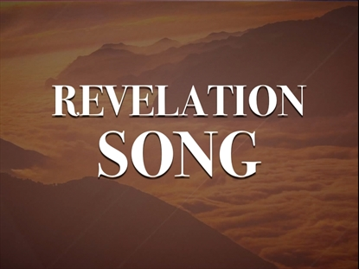
Synopsis: In recent years, people have looked to Revelation to explain politics, the pandemic, and other undesirable events, interpretations which are neither helpful nor accurate. The pastoral letter was written to specific people in a specific time and place using what we generally describe as bizarre imagery. It was never intended to frighten or confuse; it was intended to create unshakeable hope! *

2021 theme connection: This (lectionary-based) series can offer us the same hope to us in our messed-up world as it did to its original audience.
Resource:
- Breaking the Code by Metzger Silva
- *https://summitview.net/revelation/?sapurl=Lys1YTU2L2xiL21zLyszM203anE2P2JyYW5kaW5nPXRydWUmZW1iZWQ9dHJ1ZSZyZWNlbnRSb3V0ZT1hcHAud2ViLWFwcC5saWJyYXJ5Lm1lZGlhLXNlcmllcyZyZWNlbnRSb3V0ZVNsdWc9JTJCMzNtN2pxNg==
Illustration: Ralphie’s secret decoder ring from “The Christmas Story”
Note: Annual Conference is May 31 – June 5
Music: “Revelation Song”

Week 1 - April 24: Revelation 1: 4-8 (I am the Alpha and the Omega…)
Week 2 - May 1: Revelation 5: 11-14 (Worthy is the Lamb…)
Week 3 - May 8: Revelation 7: 9-17 (The Multitude from Every Nation)
Week 4 - May 15: Revelation 21: 1-6 (Then I saw a new heaven and a new earth…)
Week 5 - May 22: Revelation 21: 10, 22 – 22:5 (Vision of a New Jerusalem)
Week 6 - May 29: Revelation 22: 12-14, 16-17, 20-21 (Jesus is Coming)
----------------------------------------------------
“Holy Spirit”
June 5-26, 2022 (4 weeks)
Brainstorming: Week May 9 or 16. Combine with “The Lord’s Prayer.”

Synopsis: Following the Gospels, Jesus made it very clear that God will send a helper for us. This helper is the Holy Spirit. But many of us have a hard time grasping what the Holy Spirit really is. We understand that the Holy Spirit is part of the Holy Trinity, but what does that mean? Where did the Holy Spirit come from? Is it always with me? How does this help? https://churchsermonseriesideas.com/holy-spirit/

2021 theme connection: This is a good follow-up to last year’s in-depth study of Mark. The Holy Spirit offers guidance and love. The Spirit is Christ within us and speaks for us when we can’t find words, especially when we speak about faith. Sometimes we know it as a Convicter or Discomforter, correcting us into greater obedience. How might our expectations change if we willingly become more vulnerable to its direction?
Resources:
- https://www.ministrymatters.com/all/entry/1733/sermon-series-the-holy-spirit
- https://churchsermonseriesideas.com/5-best-holy-spirit-sermon-series/
Music: “Come, Holy Spirit, Heavenly Dove”; “Pass It On”;
VBS: Food Truck Party Key verse: “Give us this day our daily bread.” Matthew 6:11 (a good lead-in to “The Lord’s Prayer” in July)

Week 1 - Pentecost - June 5: Acts 2: 1-21 (When Pentecost arrived…); Romans 8: 14-15 (All who are led by God’s Spirit are God’s sons and daughters…)
Week 2 - June 12: Romans 5: 1-5 (“Peace and Joy”)
Week 3 - June 19: Romans 8 (“Life through the Spirit”) – not part of the lectionary
Week 4 - June 26:
----------------------------------------------
“The Lord’s Prayer”
July 3-31, 2022 (5 weeks)
Brainstorming: Week of May 9 or 16. Combine with “Holy Spirit.”

Synopsis: The Lord’s Prayer. This incredibly famous prayer is memorized and recited by millions all around the world. It has shown up in countless films, TV, shows, books, and song. The Lord’s Prayer is so well-known and widely quoted, many people think of it as just an old prayer from the past… it’s a powerful truth that should define how we live and pray in the present. In just a few short sentences, Jesus gave us a timeless prayer containing the most important things we need to know and believe. In this series, we will break down the prayer line by line and reveal how its truth apply to us and our prayer lives today. (https://gatewaypeople.com/series/the-lord-s-prayer)

2021 theme connection: The Lord’s Prayer is one foundation of our faith. Our spiritual journey should be built on a firm foundation.
Resources:
- https://national.cc/media/the-lords-prayer#seriesoverview
- https://www.worshiphousemedia.com/mini-movies/40400/the-lords-prayer-series-intro
----------------------------------------------
“God’s Good Gift of Sexuality”
August 7-28, 2022 (4 weeks)
Brainstorming: Week of July 11 or 18

Synopsis: Human beings are created in the image of a relational God and designed to enjoy an intimate relationship with their Creator and one another. There is no dichotomy between body and spirit in the Old or New Testaments. In this series, we will explore where our understanding of His good gift got so messed up and what he actually intended.

2021 theme connection: We don’t hear much biblical truth spoken around the topic of sexuality. Even as adults our understanding of love, lust, sex, sexuality, marriage, porn, grace, and commitment leaves a lot to be desired. How can we pick up the pieces of this puzzle and grow into healthier relationship?
Resources:
- Love to Stay: Sex, Grace, and Commitment by Adam Hamilton
- Small group study of the Five Love Languages: How to Express Heartfelt Commitment to Your Mate by Gary Chapman
- Sex God: Exploring the Endless Connections between Sexuality and Spirituality by Rob Bell
- Shameless: A Sexual Reformation by Nadia Bolz-Weber
- “Social Principles: The Nurturing Community.” https://www.umc.org/en/content/social-principles-the-nurturing-community
- “Wonderfully Made and Difficult Conversations.” https://www.umcdiscipleship.org/blog/wonderfully-made-and-difficult-conversations
- “Facing Up to Pornography and Sexual Addictions.” https://www.umcdiscipleship.org/resources/facing-up-to-pornography-and-sexual-addictions
- An Affirmation of God’s Gift of Sexuality https://family.adventist.org/an-affirmation-of-gods-gift-of-sexuality/
----------------------------------------------
“Half Truths”
Based on a book by Adam Hamilton
September 4 – October 2, 2022 (5 weeks)
Brainstorming: Week of August 8. Could be combined with Stewardship.

Synopsis: We’ve heard certain phrases all of our lives, but in Adam Hamilton’s book, Half Truths, you will learn that although they capture some element of truth, when compared to the wisdom found in Scripture, they’re really just popular sayings. What is the truth? How can we discover truth through context and close reading? What does that tell us about the nature of God? What happens when we view the world through the lens of Jesus?

2021 theme connection: Part of our spiritual journey is recognizing that we believe some things that are not biblical accurate or helpful. Too often we share these “half-truths” as the Gospel truth and hurt others.
Resource:
- https://my.amplifymedia.com/amplify/series/unitedmethodistpublishinghouse/14418-half-truths
- Everything Happens for a Reason and Other Lies I’ve Loved by Kate Bowler
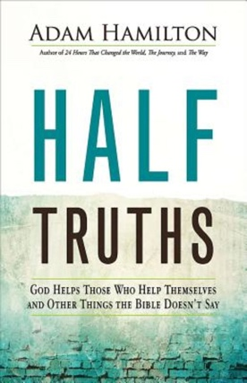
- The Will of God by Leslie Weatherhead
Half Truths promo: https://www.youtube.com/watch?v=q44KNpgbh8I&t=1s
Preview video: https://www.youtube.com/watch?v=QAEL5z38Exw

Week 1: Everything happens for a reason.
Week 2: God helps those who help themselves.
Week 3: God won’t give you more than you can handle.
Week 4: God said it, I believe it, that settles it.
Week 5: Love the sinner, hate the sin.
----------------------------------------------
Stewardship
October 9-30, 2022 (4 weeks)
Brainstorming: Week of September 5 or 12
Could be combined with “Half Truths” at the August brainstorming

Synopsis: Stewardship helps us recognize the relationship we have with our “stuff,” including the Good News (yes – evangelism aka the “E” word). Pastor Mary will draw on her current leadership development classes for material.

2021 theme connection: The pieces of our lives will never fit together into the whole without generosity in its many forms.
----------------------------------------------
“Belonging: Home and Family”
November 6-20, 2022 (3 weeks)
Brainstorming: Week of October 10

Synopsis: Everyone wants a place to belong. Home. Family. They should be places where we feel safe, loved, and comfortable. What happens when we lose life-giving relationships and our sense of belonging?

2021 theme connection: We want the pieces of our live to fit together and create a beautiful picture.
Music: “Good, Good Father”
Resources: A Place to Belong: Learning to Love the Local Church by Megan Hill. Synopsis: Christians know church is important, but sometimes it doesn’t seem worth the effort to connect. An eclectic assortment of people with differing personalities, political views, and parenting styles can make for awkward interactions and difficult connections. What’s the point of putting in the tough work to build relationships? But the Bible says God’s people ought to be bound together. It uses words like beloved, brothers and sisters, saints, and fellow laborers to describe their mutual relationship in the church…. (The author) encourages and equips both first-time visitors and regular members to delight in being a part of the local church – no matter how messy and ordinary it seems today. It is only when God’s people begin to see one another as the Lord sees them that they will truly find a place to belong. https://store.thegospelcoalition.org/tgc/products/7100/a-place-to-belong
Movies:
- “Show Me the Father.” This documentary by the Kendrick brothers explores the influence of men on children, fatherlessness, adoption, coaching, and a father’s blessing and invites you to think differently about your earthly father and also how you personally relate to God. https://www.youtube.com/watch?v=i2l0s9U4jh8
- “Luca” is a coming-of-age story about one young boy experiencing an unforgettable summer filled with gelato, pasta and endless scooter rides. Luca shares these adventures with his newfound best friend, but all for the fun is threatened when by a deeply-held secret: they are sea monsters from another world just below the water’s surface. https://www.youtube.com/watch?v=mYfJxlgR2jw
- “The Mitchells vs. The Machines.” A quirky dysfunctional family’s road trip is upended when they find themselves in the middle of the robot apocalypse and suddenly become humanity’s unlikeliest last hope. https://www.youtube.com/watch?v=_ak5dFt8Ar0

