2021 Worship Theme:
Still Blessed
Updated September 18, 2020

Members at the planning retreat: Michael Boersma, Karen Booth, David Booth, Rose Emmons, Barb Gripton, Brad Hilleary, Ivan Ivanov, Pastor Mary Ivanov, Betty Kinney, Ken Luckett, Jim Post, Karen Post, Linda Rousell, Mary Swisher, Diane Thompson

Ideas related to the theme:
- Are You Ready for 2021? Reset. Remember/Recall. Reflect. Renew. Refocus. Revival, Reinvent. Re-do. Reevaluate. Resilient. Rebirth. Regret. Respond. Reverse.
- What do we do after the “dumpster fire” year that was 2020? There has been so many layers of stuff – not seeing friends/family/congregation, COVID-19, job loss, weird school situation, social unrest, fires, election craziness, church hypocrisy, crisis fatigue, and more. Go back to basics. Make Lake Harbor a safe harbor. Realize that God still blesses everyone, even in messes. Recognize that sanctuary is an atmosphere, not a place. We need a Lovedemic not a pandemic.
- Theme song: “The Blessing” lyrics are show here (excerpt only)

The Lord bless you
And keep you
Make His face shine upon you
And be gracious to you
The Lord turn His
Face toward you
And give you peace

The Lord bless you
And keep you
Make His face shine upon you
And be gracious to you
The Lord turn His
Face toward you
And give you peace

Amen, amen, amen
Amen, amen, amen

May His favor be upon you
And a thousand generations
Your family and your children
And their children, and their children

May His presence go before you
And behind you, and beside you
All around you, and within you
He is with you, He is with you

In the morning, in the evening
In your coming, and your going
In your weeping, and rejoicing
He is for you, He is for you

Songwriters: Christopher Joel Brown / Cody Carnes / Kari Brooke Jobe / Steven Furtick
The Blessing lyrics © Essential Music Publishing https://www.youtube.com/watch?v=jiko8DSRMZI
- Related article: “‘The Blessing’ Sung around the World: 100 Virtual Choirs Spread Worship Anthem,” July 30, 2020, “Christianity Today.
---------------------------------------------------
“Incarnation:
Rediscovering the Significance of Christmas”
Based on a book by Adam Hamilton
Nov. 27, 2020 – Jan. 3, 2021
(five weeks plus Blue Christmas and Christmas Eve)
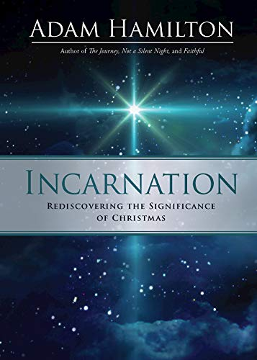
Brainstorming: Monday, November 9, 2020

2021 Theme connection: “Incarnation claims that God actually became flesh in Jesus.” See highlighted info below.
Key word: Relationship

Synopsis: Learn the meaning behind the names of Christ and the difference He makes in our lives this Christmas.
His parents gave him the name Jesus. But the prophets, the shepherds, the wise men, and the angels addressed him by other names. They called him Lord, Messiah, Savior, Emmanuel, Light of the World, and Word Made Flesh. In Incarnation: Rediscovering the Significance of Christmas, best-selling author Adam Hamilton examines the names of Christ used by the gospel writers, exploring the historical and personal significance of his birth. This Advent season church families will come together to remember what’s important. In the face of uncertainty and conflict, Christians reclaim the Christ child who brings us together, heals our hearts, and calls us to bring light into the darkness. Now more than ever, we invite you to reflect upon the significance of the Christ child for our lives and world today!

Related music: Song by Michael W. Smith
Activity: Advent devotions written by members. Reflect on the names of God. Potential volunteers: Rose Emmons (Emmanuel), Michael Boersma (Savior)
Visuals: Lights – on the tree on the north side of church

November 29, 2020: Advent 1 - Christ, Messiah, King
December 6, 2020: Advent 2 - Savior
December 13, 2020: Advent 3 - Emmanuel. God with us. How have we seen God with us during the pandemic?
December 20, 2020: Advent 4 - Word Made Flesh. Light of the World.
To be determined: Blue Christmas. Speaks to doubts, sadness, personal and collective grief in the “happiest time of the year.”
December 24, 2020: Christmas Eve
December 27, 2020: Christmas 1
January 3, 2021: Epiphany - Jesus Is Lord. Magi worship Him as Lord.

---------------------------------------------------
“Good News for a New Year”
Focus: The Gospel of Mark
Jan. 10 – Feb. 14, 2021
(six weeks)
Brainstorming: Monday, December 14, 2020

2021 theme connection/synopsis: Everyone needs good news. The Good News is needed more than anything. The Gospel of Mark wastes no time getting to the truth: We are blessed because God is here, he’s on our side, is passionate to save us, and the whole world is radically different because Jesus breaks down barriers.
Key word: Reset

Scripture: The Gospel of Mark (from the lectionary – Year B)
The Gospel According to Mark has no story of Jesus’s birth. Instead, Mark’s story begins by describing Jesus’s adult life, introducing it with the words, “The beginning of the good news of Jesus Christ, the Son of God…” (1:1). As a result of its proximity to original sources, the Gospel of Mark has transformed from a book disregarded for its lowly prose to one of the most important books in the New Testament. Its historical importance has affected its evaluation by literary scholars as well. Though crude and terse, the Gospel of Mark is vivid and concrete. Action dominates. A dramatic sense of urgency is present, and Mark has a developed sense of irony that permeates the Gospel. (https://www.sparknotes.com/lit/newtestament/section2/)

Topics: Breaking down barriers
---------------------------------------------------
Notes from Karen: From 2016-2020, we’ve had a “Faith in Films” series. Movie theaters have been closed for about half of 2020. The whole film industry has had to regroup, postponing release dates, releasing movies via streaming or premium television channels, and not even being able to finish others due to COVID-19. Since it is not clear what new movies are on the horizon or if we’ll be able to show previously released films at church, we are not having a Faith in Films series in 2021. We may wish to use individual films as part of other series.
- Just Mercy (Jan. 10, 2020) PG-13. Just Mercy shadows world-renowned civil rights defense attorney Bryan Stevenson as he recounts his experiences and details the case of a condemned death row prisoner whom he fought to free. Series possibility: “Are We There Yet? Eliminating Racism”
- Two Popes (December 2019 on Netflix) PG-13. Anthony Hopkins and Jonathan Pryce star in this intimate look at a historic turning point in the Catholic Church. Series possibility: “Are We There Yet? Being the Church in Divisive Political Times”
- The One and Only Ivan (August 2020 on Disney+) PG. An adaptation of the award-winning book about one very special gorilla, this is an unforgettable tale about the beauty of friendship, the power of visualization and the significance of the place one calls home. Series possibility: “Help, Thanks, Wow” (connection – remembering)
- Mulan (Sept. 4, 2020 on Disney +) PG-13 When the Emperor of China issues a decree that one man per family must serve in the Imperial Army to defend the country from Northern invaders, Hua Mulan, the eldest daughter of an honored warrior, steps in to take the place of her ailing father. Masquerading as a man, Hua Jun, she is tested every step of the way and must harness her inner-strength and embrace her true potential. It is an epic journey that will transform her into an honored warrior and earn her the respect of a grateful nation…and a proud father. Series possibility: “Empowered”
- Selma (2014) PG-13. The film tracks a dangerous and terrifying three-month campaign led by Martin Luther King Jr. which culminated in the epic march from Selma to Montgomery, Alabama. The campaign galvanized American public opinion and persuaded President Johnson to introduce the Voting Rights Act, protecting Africa-Americans’ right to vote. Series possibility: “Are We There Yet? Being the Church in Divisive Political Times”
- Emanuel (June 2019) Not rated. On June 17, 2015, a white supremacist walks into a bible study at the Emanuel African Methodist Episcopal Church and guns down nine African Americans. This is the story of the victims and survivors of that night. Series possibility: “Are We There Yet? Eliminating Racism”
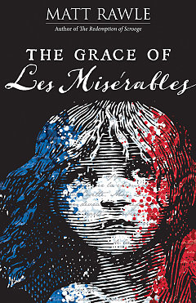
---------------------------------------------------
“The Grace of Les Misérables”
Based on a book by Matt Rawle
Feb. 21 – April 4, 2021
(7 weeks plus Holy Thursday)
Brainstorming: Monday, February 1 or 8, 2021

2021 theme connection:
Key words: Repent. Refocus. Redeem (Easter).
Quote: “To love another person is to see the face of God.” - Jean Valjean (Victor Hugo)
Related: Pastor Mary’s friend, Matt Mikalatos, posted a reflection on 9/1/20

Synopsis:

This Lent ponder the themes of justice, poverty, freedom, and love. Victor Hugo’s Les Misérables is a truly epic story. Whether you’ve tackled the 1,400-page 19thcentury novel, witnessed the Broadway musical (and memorized its soundtrack), or seen the several screen adaptations of it, you already know the power of its story.
In the six-week study The Grace of Les Misérables, author and pastor Matt Rawle dives into six ideals found in the story—grace, justice, poverty, revolution, love, and hope—each represented by a character in Hugo’s story. As these imperfect and relatable characters interact, we can see how these ideals work together (perhaps even in spite of each other) out in the world.
In keeping with his previous works, Matt Rawle brings us to the intersection of Church and Pop Culture by drawing parallels between the iconic story and musical and our Christian calling, inspiring us to both understand our faith and live it out in the world. https://www.abingdonpress.com/product/9781501887109/

Media:
- Series promo (https://www.youtube.com/watch?v=wRzM8ES_yas)
- Session 1 (https://www.youtube.com/watch?v=J6IMHZ_hs_U)
- 2012 movie trailer https://www.youtube.com/watch?v=IuEFm84s4oI
Set against the backdrop of 19th-century France, Les Misérables tells an enthralling story of broken dreams and unrequited love, passion, sacrifice and redemption-a timeless testament to the survival of the human spirit. Jackman plays ex-prisoner Jean Valjean, hunted for decades by the ruthless policeman Javert (Crowe) after he breaks parole. When Valjean agrees to care for factory worker Fantine's (Hathaway) young daughter, Cosette, their lives change forever.

February 21, 2021: Lent 1 – Jean Valjean
February 28, 2021: Lent 2 – Javert
March 7, 2021: Lent 3 – Fantine
March 14, 2021: Lent 4 – Marius and Cosette
March 21, 2021: Lent 5 – Building the Barricade
March 28, 2021: Palm Sunday – Blessed Garden
Thursday, April 1, 2021: Holy Thursday – to be determined
April 4, 2021: Easter – to be determined
---------------------------------------------------
“Are We There Yet?”
April 11 - May 16, 2021
(six weeks)
Brainstorming: Monday, March 22, 2021

2021 theme connection: God calls us to bless others so that we might bring about his kingdom on earth. Are we there yet?
Key word: Reflect
Key scriptures:
- Matthew 5: 1-11 - “Blessed are…”
- Matthew 6: 5-13 Lord’s Prayer
- Ten Commandments

Jesus taught us to pray (and work) for His “kingdom on earth as it is in heaven.” Are we there yet?
In the 2000 years since he came, many things have changed for the better. We still have a ways to go. Civility, integrity, truth-telling, grace and forgiveness have fallen out of favor. Being right has replaced being kind. Face-to-face conversations that might lead to understanding and cooperation have been replaced by often divisive social media encounters. The 24/7 media cycle feeds the ugliness. Wow! In this series, we’ll look at Jesus’ teaching from The Sermon on the Mount so that we can heed his kingdom call.

Related: Socrates asked people to consider, “Is it true; is it kind, or is it necessary?” before speaking.

Potential topics: Social justice, personal accountability, soul detox
- “Are We There Yet? Tenacious Civility”
  - Scripture: 1 Peter 3: 8-17 (⁸ Finally, all of you be of one mind, sympathetic, lovers of your fellow believers, compassionate, and modest in your opinion of yourselves. ⁹ Don’t pay back evil for evil or insult for insult. Instead, give blessing in return. You were called to do this so that you might inherit a blessing….)
  - Felt need: Change the way we interact with others – both words and actions – and call others to do the same
  - Incivility, cancel culture, loud voices, being a jerk
  - Message illustration: 9/29/20 Frank & Ernest cartoon – “Civility or else – a sign of the times”
- “Are We There Yet? Loving Resistance”
  - Scripture: 1 Timothy 1:10 (selling slaves); Jesus calling Herod a fox
  - Felt need: Speak truth and love to power (like Jesus)
  - See “Being the Church in Divisive Political Times,” below
- “Are We There Yet? Eliminating Racism”
  - Scripture: 1 Genesis (created in the image of God); Romans 10: 12 (no distinction between Jews and Greeks)
  - Felt need: To understand and eliminate racism. Give examples of specific ways individuals can implement positive change.
  - Related resource: Between the World and Me by Ta-Nehisi Coates
  - Anti-racism, white privilege, peaceful protest vs. riots, removing obstacles, equality of opportunity, the power of lament to move us toward reconciliation
- “Are We There Yet? Who Can We Trust?”
  - Felt need: To address our culture of distrust and fear mongering – sacrifice, accountability, see the many sides of issues, integrity in the church and politics
  - Scripture: Matthew 21: 28-32 (Prodigal Son – the second son’s inaction – lack of accountability)
- “Are We There Yet? Being the Church in Divisive Political Times”
  - Scripture:
  - Felt need:
  - “Kingdom justice is not up for partisan political debate. All who become part of Jesus’ movement will be working together in community to change oppressive systems that fail to honor the least and the lost.” https://www.ministrymatters.com/all/entry/10524/being-the-church-in-divisive-political-times?utm_source=newsletter&utm_medium=email&utm_content=Being%20the%20church%20in%20divisive%20political%20times%20&utm_campaign=MM%20Newsletter%2009-30-20
---------------------------------------------------
“Empowered”
Fruit of the Spirit
May 23 – July 18, 2021
(nine weeks beginning on Pentecost)
Brainstorming: May 3 or 10, 2021

2021 theme connection: God blesses each one of us with gifts of the Spirit.
Key word: Recharge.
Key scripture: Galatians 5: 22-25 (lectionary 6/30/19); Matthew 7: 15-20

Related info/synopsis:
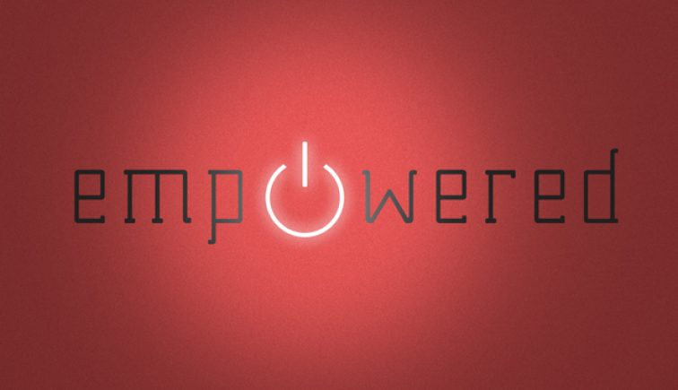
During His life on earth, Jesus was empowered by the Holy Spirit to do ministry. Jesus said that one day Christians would do even greater ministry than He did (John 14:12). While this does not mean that Christians are greater than Jesus, it does mean that Christians, who have the same Spirit as Jesus, can minister to more people than Jesus did because of the sheer number of believers around the world.
As we begin our study of spiritual gifts, it is important to remember that we first see that our ministry is simply a continuation of the ministry of Jesus. The spiritual gifts are given by God through the Spirit of God so that the church of God can minister like the Son of God. https://summitview.net/empowered/

---------------------------------------------------
“Uncomfortable: Finding Comfort in Uncomfortable Times”
July 25 – August 22, 2021
(five weeks)
Brainstorming: Tues., July 6 or Mon., July 12, 2021

2021 theme connection: Blessings can come
Key words: Repair. Refuse.
Synopsis: We’ve all been in uncomfortable situations – disagreeable (political) dinner conversations, work situations where we’ve been asked to questionable things, deciding whether or not to send kids to school during a pandemic, being called names (or being present while it happens to someone else), and more. Our first instinct might be to lash out – or be paralyzed by fear? How can a loving response provide us with an opportunity to grow more like Jesus?

Unity Music Festival: August 11-14

Additional topics: Inauthenticity (FakeBook). Don’t Call Me a Christian. General Conference/sexuality. Integrity/lack thereof. Navigating change.
---------------------------------------------------
“Mission: Possible”
August 29 – September 19, 2021
(four weeks)
Brainstorming: Monday, August 9, 2021

2021 theme connection: Mission is not a trip. Rather it is an opportunity to bless others as we’ve been blessed.
Key words: Respond. React.
Alternate series title: Mission from God. On a Mission Every Day.
Labor Day: September 5

*Synopsis: One of the five practices of fruitful living is risk-taking mission and service.
- Definition: All that we do to make a positive difference in the lives of others for the purposes of Christ, whether or not they will ever be part of the community of faith.
- Mission turns us outward.
- We serve God by serving others.
- Risk-taking mission and service takes us into ministries that push us out of our comfort zone, stretching us beyond the circle of relationships and practices that routinely define our faith commitments.
Ideas for the series:
- Use our mission and vision statements
  - The mission of Lake Harbor United Methodist Church is to make disciples of Jesus Christ for the transformation of the world.
  - The vision of Lake Harbor United Methodist Church is that all people may experience the love of Jesus. Our call then, is Love: welcoming all, empowered by Christ, sent forth to serve.
- Use mission statements from each organization – if we invite in guest speakers
- Show the connection between personal and social holiness; you can’t have one without the other. Wesley worked with those in poverty, schools, hospitals. He shared the gospel through acts of service.
- Use Social Creed: http://www.umc.org/what-we-believe/our-social-creed
- UM Social Principles references: Family, sexual abuse, criminal justice and restorative justice, poverty,

*These ideas are primarily from our September 2017 series on mission.

Scripture: Micah 6: 6-8 (What does the Lord require of you?); Matthew 25: 31-46 (sheep and goats)
---------------------------------------------------
“How to Build a Strong Family of God”
Focus on Stewardship
September 26, 2021 – October 31, 2021
(six weeks)
Brainstorming: Tues., Sept. 7 or Mon., Sept 13, 2021

2021 theme connection:
Key words: Rebuild. Responsible. Relationship.

Synopsis (Karen B – trying to recall Ken’s points): Everyone is part of a family though it might not be the “classic mom, dad, 2.1 kids all of whom are related and happily living together under the same roof” variety – and that’s okay. Whatever our family looks like, God has a plan for making it stronger.
Synopsis #1 (https://churchsermonseriesideas.com/building-great-families-in-tough-times/): This sermon series idea is about the family and making sure they are strong enough to weather the tough storms of life.
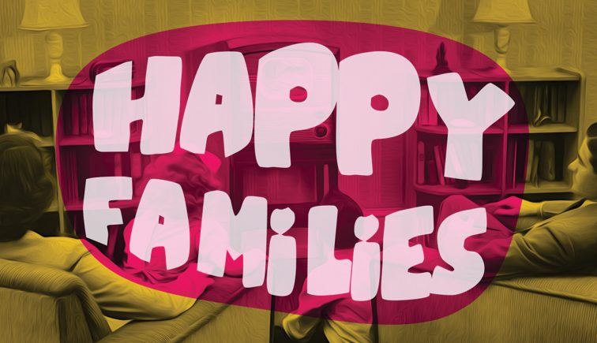
Synopsis #2 (https://churchsermonseriesideas.com/happy-families/):
Family has been described as ‘happy’, ‘loving’, ‘supportive’, ‘strange’, ‘modern’, ‘dysfunctional’ and ‘broken’. But we believe that from the start it was God’s plan and purpose that we should not just be born into this world and have to go it alone, but that we should be supported by family.
In this present day and generation, the whole concept of ‘family’ is coming under more and more pressure and often we might be tempted to think that the family design is irreparably broken.
In this series we looked at what God has to say about the family unit today – we might not accept that the ‘family design’ is broken but we would be shortsighted if we were not to accept that the family unit has become increasingly fragile.

FAMILY: Scripture – Book of James
- Sept. 26, 2021: “Faith”
- Oct. 3, 2021: “Ask for and Offer Forgiveness”
- Oct. 10, 2021: “Make Commitments”
- Oct. 17, 2021: “Invest in Each Other”
- Oct 24, 2021: “Listen to Each Other”
- Oct. 31, 2021: “Yield in Love” (Celebrate All Saints Day)
---------------------------------------------------
“Help, Thanks, Wow”
Based on a book by Anne Lamott of the same name
November 7-21, 2021
(three weeks)
Brainstorming: Monday, October 18 or 25, 2021

2021 theme connection: Prayer connects us to God and reminds us that we are blessed.
Key word: Remember
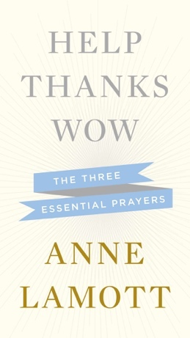
Synopsis:
Author Anne Lamott writes about the three simple prayers essential to coming through tough times, difficult days and the hardships of daily life….It is these three prayers – asking for assistance from a higher power, appreciating what we have that is good, and feeling awe at the world around us – that can get us through the day and can show us the way forward. In Help, Thanks, Wow, Lamott recounts how she came to these insights, explains what they mean to her and how they have helped, and explores how others have embraced these same ideas. https://www.goodreads.com/book/show/15737147-help-thanks-wow

